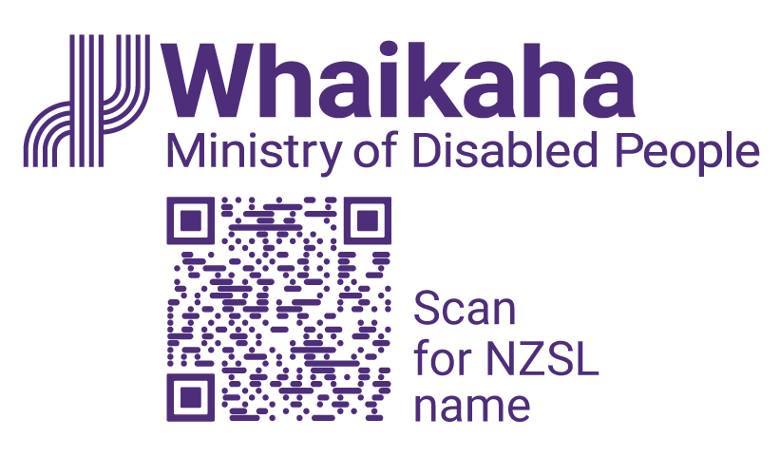
Advisor, Outreach
Adapted in 2026 by Accessible Formats Service,
Blind Low Vision NZ, Auckland
TN: The logo on the top of the page is Whaikaha Ministry of Disabled People and a QR code to Scan for NZSL name.

Advisor, Outreach

Mō te tūnga | About the role:
Join our Outreach team and work closely with the disability community, government agencies, businesses, and employers to provide quality information and advice on issues important to disabled people and bring about real change.
Key responsibilities:
- Build strong relationships with stakeholders, including Deaf and disabled people, Turi Māori, tāngata whaikaha Māori, and government agencies.
- Promote the New Zealand Disability Strategy, UN Convention on the Rights of Persons with Disabilities, and the Accessibility Work Programme.
- Provide innovative and purposeful advice to influence programmes of work and service delivery across government.
- Support Ministerial servicing, including briefings, correspondence, and responses to Parliamentary Questions.
- Contribute to key projects, frameworks, and cross-government initiatives.

Mōu | About you:
- Great relationship-building skills and a collaborative approach.
- Experience providing advice or analysis on engagement and participation approaches.
- Knowledge of the priorities and issues affecting the disability community.
- Ability to communicate clearly and assemble information in accessible ways.
- A commitment to equity, accessibility, and Te Tiriti o Waitangi.
We encourage applications from Deaf and disabled people, Turi Māori, tāngata whaikaha Māori, and those with lived experience. If you're passionate about inclusion and ready to learn, we'd love to hear from you.

He Whakaahuatanga Tūnga | Position Description:
The job description, closing date, salary, application process and alternate formats of this advertisement can be found here: Work with us | Whaikaha—Ministry of Disabled People (https://bit.ly/3Vz8jFi)

Mō mātou | About us:
At Whaikaha, we want an Aotearoa New Zealand where Deaf and disabled people, Turi Māori and tāngata whaikaha Māori are thriving.
As a Ministry we are dedicated to this goal, working with government, businesses, and communities to drive real change.
We do this by investing in disability communities, providing strategic and policy advice across government, monitoring how well services are working, and identifying new, exciting opportunities to make a difference.
We care about the wellbeing and success of our people and provide a supportive and inclusive environment.

Me pēhea te tuku tono | How to apply:
Click the 'Apply' button to complete the online form, or let's kōrero about what you need to feel supported in your application. For example, you may prefer to use video instead of a traditional CV and cover letter, or you might want whānau or a friend to tell us about you.
Contact us about the best way for you to apply by emailing:
PeopleandCulture@whaikaha.govt.nz.
If you work for Whaikaha please apply through the myHR portal so that your employee profile is visible as an internal candidate.
End of Advisor, Outreach

