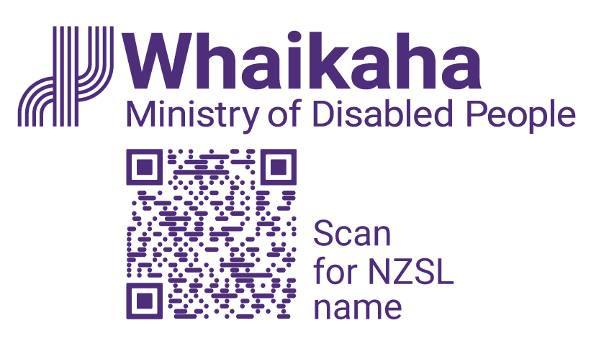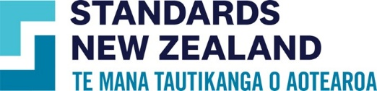

Environmental Scan for Review of NZS 4121 – Design for Access and Mobility: Buildings and Associated Facilities

Executive summary
Standards New Zealand asked for this scan to inform the review of New Zealand Standard (NZS) 4121:2001 Design for Access and Mobility–Buildings and Associated Facilities (NZS 4121). This standard is about making buildings easier to access for everyone. This standard is now over 20 years old. This scan looks at how well New Zealand’s approach to accessibility still matches international good practice, keeps up with new technology, and reflects how our understanding of disability has changed.
NZS 4121 has provided the basic guidance for accessibility in New Zealand’s built environment. However, since its publication, global standards have advanced considerably, adopting wider definitions of disability, integrating Universal Design principles, and including provisions for needs such as emergency evacuation, sensory accessibility, and cultural considerations.

Scope of the Scan
This scan compared NZS 4121 against standards from:
- Canada (CSA/ASC B651:23)
- European Union (EU) (EN 17210:2021)
- United States (US) (ADA Standards 2010)
- United Kingdom (UK) (BS 8300-2:2018 and Document M)
- Australia (AS 1428 series and Disability Access to Premises Standard 2010).
The International Standard – ISO 21542:2021 (E) was also considered. However, as the EU standard mirrors the ISO standard, a detailed analysis of ISO 21542:2001 (E) was deemed unnecessary.
Together, these standards represent global good practice and highlight where New Zealand’s standard is good, and where it is outdated or incomplete.

Overall findings
The standards were assessed by their format, scope, comprehensiveness, level of detail, and age of the standard. Each standard was given a score out of five for each criterion. Based on this assessment, the Canadian and EU standards were found to have the best quality overall.
Topic analysis was carried out on individual aspects contained in NZS 4121, to allow for easy comparison with other standards. Canada and the EU both scored the highest in this analysis as well.
Additionally, unlike New Zealand, Australia, and the UK, both Canada and the EU have all their accessibility information covered in one standard, making them easier to follow and to find relevant information.
Overall, the Canadian standard is easier to follow due to its coverage of technical details, however the EU standard covers a wider range of topics.

Strengths and limitations of NZS 4121

Strengths
- The standard has clear formatting and imposes requirements which are measurable and actionable.
- Includes unique coverage of topics such as design and access, shelters within carparks, the location of toilet and shower facilities, and access to accommodation.

Limitations
- Often lacks explanation or detail for its guidance.
- Uses a narrow definition of disability, primarily focusing on mobility related disabilities.
- Lacks coverage in areas such as emergency alerts and building evacuation, air quality, and acoustic design in built environments.
- Lacks cultural considerations for accessibility in buildings such as marae.
- Some language in this standard is outdated. For example, it describes accessibility as “not an emotional issue” which minimises the personal and social impact of inaccessibility. The use of this terminology may not be considered as inclusive.
- It does not cover topics of acoustics, children and adolescents, air quality, functional and cognitive barriers, and security access.
- Issues around the implementation of the standard are covered in section 6.6.2 of the full report. The inclusion of NZS 4121 in the Building Act creates conflicts with the Building Code, which leads to gaps in the regulatory framework for accessibility requirements and makes updating NZS 4121 harder.

Recommendations for updating the New Zealand Standard
A small update to NZS 4121 will not be enough to meet current needs. Internationally, accessibility standards are broader, more detailed, and better aligned with a modern definition of disability.
A revision of NZS 4121 should:
- Incorporate inclusive language and explanations for guidance.
- Extend coverage to emergency evacuation, sensory environments, cultural considerations, and accessibility for a wider range of disabilities.
- Draw on the Canadian and the EU standards as primary benchmarks, while also integrating selected provisions from the UK, US, and Australia.
- Reference complementary standards such as AS/NZS 1428.4.1:2009 (tactile indicators).
If New Zealand chooses to adopt an overseas standard, the Canadian standard is recommended because it is detailed and easy to follow. Unique aspects of the EU standard should also be included into this new standard. Additionally, selected information from the existing New Zealand and Australian standards which is not in the Canadian and EU standards should also be included.
The following lists covers key aspects of NZS 4121:2001 and highest rated aspects from international standards.

Topics not currently covered in NZS 4121:2001
- Canada: Is the only standard to cover ways to reduce functional and cognitive barriers. Provides additional information for acoustics, air quality and security access.
- EU: Provides detailed coverage of acoustics and air quality. Provides additional information for security access.
- Australia: Includes additional requirements for children and adolescents.

How the countries standards rank in different topics

Definitions, Design and Access
- Canada: Highest rated definitions.
- EU: Includes people with allergies
- New Zealand: Ranked best for Access and Design.

Accessible Routes
- Canada: Detailed analysis on hazards and obstructions, direction indicators, signs, controls and fittings, and emergency provisions. Extra information on surfaces finishes and audible and visual.
- EU: Detailed analysis on surface finishes, emergency provisions and audible and visual. Provides extra information on direction indicators and signs.
- UK: Only standard to include Site and Building Layout.
- Australia: Includes extra information for emergency provisions and audible and visual.

Car Parks
- Canada: Detailed information on only access from carparks/pick up areas. Extra information on dimensions.
- EU: Best overall requirements for signs, number of carparks required, dimensions, surfaces, and facilities.
- New Zealand: The only standard to include shelter. Provides detailed analysis for facilities, and number of carparks required.

Footpaths, Ramps, and Landings
- Canada: Best standard for moving walkways and escalators, and ramps/ramp landings.
- EU: Detailed requirements for footpaths and fairing of surfaces. Extra information for moving walkways.
- New Zealand: Provides good information regarding ramps/ramp landings and fairing of surfaces. Extra information on moving walkways.

Entrances, Corridors, Doorways, and Doors
- EU: Best standard for corridors. Provides extra information for entrances and doorways.
- New Zealand: Ranked highest for entrances and doorways.
- UK: Provides extra information on corridors.
- Australia: Provides extra information on doorways.

Stairs and Lifts
- Canada: Extra information on stair design and construction.
- EU: This standard was ranked highest for auditory, tactile and visual cues, and design of lifts. Provides extra information on stair handrails.
- New Zealand: Ranked highest for stair design and construction, and handrails. Provides extra information on auditory, tactile, and visual cues.
- UK: provides extra information on design of lifts.

Toilet and Shower
- Canada: Highest ranked for signs and design.
- EU: Highest ranked for design and the inclusion of baby facilities such as breast-feeding rooms and non-gendered baby changing rooms.
- New Zealand: Ranked the highest for location and number of toilets and showers. Provides extra information regarding design.

Public Facilities
- Canada: Highest ranked for dressing/fitting rooms; and drinking fountains. Provides additional criteria for telephones.
- EU: Highest ranked for public counters and desks, ATMs and vending machines. Provides unique requirements for assistance dog facilities, rubbish bins, seating and waiting and storage spaces.
- New Zealand: Provides extra information about telephones and ATMs and vending machines.
- US: Provides additional information about drinking fountains.

Places of Assembly, Entertainment, and Recreation
- Canada: Highest ranked for places of recreation.
- EU: Highest ranked for places of assembly and entertainment.
- UK: Has additional requirements for places of assembly and entertainment.
- US and Australia: Have additional coverage of places of recreation.

Accessible Outdoor Public Areas
- Canada: Provides additional coverage of outdoor hazards, kerb ramps, street furniture and facilities, pedestrian crossings, and transit facilities.
- EU: Has the highest rated requirements for outdoor hazards, street furniture and facilities, landscaping, pedestrian crossings, and transit facilities.
- New Zealand: Provides the best coverage of kerb design and kerb ramps.

Accommodation
- EU: In-depth requirements for accommodation arrival and departure. Provides additional recommendations for accessible accommodation.
- New Zealand: Has the best coverage of the application of the standard, access, and accessible accommodation. Extra information regarding arrival and departure.
- UK: Provides additional coverage of accessible accommodation.

Next Steps
This scan is the first stage in the review process. The next phases will include:
- Consultation with disability communities, design professionals, and other stakeholders.
- Identification of priority areas for revision of NZS 4121.
- Recommending a process for updating NZS 4121 to ensure it is future-proofed, internationally aligned, and culturally appropriate for Aotearoa New Zealand.
More information can be found in the full report at www.whaikaha.govt.nz/4121
End of: Environmental Scan for Review of NZS 4121 – Design for Access and Mobility: Buildings and Associated Facilities
This Large Print document is adapted by Blind Citizens NZ from the standard document provided by Standards NZ, and Whaikaha | Ministry of Disabled People.

