


Summary of submissions
New Zealand Disability Strategy 2026 - 2030

December 2025

The Ministry would like to thank all those who took the time to submit feedback on the draft strategy.
Whakawhetai ki a koutou.

This work is licensed under the Creative Commons
Attribution 4.0.

In essence, you are free to copy, distribute and adapt
the work, as long as you attribute the work to the Crown
and abide by the other licence terms. To view a copy of
this licence, visit: CC BY 4.0 Legal Code | Attribution 4.0
International | Creative Commons.

Please note that no departmental or governmental
emblem, logo or Coat of Arms may be used in any way
which infringes any provision of the Flags, Emblems,
and Names Protection Act 1981. Attribution to the Crown
should be in written form and not by reproduction of any such emblem, logo or Coat of Arms.

ISBN 978-1-991429-06-3 (Online)

Citation
Ministry of Disabled People – Whaikaha (2025). New Zealand Disability Strategy 2026-2030: Summary of submissions. Retrieved from www.whaikaha.govt.nz
Published in December 2025
Ministry of Disabled People – Whaikaha
Wellington, New Zealand.

Contact
disabilitystrategy@whaikaha.govt.nz or 0800 WHAIKAHA (0800 942 452)

Contents

1 Executive summary 4
2 Strategy development 7
3 The vision 10
4 The 7 principles 11
5 Strategy overall 14
6 Education 19
7 Employment 27
8 Health 32
9 Housing 37
10 Justice 43
11 Monitoring and measuring progress 49
12 Impact of submissions on the final strategy and next steps 51
Appendix 1 Consultation process 52
Appendix 2 Agreement levels 58

1 Executive summary

1.1 The consultation process
The Ministry of Disabled People – Whaikaha (‘the Ministry’) consulted on the draft New Zealand Disability Strategy (‘the strategy’) over 6 weeks from 19 August to 28 September 2025. Feedback was gathered through accessible feedback forms, including in alternate formats, email and video submissions, and online and in-person meetings hosted by the Ministry or community groups.

1.2 Overarching themes from feedback
Enabling Good Lives is missing
Submitters strongly supported the inclusion of Enabling Good Lives (EGL) in the strategy. They wanted the EGL approach applied across health, education, employment, and disability support services (DSS), and called for a unified system where support is not based on impairment type. Many submitters also stated a clear preference for the EGL principles, viewing them as a trusted framework that works with disabled people rather than for them.
Effective implementation needs public sector collaboration and robust oversight mechanisms
Submitters sought stronger collaboration among agencies, governance to oversee progress, and alignment with the United Nations Convention on the Rights of Persons with Disabilities (UNCRPD). Concerns about implementation included the need for legislative frameworks, equitable funding, cross-agency collaboration, enforceable rights, independent oversight, and disabled leadership. Many questioned the 5-year timeframe and urged bipartisan support.
Transport should be a priority in the strategy
Many submitters raised the importance of transport to participation and better outcomes for disabled people and asked for it to be included as a priority outcome area. It was specifically mentioned as a barrier to good outcomes in employment, education and health.

Poverty should be addressed in the strategy
Poverty and the issue of material hardship for disabled people and their families was identified as a significant barrier to wellbeing, with recommendations to increase the Supported Living Payment and remove spousal income tests.

Recognising diverse experiences of disability and needs of disabled people
Feedback stressed the importance of reflecting the diversity of disabled people, including those with complex needs, children, older people, neurodivergent individuals, and whānau. Carers and community roles should be recognised.
More accessible language in the strategy
Submitters wanted simpler language, clearer measurable actions, and removal of jargon. They called for practical examples and definitions of terms such as equity and accessibility.
A Government strategy with feedback from disabled people
Submitters were dissatisfied with the engagement process, saying this was a government-led strategy with consultation from the disability community rather than co-designed, and that compressed timeframes compromised the final draft. Submitters called for genuine co-design in implementation and monitoring. Public awareness campaigns were recommended to challenge negative attitudes.
Tāngata whaikaha Māori perspectives
Tāngata whaikaha Māori stressed the importance of Māori-led solutions, whānau-centred approaches, and partnership under the Treaty of Waitangi (Te Tiriti o Waitangi). There was also criticism that the strategy is too focused on individuals, and that it could better encompass a collective worldview and emphasise the importance of whānau and communities to tāngata whaikaha Māori and Māori. Submitters also raised concerns about data collection and called for the explicit recognition of Māori data sovereignty. Further analysis will be available in a forthcoming report – analysing feedback from tāngata whaikaha Māori and Māori.
Pacific perspectives
Pacific disabled submitters prioritised culturally centred approaches, strengthening provider capability and raising awareness among Pacific families about what supports are available. Partnership and investment in Pacific providers were seen as essential. Further analysis will be available in a forthcoming report analysing feedback from the Pacific disabled community.

1.3 Feedback on the outcome areas
Education
Submitters called for systemic change to make learning support accessible and effective. They highlighted workforce shortages and the need for disability awareness, universal design, and personalised planning in teacher training. Disabled Māori and Pacific learners face severe inequities, requiring culturally grounded approaches and investment in kaupapa Māori and Pacific supports. Submitters welcomed investment in early intervention but warned that workforce shortages could undermine progress.
Employment
Submitters said the definition of success should include part-time work, volunteering, and community participation, alongside financial security. They raised concerns about systemic barriers, discriminatory attitudes, and inaccessible recruitment processes. Recommendations included legislative reform, employer education, New Zealand Sign Language (NZSL) access, and enforceable standards. Transport was identified as a major challenge, especially in regional areas.
Health
Submitters said the health system is hard to navigate, with long delays and confusing processes. They called for fair access regardless of origin of disability (by birth or acquired), better coordination, and centralised information. Priorities included culturally safe care, mental health services, NZSL access, and investment in workforce training. Submitters supported data collection but stressed privacy and Māori data sovereignty.
Housing
Submitters called for more affordable and accessible homes, and mandatory design standards. They supported Māori-led housing solutions and whānau-centred approaches for intergenerational families. Barriers to renting and home ownership were highlighted, with calls for tenancy protections and incentives for accessible rentals.
Justice
Submitters strongly supported a safeguarding framework with independent oversight and stronger penalties for abuse. They called for mandatory workforce training on accessibility and cultural safety, plain language, and advocacy support. Concerns included a lack of focus on preventing violence and there was a call for Māori-led justice solutions grounded in tikanga, whakapapa, and mana motuhake.
Monitoring and Data
Submitters stressed the need for independent monitoring with clear indicators and targets, shared systems, and ethical data collection that allows for opt-in collection of personal information.

1.4 Conclusion
Feedback underscored the importance of a strategy that is culturally responsive and addresses the needs of a diverse disability population. Submitters called for a strategy where the EGL Principles are included, and EGL approaches are adopted as part of education, employment, health, housing and justice. They wanted rights to be protected, poverty tackled as a systemic issue, and sustained commitment and resourcing across political cycles to ensure the strategy delivers lasting change for all disabled people and their whānau.

2 Strategy development
The current New Zealand Disability Strategy was published in 2016 with a 10-year time frame which was due to expire in 2026. On 11 March 2025, Cabinet authorised the Minister for Disability Issues to develop a refreshed New Zealand Disability Strategy 2026 - 2030 (the strategy). It was agreed that the strategy would focus on 5 priority outcome areas: education, employment, health, housing, and justice and included an overarching vision and a set of principles to guide the interpretation and implementation of the strategy.

2.1 Collaboration with the sector
The vision and principles of the strategy were developed through 11 workshops with disability groups, including 5 workshops with tāngata whaikaha Māori groups.
The Ministry established Working Groups for each of the 5 outcome areas. These included disability community and sector representatives alongside officials from relevant agencies. Working Group members collaborated to develop proposals for the refreshed strategy between April and June 2025. For each outcome area they developed a proposed goal, a description of what success means, a case for change, and actions.
The Working Groups prioritised their proposed actions based on key criteria. These included how feasible is the delivery of actions within the 5-year period, how the actions align with Government priorities, evidence for positive impacts on the lives of disabled people and tāngata whaikaha Māori, affordability and value for money, and whether the actions are sufficiently tangible, specific, and measurable.
Cabinet gave the Ministerial Disability Leadership Group and the Minister of Justice authority to approve the draft strategy for consultation. The Ministerial Disability Leadership Group and the Minister of Justice considered the drafts prepared by the Working Groups and officials and approved it for public consultation in August 2025.

2.2 Approach to strategy refresh and consultation
Consultation on the strategy took place over the period 19 August to 28 September 2025. The Ministry sought feedback from the public to understand the level of support for different aspects of the strategy and identify gaps and emerging priorities. We received feedback from a wide range of stakeholder groups, individuals, and whānau on the following:
- clarity, alignment and confidence in the vision
- importance of the principles
- level of agreement with the goal, success description and actions in each outcome area
- overall agreement with and confidence in the strategy.
Feedback was sought in a range of ways including:
- an accessible online feedback form
- a Word feedback form, to complete and return via email or post
- a 3-minute video
- online hui and in-person hui
- email submissions.
A total of 900 people attended 47 hui held by either the Ministry or community groups, and the Ministry received almost 570 items of separate feedback:
- over 400 online accessible feedback form responses
- 50 feedback forms were delivered by email, post or in person
- almost 120 emailed submissions.
Feedback form respondents were asked and if they were responding on behalf of themselves, another person, a group or an organisation. Individual respondents were also asked about their age, disability status, ethnicity, and gender, and whether they were a carer or family member of a disabled person.
The quantitative data in this report is from the online and Word feedback forms. Respondents were asked to answer questions using 5-point Likert scales:
Agreement scale (1 = strongly disagree, 3 = neither agree nor disagree, 5 = strongly agree) for the vision, strategy, and five outcome areas.
Importance scale (1 = not at all important, 3 = neutral, 5 = very important) for the principles.
The qualitative analysis includes written feedback form a wide range of sources including the feedback form, email submissions and meeting notes.
Appendix 1 provides more details on the consultation process, analysis approach and demographic characteristics of respondents.

Each section of this report begins with a statistical summary of data collected from the feedback forms. The results are provided both visually in graphs and with explanatory text set out below the graphs to highlight key data points for that section. Where these results discuss levels of support among certain groups, the following definitions apply:
- sample overall (all feedback form responses including disabled people, tāngata whaikaha Māori, non-disabled people, groups, and organisations)
- disabled people (all people who identified as disabled and/or as tāngata whaikaha Māori, due to sample sizes these results are not reported separately)
- non-disabled people
- groups and organisations (combined responses from both groups and organisations, due to the small sample sizes it was not possible to report results for groups and organisations separately).

3 The vision
The Ministry consulted on the following proposed vision: ‘New Zealand is an accessible and equitable society for disabled people and their whānau – a place where disabled people thrive, lead, and participate in all aspects of life’.

3.1 Summary of data: Vision

There were high levels of agreement with the vision’s alignment and clarity, but lower confidence that it will lead to meaningful change
A total of 451 respondents responded to the vision questions. The feedback form asked respondents how much they agreed with 3 statements: the proposed vision is clear and easy to understand; the vision aligns with the values and aspirations of disabled people; and I feel confident that the vision will lead to meaningful change. Figure 1 below shows levels of agreement with these statements. Most respondents agreed or strongly agreed that the vision is aligned with the values and aspirations of disabled people (69 percent), and the vision is clear and easy to understand (73 percent), but only 27 percent agreed or strongly agreed that the vision will lead to meaningful change.
Figure 1: Agreement that the vision is clear and easy to understand, aligns with the values and aspirations of disabled people, and will lead to meaningful change
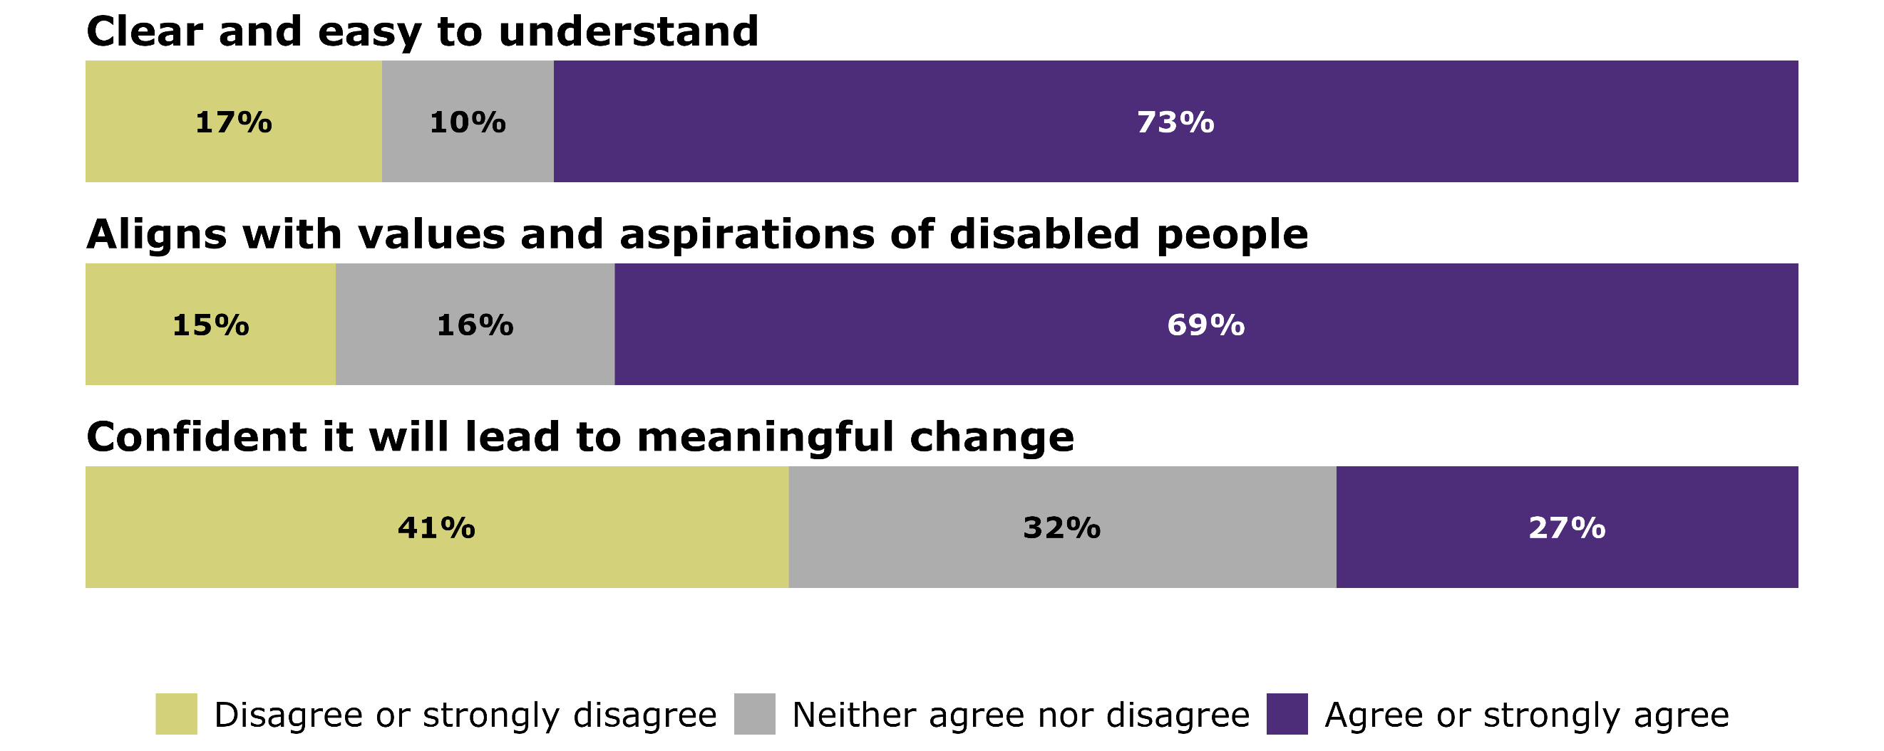
Mean agreement scores for all items are presented in Appendix 2.
Average agreement levels were slightly lower among disabled respondents compared with non-disabled respondents for both vision clarity and vision alignment.

3.2 Common themes and insights: Vision

Submitters want language to be simple and drive change
Submitters appreciated the intent and focus on inclusion, equity, and lived experience. However, many said the proposed vision statement was unclear, uninspiring, and lacked direction. Others said it reflected the status quo rather than driving meaningful change, and that there should be a clearer set of responsibilities for government and society.
Others, such as parents of vision-impaired people, felt the vision did not adequately reflect the voices of disabled people and their whānau. However, contrasting views expressed that whānau should not be included in the vision as they can sometimes exert too much control over disabled people’s lives.
Many submitters said the vision excluded some disabled people as they felt terms like ‘lead’ and ‘participate’ do not reflect the lives of people who require lifelong support. For some, living ‘ordinary lives’ is a meaningful aspiration. Submitters also suggested including practical examples and case studies across all outcome areas to show how the strategy applies to people with high and complex needs.
Several submitters raised concerns that the term ‘equitable’ may not be well understood by readers or implementing agencies, potentially leading to inconsistent application. ‘Equity’ also means different things in different contexts. For Deaf people, equity can mean ‘full linguistic access in every aspect of life’, which may differ for others. Some suggested replacing ‘equity’ with ‘fair and just’. Conversely, some submitters supported retaining ‘equitable’, noting its complexity but also its strength and significance.
Submitters said that the aspiration of the vision statement was not matched by the actions of the outcome areas, and expressed concern that the strategy would not lead to meaningful change.

4 The 7 principles
The strategy proposed 7 principles which outline the key values and commitments that underpin the strategy: Accessibility, Choice and control, Equity, Cultural inclusion and intersectionality, Human rights, Participation and inclusion, Respect and dignity, and the Treaty of Waitangi (te Tiriti o Waitangi).

4.1 Summary of data: Principles

There were high levels of support for most of the principles
The feedback form asked respondents to rate the importance of each principle. This is shown in Figure 2. Five of the principles had strong support from more than 9 in 10 people. Support was lower, though still high, for the Treaty of Waitangi (Te Tiriti o Waitangi) principle, with 79% rating it as important or very important. As will be discussed further, this may reflect feedback that the Treaty of Waitangi (Te Tiriti o Waitangi) should not be listed as a principle but rather as a foundational document with more prominence in the strategy.
Figure 2: Importance of each principle
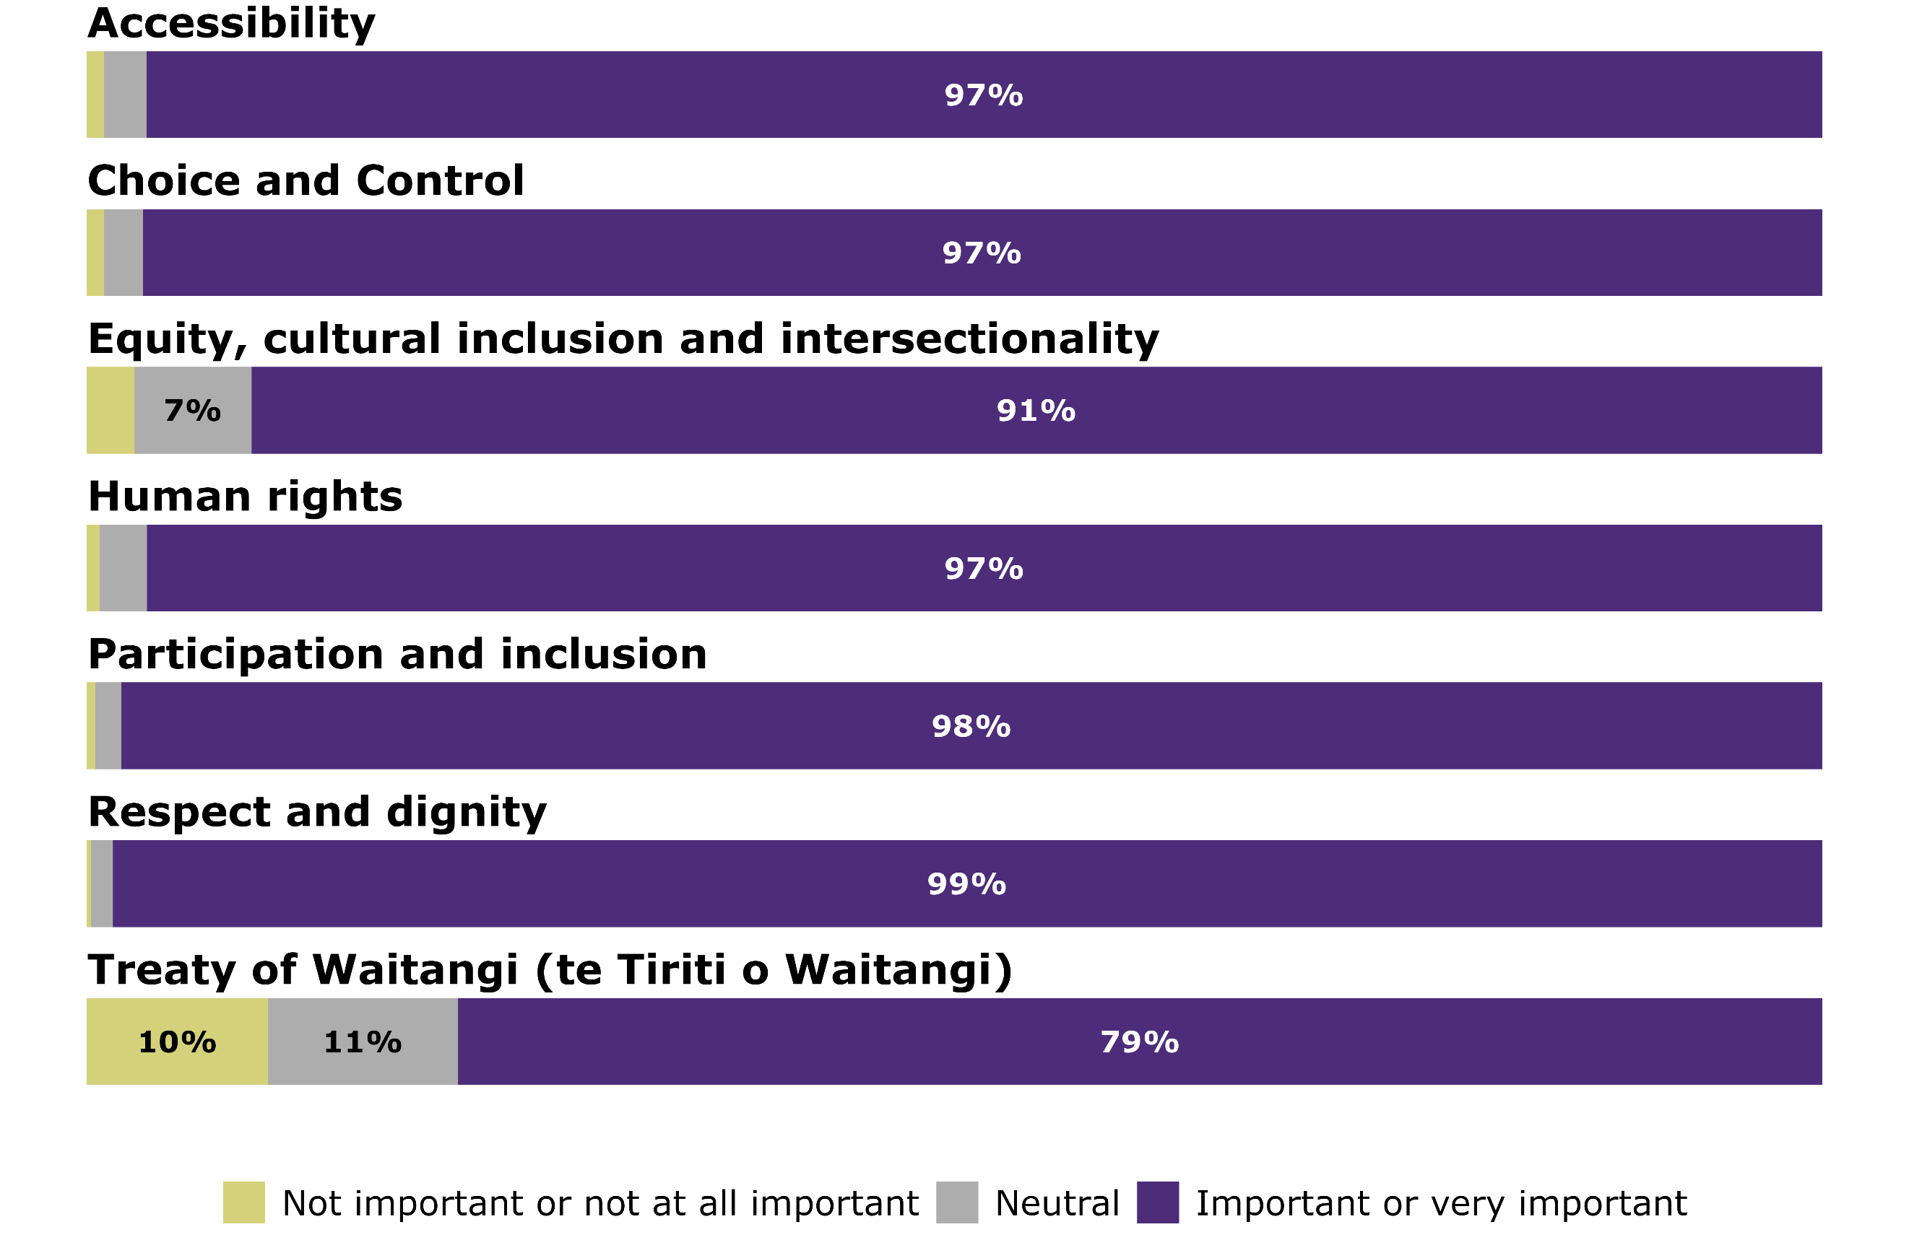
Support was generally high for the principles. However, there was less support on two principles – Equity, cultural inclusion and intersectionality, and The Treaty of Waitangi (Te Tiriti o Waitangi). The perceived importance of these differs by disability status. For the Equity, cultural inclusion and intersectionality principle, support was slightly lower among disabled people and tāngata whaikaha Māori compared with non-disabled people. The inverse is seen for The Treaty of Waitangi (Te Tiriti o Waitangi), where support was slightly higher among disabled people and tāngata whaikaha Māori compared with non-disabled people. Support for these two principles was higher for groups and organisations than individual submitters.

4.2 Common themes and insights: Principles

Principles should be clear, agreed, and widely supported by the community, such as those set out by Enabling Good Lives
There was a high level of support for the principles, but the strongest theme of feedback received was the desire to include the EGL principles, with some submitters calling for the principles in the strategy to be replaced with the EGL principles.
Submissions referred to EGL as an established and trusted set of principles that were well understood by the disabled community. In large part, this was because they were developed by the community and were viewed as more than just a concept, but a call for ‘one cohesive system across all government agencies, one that works with, not for, disabled people.’
Other submitters felt there were too many principles, and that the number of principles and the overlaps between them created confusion and diluted the strategy’s focus.
Submitters felt the principles lacked aspiration and noted the lack of mechanisms and resources to put them into practice. Some felt that accountability should be a standalone principle, alongside interagency partnership, and ‘nothing about us without us’.
Key feedback included:
- Accessibility: Submitters said the definition was too narrow and called for adding digital accessibility, universal design, assistive technology, and accessible language.
- Choice and control: Submitters suggested ‘self-determination,’ as an alternative, noting that ‘control’ can be viewed negatively and that the concept of control differs for people with complex needs. They also raised concerns about carers’ roles being invisible and recommended adding ‘supported decision-making’ as a principle.
- Equity, cultural inclusion, and intersectionality: Submitters described these terms as jargon and open to different interpretations. Many suggested making ‘equity’ a standalone principle.
- Human rights: Submitters urged alignment with articles of the UNCRPD and reference to the UN Convention Against Torture (UNCAT). They also recommended specifically including ‘reasonable accommodations’ in this section.
- Participation and inclusion: Submitters suggested this principle should include opportunities for leisure and social sports.
- Respect and dignity: Submitters called for removing barriers such as discrimination and ableist attitudes.
- Treaty of Waitangi (Te Tiriti o Waitangi): Submitters urged using ’te Tiriti,’ and replacing ‘partnership, participation, and protection’ with ‘tino rangatiratanga and mana motuhake’.

5 Strategy overall

5.1 Summary of data: Strategy overall

There was support for the strategy’s aims and aspirations, but low confidence it will lead to meaningful change
In total, 451 respondents provided feedback on the strategy through the feedback form. The feedback form asked respondents how much they agreed with two statements about the overall strategy: the strategy reflects what matters most to disabled people; and I feel confident that the strategy will lead to meaningful change.
Figure 3 shows levels of agreement with these statements. Most respondents (70 percent) agreed or strongly agreed that the strategy reflects the values and aspirations of disabled people. However, only 34 percent agreed or strongly agreed that they are confident that the strategy will lead to meaningful change.
Figure 3: Level of agreement that the strategy reflects what matters most to disabled people and confidence it will lead to meaningful change
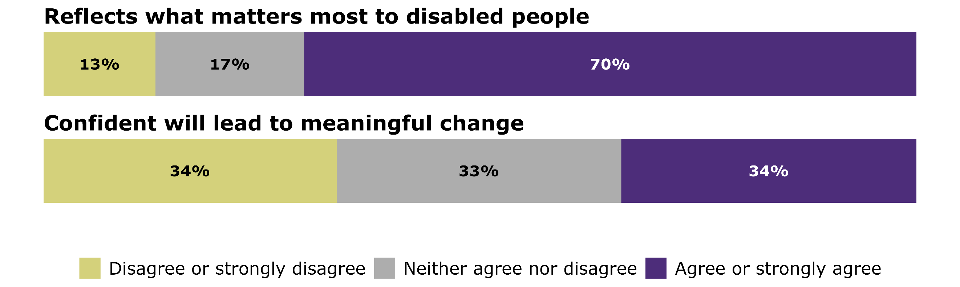
Average levels of agreement were slightly lower among disabled respondents compared to non-disabled respondents on whether the strategy reflects the values and aspirations of disabled people.

5.2 Common themes and insights: Strategy overall

Calls for a simpler strategy with clearer goals and stronger accountability
While submitters appreciated the intent and vision of the strategy, especially its focus on inclusion, equity, and lived experience, many submitters expressed a lack of confidence in the strategy to improve the lives of disabled people, particularly within the 5-year timeframe.
Submitters called for the document to be simpler, and for clearer, measurable actions. Some submitters suggested that the actions in the outcome areas lacked specificity, there was a need to make the goals clearer, and there were too many actions to complete in 5 years.
Some submitters called for more explicit collaboration among government agencies and a governance structure to oversee the progress. Others called for clearer alignment between the strategy’s actions and the recommendations of the UNCRPD and related human rights mechanisms.

There were strong calls for Enabling Good Lives to be included
The strategy did not contain a reference to EGL and this absence was commented on frequently by submitters. As discussed earlier, many submitters called for the strategy to adopt the EGL principles, and for the specific inclusion of EGL within the priority outcome areas.

Key gaps identified: Transport, DSS, and the inequity of supports for different groups of disabled people
Many submitters raised the importance of accessible and affordable transport to enable participation and better outcomes for disabled people and asked for transport to be included as a priority outcome area. Poor access to transport options was specifically mentioned as a barrier to good life outcomes in employment, education and health.
Some submitters suggested that DSS should be included in the strategy and asked for the national rollout of an EGL approach to DSS.
Submitters frequently highlighted the inequities across disability support systems, including disparities between the ACC support received by people with acquired disability compared with the DSS support received by those who are disabled from birth or have health conditions.
There was strong support for a unified system where support available for disabled people does not depend on the type or the cause of their impairment.

Poverty is a barrier to participation, wellbeing and inclusion
Submitters expressed frustration that the strategy did not directly address the issue of poverty. Many noted that disabled people and their families cannot rely on employment alone for their financial security, and that paid work is not an option for many disabled people.
Submitters called for action to reduce financial hardship experienced by disabled people. Suggestions included increasing the Supported Living Payment to meet living costs and removing spousal income tests so disabled people are not discouraged from forming relationships or placed under a partner’s financial control.

Disabled people and their supporters are diverse
Submitters said the strategy did not reflect the full diversity of disabled people. They highlighted gaps for those with fluctuating, invisible, or progressive conditions; people with high and complex needs and their families; neurodivergent people; people with rare disorders; people who acquired disability through trauma; and people in aged residential care. They also asked for explicit reference to older disabled people and disabled children and young people.
Submitters stressed the need to recognise and support whānau and family carers. They also called for greater visibility of the role of churches, local government, disability organisations, whānau, hapū, iwi, businesses, and wider society.

Meaningful change needs funding, laws, accountability and engagement
Many submitters expressed scepticism about whether the Government would deliver on the strategy’s aims. Submitters called for prioritised and equitable funding, strong implementation and monitoring mechanisms, and explicit collaboration between key agencies. Many emphasised the need to identify responsible agencies that work together to end a siloed approach to delivery. Submitters acknowledged the Ministry’s stewardship role and made calls to consolidate resources and create a central point of contact and information for disabled people, tāngata whaikaha Māori, whānau, and disability service providers.
Submitters considered enforceable rights and legal mechanisms to be essential in achieving the strategy’s goals. Suggestions included establishing an independent oversight body to review non-compliance and ableism and introducing accessibility and disability rights legislation.
They also called for disabled leadership and co-design to be embedded in the implementation, monitoring, and governance of the strategy, upholding the principle of ‘nothing about us without us’.
Many submitters questioned whether the 5-year implementation period will be sufficient and urged bipartisan political support to ensure continuity.

Language should be clear and accessible
Submitters felt the language used in the strategy was too complex. They emphasised the importance of plain language that is people-centred and rights-affirming. They recommended avoiding ableist words such as ‘normalise’ and instead using language that feels relatable to disabled people and their whānau.
They called for removing jargon like ‘intersectionality’ and ‘cross-cutting themes’ and including clear definitions for terms such as ‘equity’, ‘equitable society’, ‘thrive’, ‘disability-confident’, ‘cultural inclusion’, and ‘enhanced quality of life’.

The engagement process was unsatisfactory and there were strong calls for co-design in the implementation and monitoring phases
Submitters noted that unlike previous versions, this strategy was not drafted with the disabled community. They considered this undermined the legitimacy of the strategy and its ability to reflect the diverse needs and lived experiences of disabled people. Submitters acknowledged that using Working Groups for each outcome area was a good approach but felt that drafts were developed within compressed timeframes and many recommendations put forward by Working Groups did not appear in the strategy. Submitters described this process as ‘tantamount to receiving advice from chosen experts.’ There were strong calls to co-design the implementation and monitoring of the strategy to ensure the inclusion of those with lived experience of disability.
Not just a Government issue: a call for shared responsibility
Submitters suggested that implementation should not be the responsibility of the Government alone. They wanted implementation to include businesses and communities, emphasising that achieving the strategy will require a whole-of-society approach. Other submitters called for public awareness campaigns to address negative societal attitudes toward disability.

Māori-led solutions, genuine partnership and whānau should be at the centre
Tāngata whaikaha Māori and Māori submitters emphasised the need for Māori-led solutions and genuine partnership in implementing the strategy. They wanted whānau, rather than individuals, placed at the centre. While they raised many similar concerns to other submitters, they also highlighted distinct priorities for their communities.

Submitters called for the strategy’s aspirations to translate into meaningful actions that meet the needs of tāngata whaikaha Māori and their whānau. Although some expressed hope in the strategy’s vision, many reported low trust and confidence in whether it can be delivered within 5 years. They recommended prioritising Māori-led approaches to address inequities, noting the compounding disadvantage caused by systemic racism and ableism.
There were strong calls for increased funding and resourcing for kaupapa Māori services across priority areas, reflecting confidence in te ao and mātauranga Māori-informed care. Submitters stressed that engagement and partnership with Māori, including hapū and iwi, must underpin development, implementation, and monitoring, and be guided by the Treaty of Waitangi (Te Tiriti o Waitangi).
Tāngata whaikaha Māori and Māori submitters echoed wider concerns about inequities between DSS and ACC-funded supports and highlighted the need for whānau navigation roles to help tāngata whaikaha Māori access complex systems. A few submissions also noted the absence of a specific action plan for tāngata whaikaha Māori.
Other feedback referenced the potential of rongoā Māori, the importance of access to te ao Māori, and concerns about Māori data sovereignty.
Further analysis of feedback from tāngata whaikaha Māori and Māori can be found in the companion report: Summary of submissions - tāngata whaikaha Māori and Māori feedback on the NZDS.

There is a need to build awareness and culturally centred supports for Pacific communities
Pacific communities highlighted 3 main priorities: improving awareness of available supports; ensuring culturally centred approaches; and strengthening Pacific providers’ capability. Pacific families living with disability often follow cultural norms and are less likely to seek help from mainstream services. Knowing what supports exist is essential for the wellbeing of these families and their disabled family members.
Pacific communities stressed that interventions work best when they reflect Pacific values and include community voices. Building trust requires services to be designed in partnership with Pacific communities.
Mainstream providers also need to recognise the skills of Pacific providers. Investing in Pacific providers’ capacity and capability will ensure services are fit for purpose and responsive to community needs. Further analysis of feedback from Pacific disabled people will be published in early 2026 on the Ministry’s website.

6 Education

6.1 Summary of data: Education

Strong agreement with the goal and description of success
A total of 317 respondents provided feedback on the education outcome area via the feedback form. Figure 4 shows levels of agreement with the goal and description of success for education. There was strong support for both, with 86 percent of respondents agreeing or strongly agreeing with the education goal and 80 percent with the description of success.
Figure 4: Agreement with the education goal and description of success
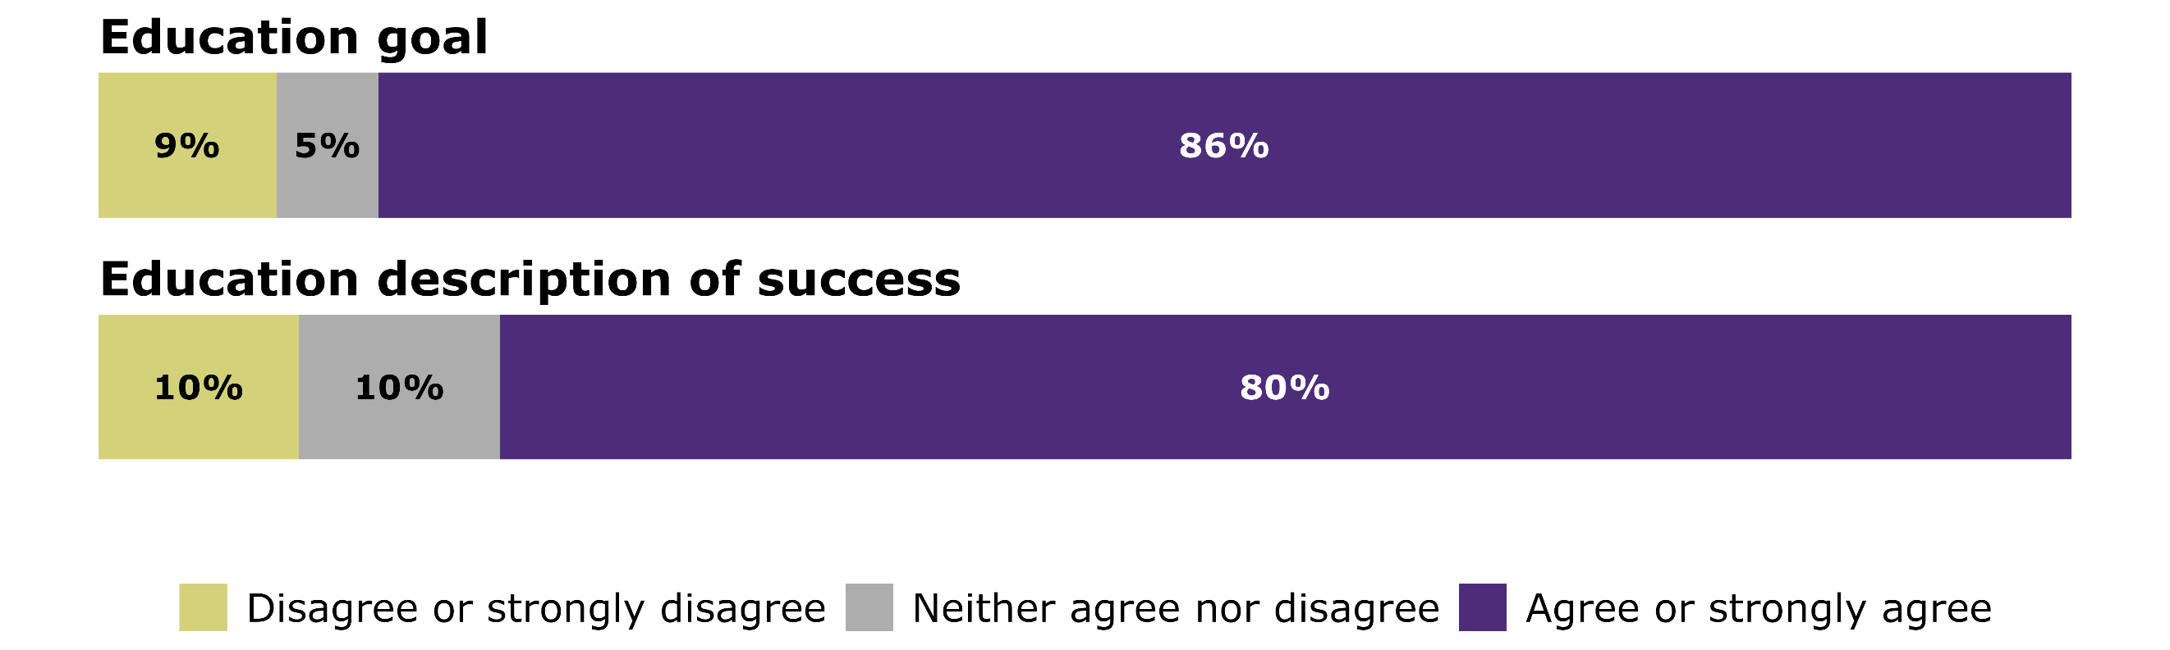
Average agreement levels were similar across disabled people and tāngata whaikaha Māori, non-disabled people, and organisation and group responses.

Actions received strong support for most education actions
Feedback form respondents were also asked how much they agree with each of the education actions. Figure 5 shows that there was a good level of agreement across most actions, but with slightly lower levels of support for action 2 (reduce wait times for learning support) and action 7 (support kaupapa Māori settings).

Figure 5: Agreement with the education actions
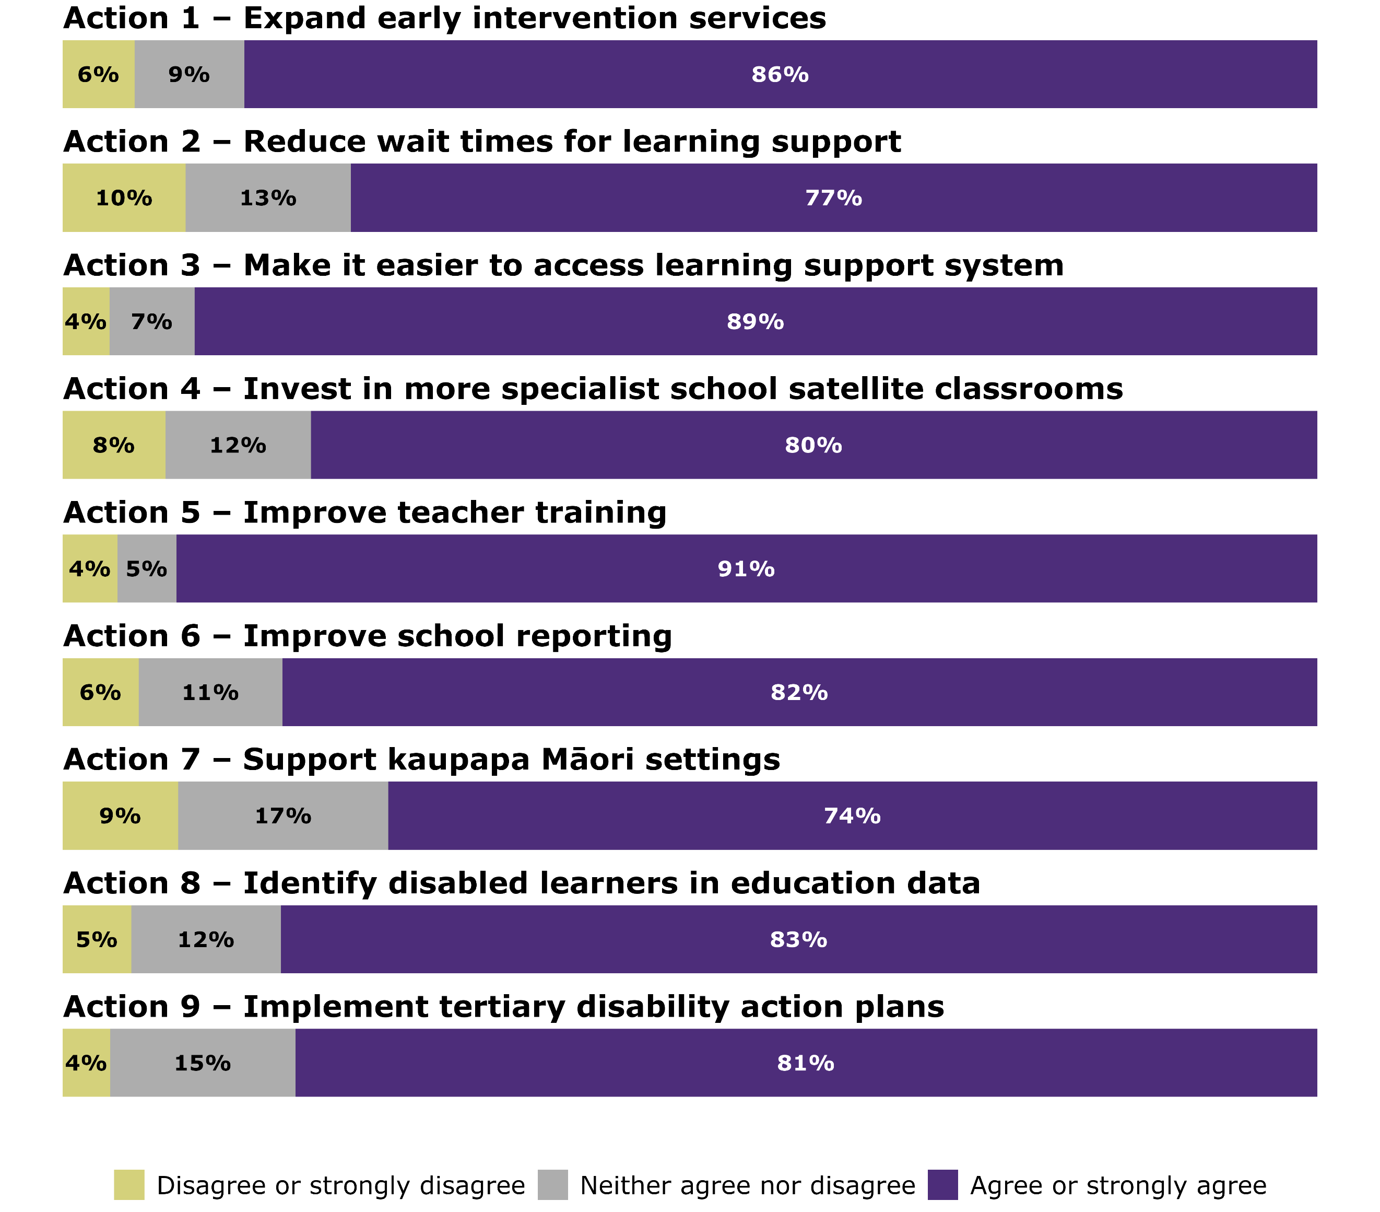
Average agreement levels across actions were similar across disabled people and tāngata whaikaha Māori, and non-disabled people. Mean scores were slightly higher among groups and organisations.

Importance of different aspects of education among children
The Ministry also created a survey for children and younger learners with intellectual disabilities who may not read words fluently (see Appendix 1 for details). Survey questions were designed to connect with the priority outcome areas of the strategy, but with a particular focus on education. About 35 children and young people with intellectual disabilities rated the level of importance of different aspects of education.

Figure 6 shows that young people thought that teachers listening to them (82 percent rated this as very important) and being happy at school (78 percent) were the most important factors for them in education. Also rated highly were being able to make choices at school (76 percent), having friends at school (73 percent), and getting help when it was needed (73 percent).
Figure 6: Importance of different aspects of education from children’s survey
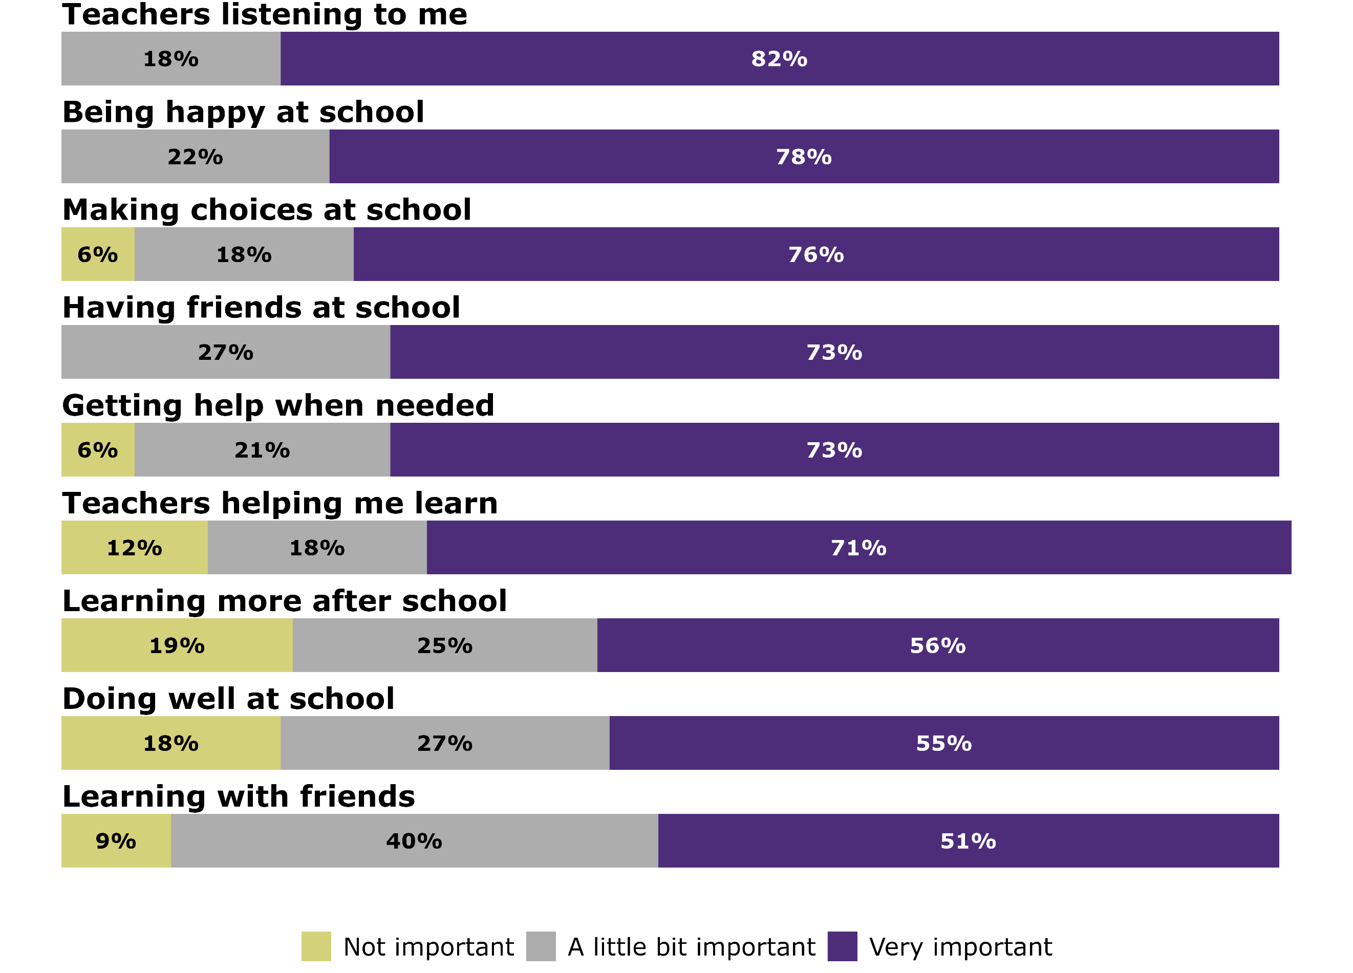

6.2 Common themes and insights: Education
‘Who decides what my potential is? Some teachers don’t think I have much potential and think I am bad and naughty. Do they get to choose this? It should say who decides my potential. I don’t have choice if a school excludes me or stands me down. That is the school having a choice about who to include. I don’t have a choice if a teacher doesn't understand me. The goal should have me at the centre.’

Systemic change is required so that learning support systems are easy to access and deliver desired outcomes
Submitters said that current systems are fragmented, complex, and inequitable - particularly for whānau navigating multiple services. Submitters felt this complexity works against disabled learners rather than supporting them. Many submitters considered that there will be no quick wins for disabled learners without addressing underlying systemic issues.
While submitters acknowledged current budget constraints, they emphasised that not all changes require additional funding. These include increasing disability awareness, leveraging natural supports, and implementing universal design. Submitters also felt there was a need to ensure that educators and boards of trustees understand schools’ obligations relating to learning and attendance for all learners, including disabled learners.
Submitters expressed a clear vision for a system that is easy to navigate for all disabled learners and their families, and that fosters confidence, enthusiasm, dignity, and self-belief. They stressed that systemic change is essential for the delivery of equitable resources and opportunities that are needed for disabled learners to reach their full potential.

There were strong calls to build a skilled and supportive education workforce
Submitters urged that the strategy should include concrete actions that tackle workforce shortages and training needs for current and future education staff. They viewed this as a critical step towards improving outcomes for all disabled learners. One principal explained, ‘We want the special needs children in our school but need help to make it work’.
Many submissions emphasised the importance of educators understanding disability culture and having access to ongoing professional development. A parent observed that ‘only teachers and support staff with a humble heart were able to work successfully with my child’. Another parent described her son’s secondary school experience as ‘sitting in a room alone doing nothing’.

Many submitters identified a gap in educators’ ability to adapt curriculum and assessments for disabled learners. They expressed concern that system-wide changes, such as reforms to the National Certificate of Educational Achievement (NCEA) and the shift to structured literacy, were making adaptation harder and could further marginalise disabled learners. One submitter warned, ‘Our special needs children will less and less fit alongside classmates’, while another feared that ‘only those able to sit exam papers will come out with qualifications’. They stressed the need for teachers to use a diverse range of teaching strategies to meet varied learner needs.
Submissions highlighted significant skills and knowledge gaps across the education sector. Many called for paid qualification pathways for teaching assistants, special educational needs coordinators, learning support coordinators, and specialist teachers. They raised concerns that too many staff in critical roles lack formal qualifications. This problem is compounded by a severe shortage of specialists, particularly speech and language therapists, psychologists, and educators with expertise in disability including Māori and Pacific specialists.
Submitters considered that a lack of disability awareness and competency often led school boards to support inequitable decisions by school leadership. They noted a strong tendency to prioritise school budgets over pupils’ needs. Families who experienced discrimination described difficulty accessing support from the Ministry of Education, citing school autonomy as a barrier to accountability and consistency.
Submitters stressed that building a skilled and knowledgeable workforce takes time. They highlighted the importance of embedding disability culture, universal design, and personalised planning in initial teacher education and ongoing professional development. Some proposed creating community hubs that bring together cross-agency specialists to provide coordinated support for disabled learners and their families.

Disabled learners must be visible in education data
Many submitters emphasised the need for data that identifies disabled learners, and strongly supported disaggregating data, with appropriate privacy protections in place. They considered that without clear visibility, the effectiveness of learning supports and interventions cannot be assessed. One parent said, ‘It would be good to find out if services actually work… My child with high needs was only ever taught by a [teacher’s aide] who had no teacher training’.
To ensure accountability, submitters called for mandatory reporting of outcomes for every learner, backed by legislation. They stressed that outcomes data must be used constructively, not punitively, and that schools need support to interpret and act on the data.

Submitters considered that the government focus on attendance has highlighted difficulties faced by many disabled learners and their families who reported bullying, coercion, shortened school days, and unlawful exclusions, yet noted that attendance data is not disaggregated for disability. One respondent said, ‘The Stepped Attendance Response programme just talks about the parents’ responsibility… but nobody holds schools accountable [for unlawful restricted attendance]’.
Submitters also urged changes to reporting systems to include reasons for absence, improve monitoring, establish a clear complaints process, and provide an advocacy service for families. They viewed disaggregated data as essential to expose inequities, drive accountability, and improve outcomes for disabled learners.

There is a need to address the inequities for Māori and Pacific disabled learners
Submitters highlighted that Māori and Pacific disabled learners experience the most severe systemic inequities in education. They pointed to a ‘lack of Māori teachers and specialists trained to work with tamariki whaikaha Māori’ and noted that the impacts of colonisation through lack of mana motuhake, inadequate workforce, and removal of kaupapa Māori resources continue to affect Māori learners.
Pacific families also reported experiencing language barriers which made accessing available supports difficult.
Submitters were concerned that supporting kaupapa Māori settings without extra funding signals that the current system is seen as good enough, despite clear evidence that it is not. Many submitters were not convinced that supporting kaupapa Māori settings without extra funding would lead to meaningful change.
The top priority for many submitters was to ensure access to te ao Māori for disabled learners and their family and whānau. They called on the Ministry of Education to uphold the Treaty of Waitangi (te Tiriti o Waitangi) by working in partnership with Ngā Kura ā-Iwi, Te Rūnanga Nui o Ngā Kura Kaupapa o te Aho Matua, whānau, and iwi to support culturally appropriate learning environments. These settings should enable co-designed learning supports and interventions that reflect Māori values, aspirations and systems of knowledge.

Early intervention is a critical investment in the future of children
Submitters welcomed the government’s recent $266 million investment in early intervention services and hoped it would reduce wait times and speed up assessments. They stressed that timely assessments help to identify each child’s strengths and needs, which enable whānau and professionals to provide holistic support. However, they warned that severe workforce shortages could undermine the investment. Many suggested stronger collaboration between health and education to streamline access and reduce delays.

Delays to diagnosis result in delays to learners’ access to supports
Submitters said a diagnosis often unlocks access to support, but the process is a heavy burden for families. They recommended a single, cross-agency process involving education, health, and disability services from an early age. Submitters noted that workforce shortages make diagnosis difficult, and most submitters opposed using private providers, citing equity concerns and the possible risks to public access, especially for Māori, Pacific, rural, and low-income families. They also noted that diagnosis alone does not guarantee support because specialist programmes remain scarce. Some submitters highlighted schools that adapt programmes using universal design and trust families’ input, showing good practice despite limited resources.

Specialist school satellite classes provide options for some learners
Submitters expressed mixed views on specialist education provision for disabled learners. Some appreciated having schooling options that could best meet learner needs. However, others viewed satellite classrooms and specialist schools as a form of segregation that can create funding disparities between special and mainstream schools. Submitters were of the view that mainstream schools should be funded at the same level as specialist schools, including access to specialist staffing and technology. This would change outcomes for learners and their families.
A notable concern was the lack of discussion in the strategy about residential specialist schools. Submitters called for alternatives that allow disabled children to remain in their own communities, supported by stronger specialist services and wraparound supports. As one submission put it, children should be able to ‘learn and succeed close to their whānau’.
There needs to be support for successful transitions for disabled learners
Submitters stressed that transitions into education, between classes and schools, and out of education, require deliberate planning and support. They reported these periods are often poorly managed, leaving disabled learners at high risk of disruption and disengagement.
Transitioning out of school was described as particularly complex and exhausting for families and whānau. Submitters called for greater support and recognition of these challenges. They emphasised giving young people agency in the process, protecting them from financial exploitation, and enabling the ‘dignity of risk’ rather than imposing overly restrictive, risk-averse practices.

Many submitters preferred a focus on lifelong learning
While tertiary education was identified by respondents as important for many disabled learners, it was not realistic for all. Respondents preferred a focus on the importance of opportunities for lifelong learning. This includes opportunities to learn and practice skills when the learner is ready.

6.3 Comments from the children’s survey

Young people want to learn in classrooms with friends, and to have agency and voice to thrive at school
Young people want to be listened to and be actively involved in decisions that affect them. One said, ‘We always get left out and we have so much we could share about what really works and what doesn’t’. All respondents valued being happy at school, which for some, meant choosing when to attend. One explained, ‘I’ve trashed classrooms before because they didn’t listen. I couldn’t be happy’. Others described happiness as playing games, drawing, swimming, eating lunch with friends, and receiving support when needed.
Friendships were very important, though hard to establish. Some wanted to “be like everyone else” and learn with friends, while others said not being understood made friendships difficult. Learning alongside classmates was important. One child said:
‘I spent so much time on my own with the TA. I get mad talking about it. Teachers wouldn’t let me in the classroom because of my stimming. That had to be outside the classroom, so I never went in. It’s hard to have friends when you are just with the TA.’
Teachers knowing how to support young people was important. Some learners wanted close support from an adult while others preferred peer support and would seek adult help as needed. Some praised specialist teachers and aides who understood them, while others said lack of support led to anger and leaving school early. One person said teachers didn’t know how to help him, ‘hence why I’m not in school anymore because I got mad. They had to bring Mum in’.
For some learners, being able to make choices was part of being listened to. One person said, ‘I need to learn how I learn’.

The school environment affected learning. Noisy, busy spaces made concentration hard, and some valued moving between mainstream classes and quiet areas. One said, ‘School wasn’t a place where I could learn—it was an overwhelming hell’. Others found success when learning about topics they enjoyed. As one put it, ‘Being happy at school is more important than doing well but doing well is helped by being happy and understood in an environment that meets my needs’.

7 Employment

7.1 Summary of data: Employment

There was strong agreement with the goal and description of success
A total of 296 respondents provided feedback on the employment outcome area via the feedback form. Figure 7 shows levels of agreement with the goal and description of success for employment. There was strong support for both, with 85 percent of respondents agreeing or strongly agreeing with each.
Figure 7: Agreement with employment goal and description of success
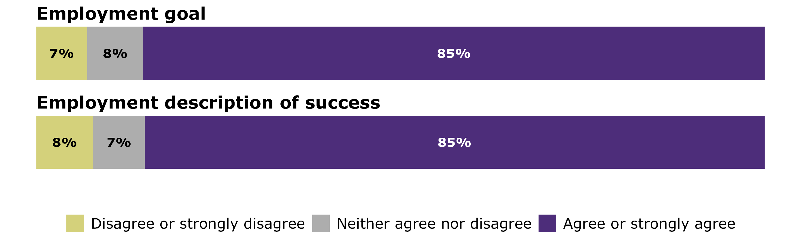
On average, agreement levels for the goal were slightly higher among groups and organisations than individuals, and agreement for the description of success was slightly higher for non-disabled people compared to disabled people.

Strong agreement with the employment actions
Figure 8 shows that there was also a high level of support for all employment actions with action 5 (improve accessibility and inclusion in workplaces) being the most highly rated (91 percent of respondents agreed or strongly agreed).

Figure 8: Level of agreement with employment actions
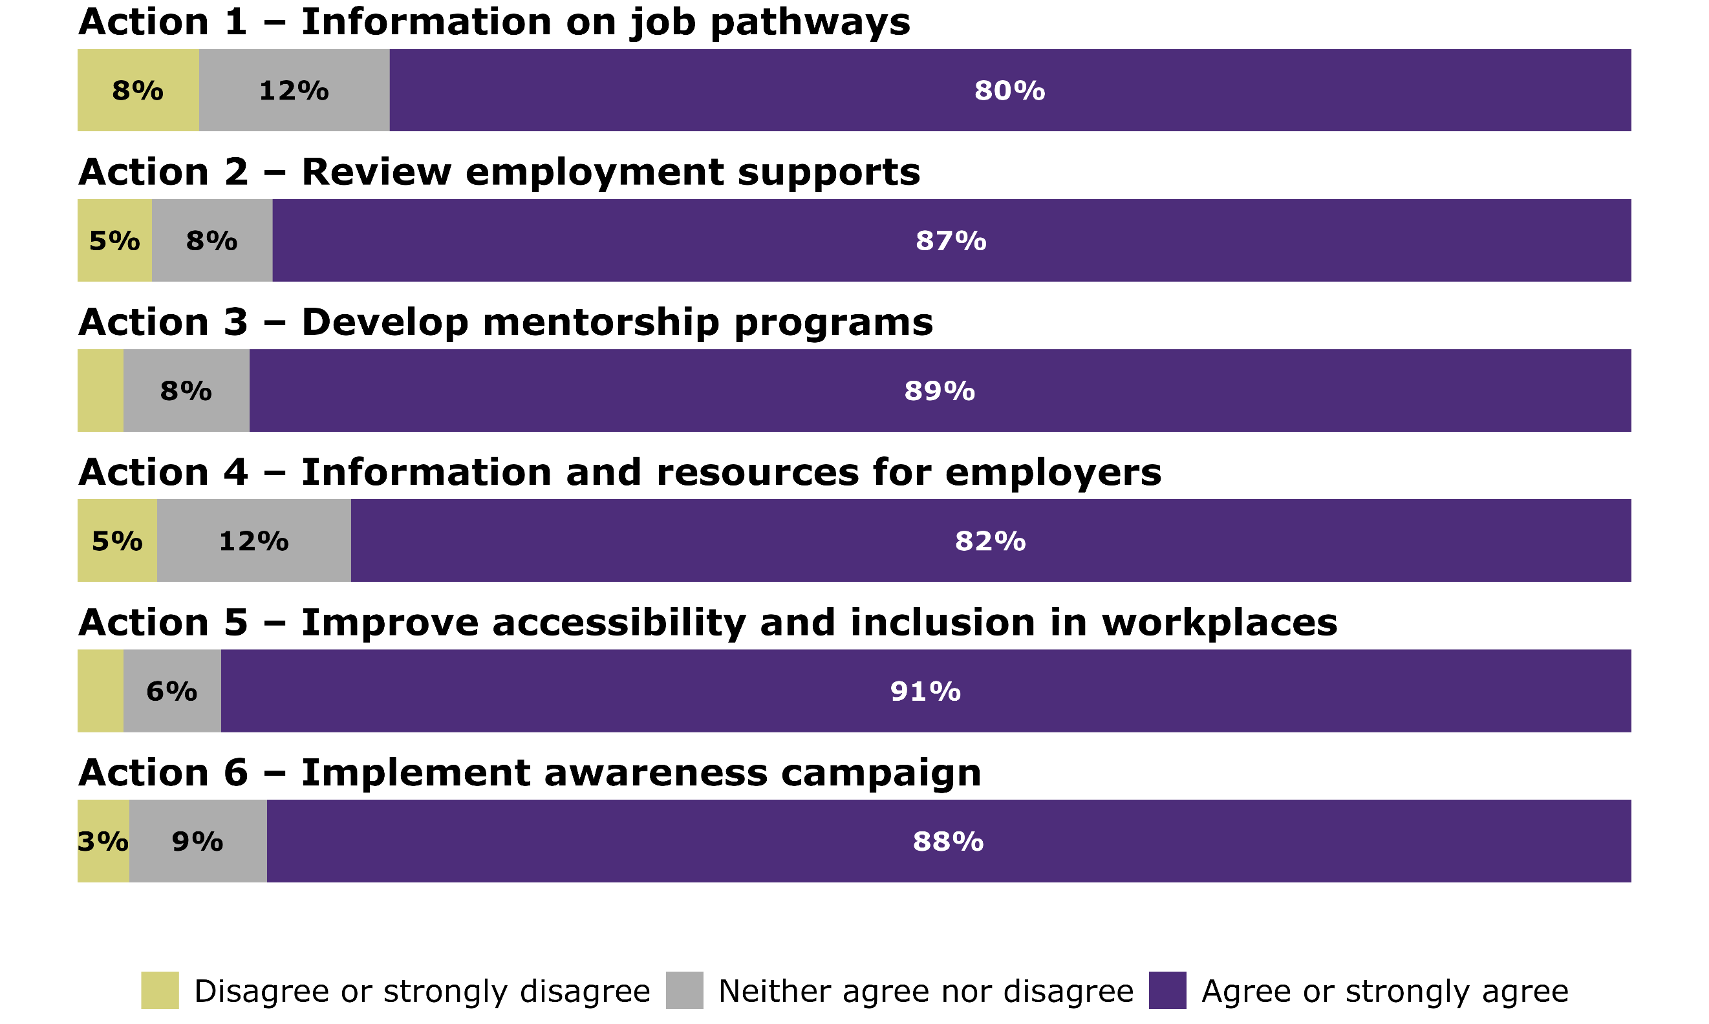
Average agreement levels were similar across disabled people and tāngata whaikaha Māori, and non-disabled people. Groups and organisations tended to have higher agreement ratings than individual respondents.

7.2 Results from children’s survey

Importance of different aspects of employment among children
The children’s survey asked about 2 aspects of employment: the importance of earning money; and getting a good job after school. Figure 9 shows that 55% of respondents rated each of these items as very important.
Figure 9: Children’s importance ratings relating to employment
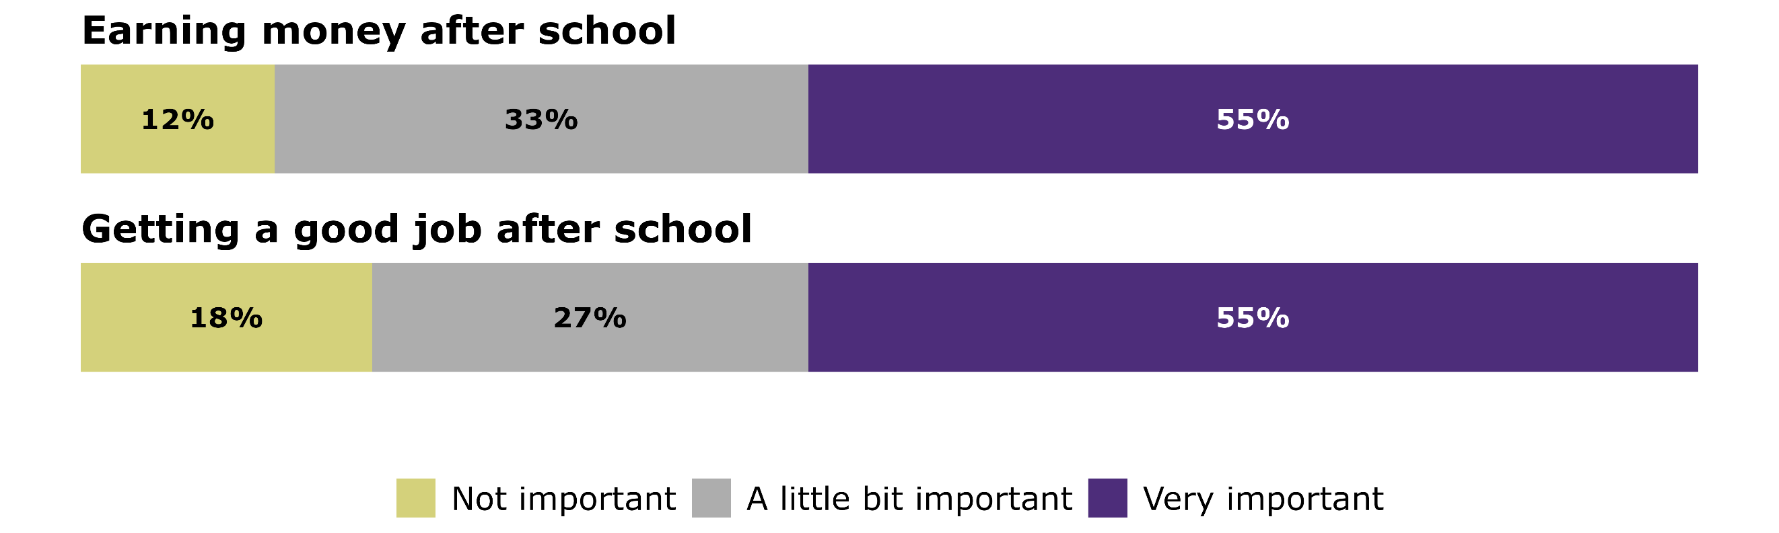

7.3 Common themes and insights: Employment
‘Not all disabled people will ever achieve employment,
and we shouldn't set the expectation that these people
are somehow falling behind or not good enough.’

Strong call to prioritise choice, control, and financial security over paid employment
Disabled people should have choice and control over how they participate in their community. While many disabled people are highly motivated to work, submitters emphasised that employment may not be the goal for everyone. Success looks different for different individuals. Part-time work, volunteering, and community involvement can be just as meaningful as full-time paid employment.
Many submitters questioned the emphasis on employment as a core outcome. Concerns were raised that this focus does not adequately reflect the experiences of disabled people with higher or more complex support needs who may not be able to work, or the distinct challenges faced by neurodivergent individuals in getting and sustaining employment. Submitters recommended shifting the focus toward financial security and addressing the material hardship experienced by many disabled people and their families.

Systemic barriers and societal attitudes limit employment opportunities for disabled people
Submitters said that disabled people often face challenges entering the workforce, are underemployed, and struggle to thrive due to non-inclusive workplace cultures and practices. Submitters noted that employers view workplace accommodations as burdensome or costly, or hold discriminatory views, which further limits opportunities for disabled people.
Submitters supported educating employers on the value of hiring disabled people and how to provide appropriate, timely and effective accommodations. They also recommended making resources and tools more visible by creating a centralised and accessible library for employers and employees. Submissions also highlighted the importance of NZSL-fluent workplaces, funded interpreter services, and Deaf awareness training to ensure accessibility in the workplace for Deaf employees.
However, some submitters cautioned that simply raising awareness (proposed action 6) would not address the deeper systemic barriers that disabled people face in employment. Submitters emphasised the need for employers to make real changes to their processes and resourcing to support disabled people during the recruitment process and throughout their employment.

Current laws and policies undermine the employment goal
Submitters identified several employment laws that enable the exploitation of disabled people, including the 90-day trial period and the minimum wage exemption. Many submitters felt that the 90-day trial period and minimum wage exemption contradict the goal of valuing disabled people equally in employment and recommended its removal.
Concerns were also raised about the Public Service Amendment Bill, which proposes repealing diversity and inclusion provisions from the Public Service Act 2020. Submitters considered this a significant setback for disabled people’s employment in the public sector, and inconsistent with the employment goal in the strategy.
Many submissions raised concerns about the lack of an effective mechanism to hold employers to account for exploitation, discrimination, or the failure to provide reasonable accommodations. Additionally, many disabled people lack knowledge of their legal rights and often do not have the financial resources to pursue legal action. Legal processes can also take a long time, which can negatively affect the employment opportunities of the person making the claim. Some submitters called for legislation to establish minimum accessibility standards for employers.

Employment services should be accessible and consistent
Submitters reported that access to government-funded employment services differs between regions, with little or no support options available in some areas. Some submitters shared experiences of disabled people having to relocate if they, or their employers, needed to access specific services.
Other submissions noted that the process to receive employment support is itself inaccessible, often inconsistent, and can require people to ‘prove’ how disability affects their life. Submitters recommended simplifying processes for obtaining physical or financial resources to support workplace adjustments (reasonable accommodations) for disabled people in or seeking employment.

There were strong calls for improved employment transitions, especially for disabled young people
Submitters called for better support during employment transitions, including moving from unemployment into work, re-employment, and career changes. They identified a critical gap in school-to-work transitions for disabled young people and urged improvements through job placement services, tailored advice, and support. Submitters stressed the need to link education, training, and supported employment pathways. They suggested recognising volunteering, internships, apprenticeships, and mentoring as valid pathways and investing in alternatives such as self-employment.
Submitters also noted that services like employment support, training, and long-term job coaching can provide respite for parents and carers. Many called for a review of benefit abatement rates to ensure disabled people are not financially disadvantaged when entering work. They viewed this as essential for successful employment transitions.

Lack of transport is a significant barrier to employment
Submitters frequently identified the lack of suitable transport as a major barrier to employment for disabled people. Many highlighted the shortage of accessible transport options, especially in regional areas where long distances and limited choices make commuting difficult. The high costs of public transport and modified vehicles also create significant challenges. To address these barriers, submitters suggested including transport accessibility in workplace audits, and reporting and making transport an outcome area in the strategy.

Government leadership is needed in inclusive employment
Submitters urged the government to lead by example in creating inclusive recruitment and employment practices. They called for specific targets for hiring disabled people and for the public sector to model inclusive employment. Submitters said government leadership could build a more supportive framework for disabled people and employers. Some suggested using procurement levers or recognition schemes to promote inclusive practices across the wider workforce.

Robust data is needed to improve supports and policy decisions
Submitters called for stronger data on the needs and experiences of disabled people in the workplace. They said better information would help employers respond effectively. One submission proposed that large employers publish disaggregated data on workforce representation, reasonable accommodation requests, and retention rates. Submitters also recommended that employment outcomes for disabled people be monitored to guide government policy and action.

The strategy should address the employment needs of disabled people
Several submissions emphasised the importance of recognising the diverse needs of specific groups within the disabled community. Submitters suggested that the strategy should include a focus on disability supports and workplace accommodations for older disabled people. Submitters noted that disabled women, particularly those who are Māori or Pacific, experience disproportionately high pay gaps and called on the strategy to address this. Submitters also suggested that the strategy should acknowledge the employment-related needs of carers, particularly those who wish or need to work but face barriers due to their caregiving responsibilities.

8 Health

8.1 Summary of data: Health

Strong agreement with the goal and description of success
A total of 349 respondents provided feedback on the health outcome area in the feedback form. Figure 10 below shows levels of agreement with the goal and description of success for the health priority outcome area. Support for both was high, with 88 percent of respondents saying they agreed or strongly agreed with the goal and 84 percent with the description of success.
Figure 10: Agreement with health goal and description of success
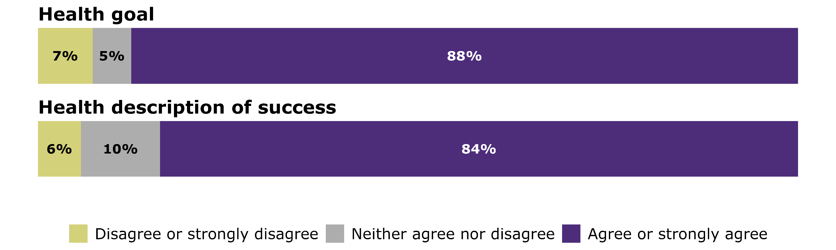
Average agreement levels were similar among disabled people and tāngata whaikaha Māori, and non-disabled disabled people. Groups and organisations tend to have slightly higher ratings.

Strong agreement with the health actions
Figure 11 shows high levels of agreement with the 5 health actions. Health actions 1 (review and improve policies and practices to support self-determination) and 2 (build workforce capability) received the strongest support each with 93% of respondents indicating they agreed or strongly agreed.

Figure 11: Agreement with health actions
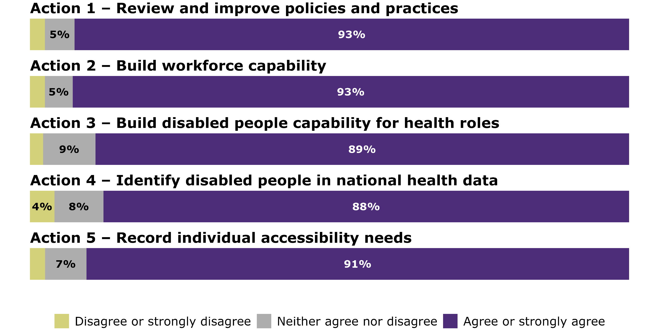
Average agreement levels were similar among disabled people and tāngata whaikaha Māori and non-disabled people, and groups and organisations had the higher levels of agreement with the actions.

8.2 Results from children’s survey: Health

Important for children to have health issues explained
There was one question related to health in the children’s survey, which asked the children responding about the importance of doctors explaining things to them. Figure 12 shows that just over half of children (53%) rated this as very important.
Figure 12: Children’s importance ratings relating to health
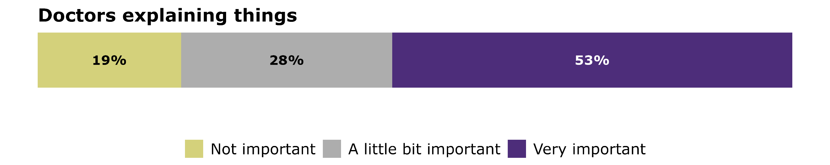

8.3 Common themes and insights: Health
‘While the inclusion of disabled people at every level is a goal worth striving for, the current [health] system often forces disabled people to fight uphill battles just to access their entitlements. Many give up
due to exhaustion, bureaucracy, and lack of support.
This is not inclusion—it is exclusion by attrition.’

Disabled people face unequal treatment and delays in a health system that is difficult to navigate
A consistent theme in the feedback was the difficulty of engaging with a health system that is complex, fragmented, and often inaccessible. Many described the experience of having to fight at every stage to access the services and supports they are entitled to, an exhausting but common reality. These challenges frequently result in unmet health needs. Submitters highlighted barriers including communication difficulties, inaccessible physical environments, and digital platforms that were not designed with disabled users in mind.
Navigating the system was another major challenge. Submitters shared that they were confused about what services were available and their eligibility criteria, their entitlements, and how to access support. The siloed nature of the health sector made this even more difficult. Many described the significant energy required to research options, demonstrate need, and advocate for themselves, an effort that often felt overwhelming and unsustainable.

Structural inequities affect disabled people’s health
Submitters highlighted equity concerns, including regional disparities in service availability and inconsistent support depending on whether their disability resulted from an accident or a long-term condition. Many felt people covered by ACC receive better support than those relying on DSS or general health services.
They also described challenges with continuity of care, particularly for young disabled people navigating multiple health services. Transitions from paediatric to adult health support were seen as poorly coordinated, leaving families without navigation assistance. Submitters said these gaps force young people to retell their stories and often lead to a decrease in support, with the shift to adult healthcare making them feel the system has turned against them.
Submitters also raised concerns about long waitlists and delays in diagnosis. While these issues affect many, submitters stressed that delays have more severe consequences for disabled people, including preventable deterioration and the emergence of behavioural or mental health challenges.

Including family, whānau and community is critical for many disabled people
Many submitters called for the importance of family, whānau, carers and supporters of disabled people in health settings to be explicitly stated in the strategy. Family provides critical supports for many disabled people, especially those with high or complex needs.
‘While I like that my son can participate in making decisions about his own healthcare. With his intellectual disability he wouldn’t be able to make a lot of decisions on his own – so I still believe in those instances having family as part of the collective in the decision is important.’
This was tempered by submitters who were keen to ensure that health professionals prioritised the wishes of the disabled person in decision-making.

A disability-competent health workforce requires investment
Disabled people want to access health information and services in a way that is timely and dignified. One submitter simply put it as, ‘I want my GP to explain things in a way I can understand’.
There was strong support for a health workforce that is both disability-competent and culturally safe, as this was seen as essential for improving health outcomes. Submitters called for more inclusive and accessible training and employment practices across the sector. However, organisations representing health workers noted that while many staff are eager to improve their disability awareness, workforce shortages and high demands on the system leave little time for non-clinical learning and development. Submitters felt that without dedicated resources and commitment, these aspirations are unlikely to be realised.

A proactive approach to habilitation and rehabilitation is vital to preventing further disability, and supporting functional health
Submitters emphasised the importance of referencing Article 26 of the UNCRPD, which calls for habilitation and rehabilitation to enable disabled people to maintain independence and participate fully in life. They supported a comprehensive and long-term approach that includes habilitation, rehabilitation, and prehabilitation to restore lost function and prevent secondary health issues such as falls, injuries, and illnesses. This work is vital to preventing further disability and supporting functional health. Submitters urged the strategy to strengthen and extend these services early, using an end-to-end model of care focused on optimal health and wellbeing rather than short-term, reactive solutions. They stressed the need for continuous support for individuals and their whānau throughout life, not just in times of crisis.

Data is important but must be collected securely and used appropriately
Overall, submitters were supportive of data being used to understand unmet health needs, support disabled people’s requirements, and to minimise the need to repeat information. However, submitters raised concerns about the potential for information to be used against disabled people and noted historical discrimination based on disability status. They called for mechanisms to ensure that any data is collected and used in a way that upholds data security regulations and data sovereignty.

Expanding mental health and wellbeing support for disabled communities
Some submitters asked for mental health and addiction services to be explicitly included in the health outcome area. They emphasised the need to reduce barriers, increase service capacity, and ensure that mental health services are fully accessible to disabled people and their families.
Others highlighted the specific needs of the Deaf community and called for improved access to mental health support, greater use of NZSL, and culturally safe services for Deaf people.
Submitters also stressed the importance of promoting long-term health and wellbeing. They recommended that health models expand to include holistic and Māori approaches such as Te Whare Tapa Whā.
Several submissions noted the positive impact of physical activity and participation in community and cultural events and asked that these be formally recognised as contributing to health and wellbeing.

9 Housing

9.1 Summary of data: Housing

Strong agreement with the goal and description of success
A total of 305 respondents provided feedback on the housing outcome area via the feedback form. Housing was also discussed in several consultation hui held by the Ministry and community groups. Figure 13 shows that 91 percent of respondents agreed or strongly agreed with each of the goal and description of success for housing, although many noted in comments that the goal and outcomes currently feel out of reach.
Figure 13 Agreement with housing goal and description of success
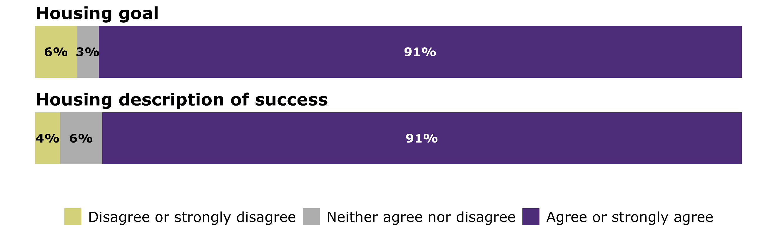
On average, agreement levels were slightly lower among disabled people and tāngata whaikaha Māori than among non-disabled people. The housing goal and description of success had the highest level of agreement of all outcome areas.

Strong agreement with the housing actions
Figure 14 below shows levels of agreement with the housing actions. There was a high level of support for all the housing actions, with particularly strong support for action 4 (review the housing modification system) with 92 percent of respondents saying they agreed or strongly agreed. Action 6 (develop national residential accessibility guidelines) received the lowest level of support with 73 percent of respondents agreeing or strongly agreeing.

Figure 14: Agreement with housing actions
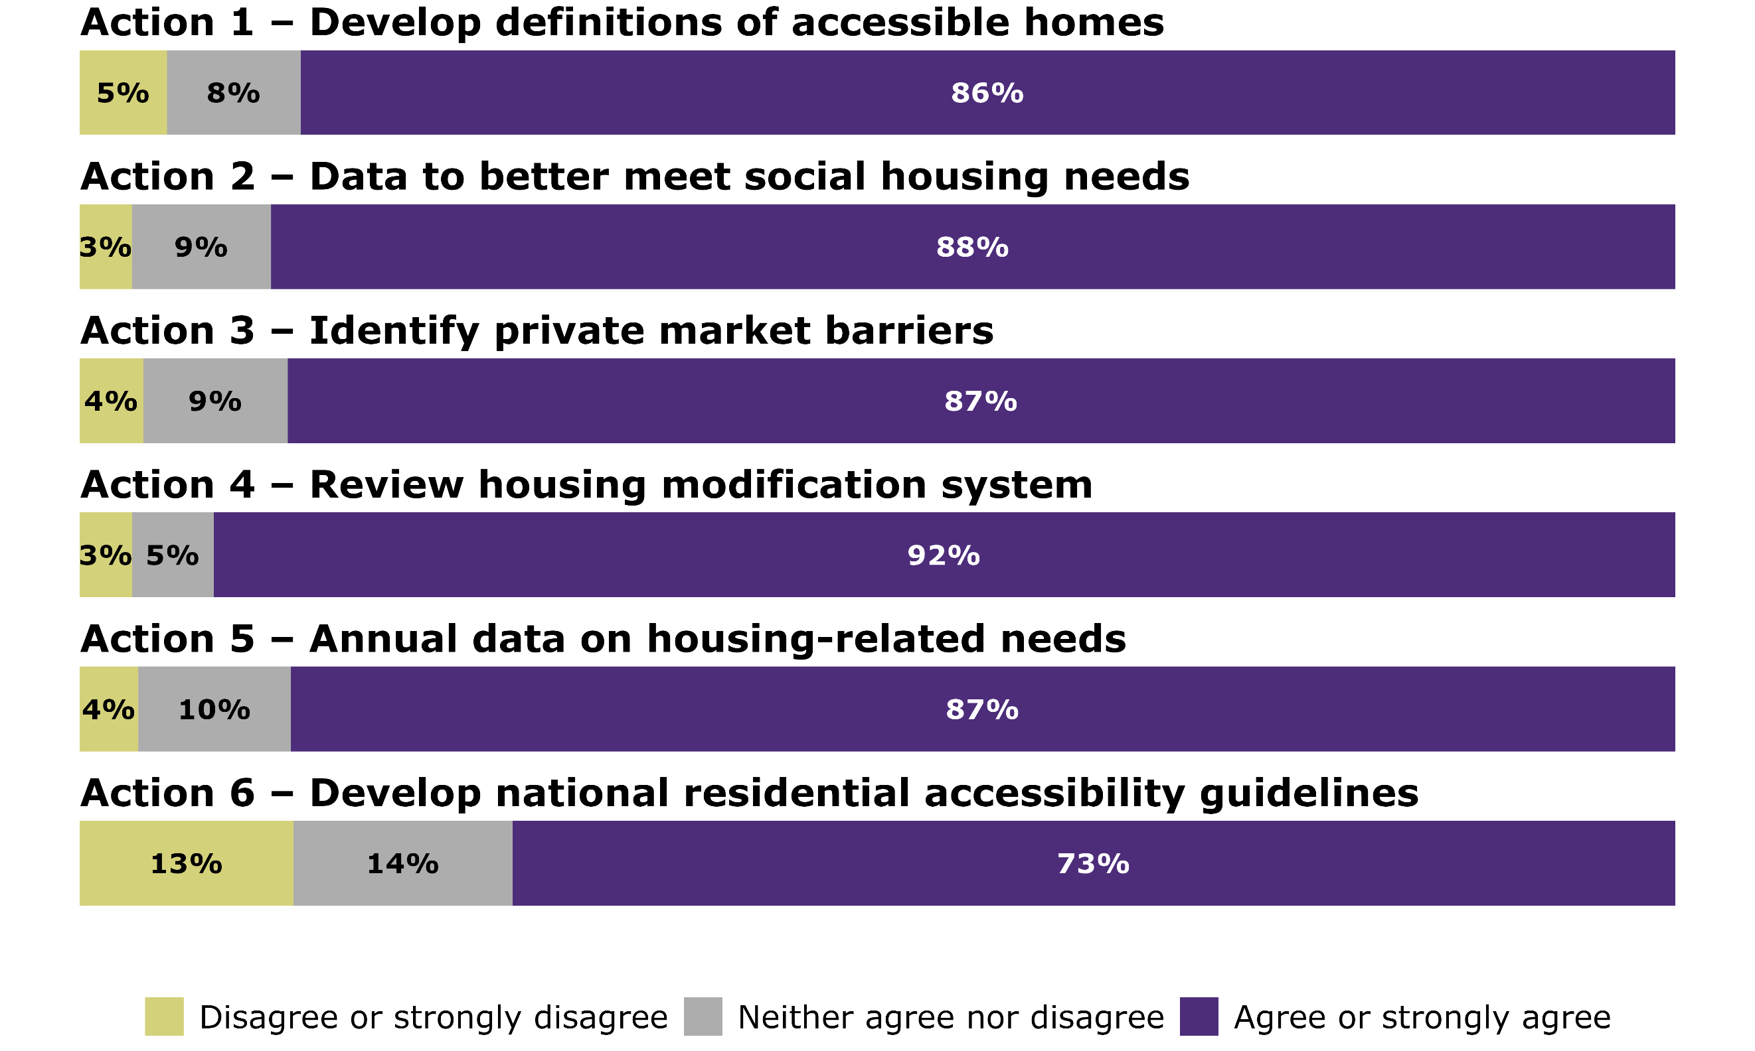
Average agreement levels were slightly lower among disabled people and tāngata whaikaha Māori compared to non-disabled people. Compared to other outcome areas, groups and organisations had relatively low levels of agreement.

9.2 Results from the children’s survey: Housing

Choice in housing is important for children
The children’s survey included 2 questions related to housing – one about the importance of choosing where they live and another on choosing who they live with. Figure 15 shows that 70 percent of children rated choosing where they live as very important, and 55 percent rated choosing who they live with as very important.
Figure 15: Children’s importance ratings relating to housing
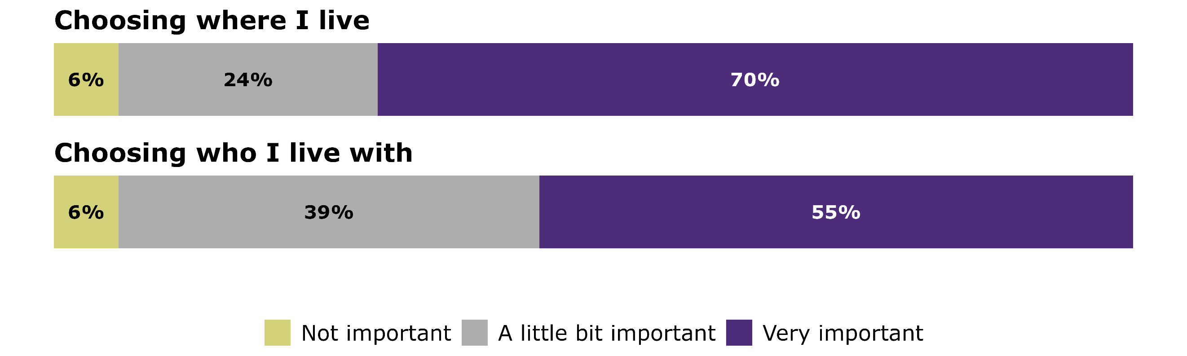

9.3 Common themes and insights: Housing
‘Disabled people and their whānau should be able to choose where
and with whom they live and feel safe knowing
their housing is stable and secure.’

Housing is essential to wellbeing and there is an urgent need to increase supply of affordable, accessible housing
Submitters called for urgent action to increase the supply of affordable, accessible housing so disabled people and their whānau can find suitable homes and have real choice in where they live. Many shared experiences of struggling to secure appropriate housing or being unable to do so.
They also highlighted the wider benefits of accessible housing for older adults, people with temporary injuries, and young families. Submitters stressed that designing for accessibility from the outset is cost-effective, avoids expensive retrofits, and reduces pressure on the health, DSS and ACC systems. They urged stronger government intervention, including incentives for accessible builds and mandatory training in universal design for building and urban design professionals.
Submitters raised concerns about future housing for disabled people who are living with family, and those transitioning from residential care into the community. Submitters recommended there should be more support for people to move into social or private housing and noted that many retirement and aged care facilities are unsuitable for some older people, with autistic people raised as a specific example.
Submitters highlighted poverty as a major barrier to housing for disabled people, while others noted that financial constraints, more than accessibility, are often the main obstacle to securing suitable homes.

Voluntary guidelines for accessible builds are ineffective
As discussed above, housing action 6 (to develop voluntary accessibility guidelines for residential dwellings) received the lowest level of support from respondents in the feedback form. Submitters considered that voluntary guidelines were inadequate to address the shortage of accessible homes. Instead, submitters called for mandatory minimum accessibility standards for all new builds to future-proof housing stock, noting that this would be aligned with an increasing number of Organisation for Economic Co-operation and Development (OECD) countries.

Some submitters suggested implementing existing private sector standards, such as Lifemark Design Standards, rather than creating new guidance. Others raised concerns about the volume of new high-density housing being built that cannot be made accessible.

Support services are essential for achieving positive housing outcomes
Some submitters expressed concern that the strategy seemed to prioritise physical accessibility needs over the needs of those with intellectual or sensory disabilities, and/or high and complex needs. These submitters emphasised the importance of having sufficient personal and community supports.
Some submitters described a difficult tension between their desire to live more independently and the fear that doing so could result in reduced funded support.
Submitters also highlighted significant inequities across the disability community depending on where they lived. Regional disparities in funded supports and access to accessible housing, especially in rural and underserved areas, create uneven opportunities for disabled people and their whānau. Some submitters highlighted a lack of support for Pacific disabled people and aiga (families) to access suitable housing, which can contribute to the issue of overcrowding for Pacific families.

The strategy should have a greater focus on social housing
Many submitters called for the strategy to place greater emphasis on social housing, and urged the Government to construct more accessible social housing to help reduce long wait times.
Submitters also called for emergency housing to be made accessible to ensure disabled people are not excluded during times of urgent need.
Some submitters suggested that disability related needs should be explicitly recognised in social and emergency housing prioritisation processes. Submitters also highlighted the importance of housing assessments that account for the unique circumstances of intellectually disabled people, such as those who may technically have shelter but lack appropriate living arrangements, including individuals living in group homes or with ageing parents.

Housing modification system needs improvement
Many submitters shared personal experiences of how delays and shortcomings in the current housing modifications system have had harmful impacts on their lives such as long wait times, which can be harmful for people with rapidly progressing conditions. Submitters described the modification services as slow, costly, difficult to navigate, and lacking flexibility, making them inaccessible for many and contributing to challenges in other areas of life. Some of the suggestions for how to improve the system are listed as follows.
- Housing modification access should extend to people with chronic illnesses, not just those who access DSS and ACC supports.
- Greater support should be available for housing modifications which are preventative or needed for safety reasons.
- There should be greater clarity around funding allowances, and guidance on providing housing modifications to meet different needs.
- Disabled people should be able to receive housing modifications more than once for the same need to enable them to relocate in the same way non-disabled people can.
- Builders who specialise in disability-related housing modifications should receive financial incentives.

Safety and wellbeing for disabled people should be prioritised
Submitters emphasised that the safety and wellbeing of disabled people and their whānau should be a central focus of accessibility definitions and guidelines.
Submitters highlighted natural disaster relief as an area in which disabled people face increased risks. They stressed the need for features such as safe emergency exits, secure doors and visual alerting systems and technologies which support NZSL users.
Concerns were also raised about the disproportionate impact of cold, damp, and poorly insulated housing on disabled people, which can lead to serious health issues. Submitters said that that providing warm, dry, and energy-efficient homes is fundamental to ensuring safety and wellbeing.
In addition, some submitters noted that increasing the supply of accessible housing must be accompanied by the development of surrounding community infrastructure to support the wellbeing and participation of disabled people. This includes schools, hospitals, and accessible public transport.

The strategy should encourage choice and control in housing
Many submitters recommended the strategy should focus more on enabling greater choice and independence for disabled people in a range of settings such as living alone, flatting, living in supported living arrangements or residential care. There were also suggestions to include investment in or incentives for mixed model housing so disabled people are not isolated. Some submitters recommended the national rollout of Choice in Community Living as a proven, effective housing option.

Support for Māori housing initiatives and whānau centred approaches should be prioritised
Some submitters recommended a ‘whānau first’ approach within housing strategies to promote broader accessibility, inclusion, and support for mental and spiritual wellbeing. Feedback from a talanoa emphasised that disabled people should not have to choose between having accessible housing and living with their whānau and aiga. Another submission highlighted that tāngata whaikaha Māori are unable to count on having accessible, healthy housing which supports multi-generational living. Submitters also highlighted the lack of collective housing models and expressed support for intergenerational whānau living preferences.
Some recommended that the Treaty of Waitangi (te Tiriti o Waitangi) should be embedded in housing strategies, alongside funding for kaupapa Māori housing research and innovation led by tāngata whaikaha Māori and whānau collectives.
Some submitters emphasised the importance of the housing sector being trained in cultural safety, anti-racism, and the Treaty of Waitangi (te Tiriti o Waitangi) obligations.
In respect of monitoring success of the housing actions, some submitters recommended that success should be measured by the lived experiences and outcomes of tāngata whaikaha and whānau, not only system-level indicators.
One submission noted that the goals and success description for housing are relevant but lack specificity and do not adequately respond to the intersectional discriminations or the cultural needs of tāngata whaikaha Māori.
In relation to the collection of data in actions 2 and 5, submitters noted it was important to ensure data collection should adhere to Māori data sovereignty principles, and for data to be published by region.

The strategy should address barriers to renting and home ownership for disabled people
Several submitters noted that many disabled people are not able to own their own homes and are also ineligible for social housing. They suggested that the strategy should include stronger support for disabled people who are renting or who want to become homeowners. Submitters identified a range of barriers faced by disabled renters, including restrictive policies around reasonable accommodations, landlords lacking disability awareness, inaccessible or overly complex rental contracts, and discrimination against disabled tenants.
There was support for the goal of disabled people having tenure security. But one submitter raised concerns about current government policies, such as no cause evictions and restrictions on temporary housing assistance and emergency housing eligibility, which can limit disabled people’s security of tenure.
Submitters made several other suggestions; some are set out below.
- Introducing incentives to encourage the development of more accessible rental properties and inclusive tenancy practices.
- Creating a national register of accessible rentals with clear, transparent criteria to help disabled people find suitable housing more easily and improve accountability.
- Expanding rent-to-buy schemes and providing education to support disabled people in achieving home ownership.

There should be one single point of information about housing supports
Many submitters shared that they found the housing system overwhelming and difficult to navigate. They did not know what supports were available or how to access them, they reported not receiving disability responsive support from government agencies and struggling to access information and complete inaccessible forms.
Submitters suggested creating a single, accessible source of information dedicated to disability housing. Some also suggested that more advocates should be funded to support disabled people to navigate the housing system.

10 Justice

10.1 Summary of data: Justice

Strong agreement with the goal and description of success
A total of 237 respondents provided feedback on the justice outcome area via the feedback form. Figure 16 shows levels of agreement with the goal and description of success. There were high levels of agreement with both, with 89 percent agreeing or strongly agreeing with the goal and 87 percent with the description of success.
Figure 16: Agreement with justice goal and description of success
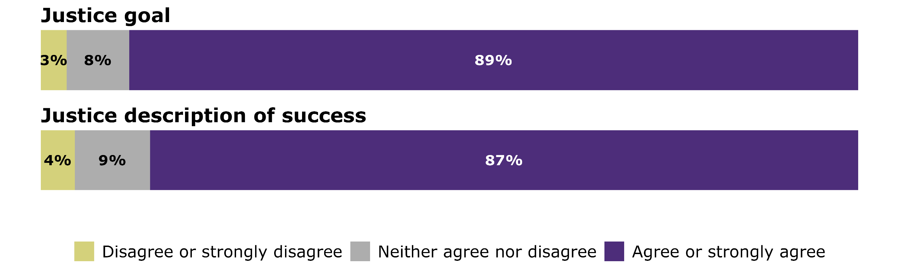
Average agreement levels were lower for disabled people and tāngata whaikaha Māori, compared to non-disabled people.

Strong agreement with the justice actions
Figure 17 shows levels of agreement with the justice actions. There was strong support overall for all the justice actions with 83% or more of respondents agreeing with each. Justice action 6 (disability specific family violence safeguarding approaches) received the strongest support, with 94% of respondents agreeing or strongly agreeing with it.
Figure 17: Agreement with justice actions
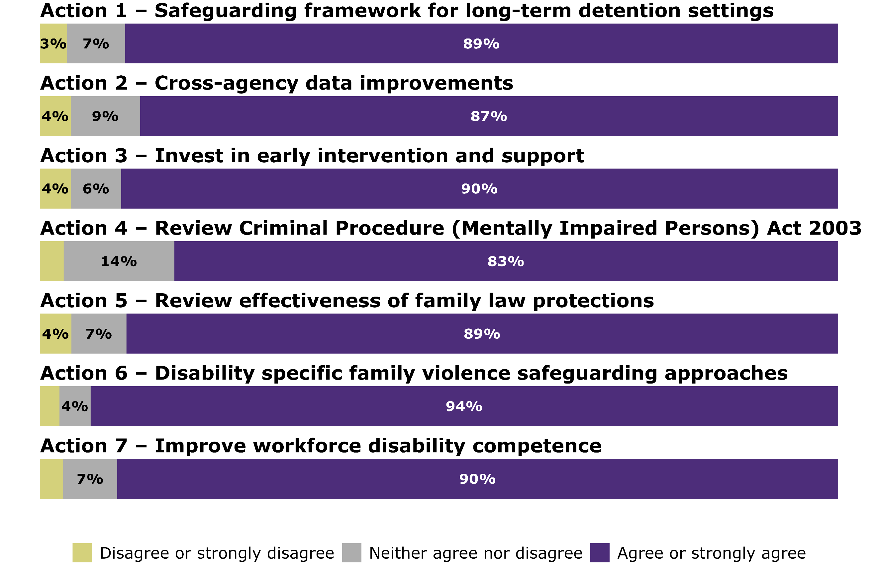
On average, levels of agreement were similar among disabled people and tāngata whaikaha Māori, non-disabled people, and groups and organisations.

10.2 Common themes and insights: Justice
’Greater accessibility, understanding, and advocacy are needed at every stage of the justice system whether that’s dealing with police, legal services, or the courts themselves, to make sure people with learning disability can participate equally and fairly.’

There was strong support for a comprehensive safeguarding framework with explicit accountability mechanisms
Submitters supported action 1 (to develop a safeguarding framework) and viewed this as an urgent and non-negotiable proposal because it aligned closely with the recommendations of the Royal Commission of Inquiry into Historical Abuse in State Care and in the Care of Faith-based Institutions. However, submitters wanted the framework to be broadly defined and for it to clearly outline how it would be implemented, monitored, and enforced.
Suggestions to strengthen the action included being explicit about the needs of neurodivergent youth, mentally impaired persons and disabled people in forensic and psychiatric units. Several submitters stressed the need to better reflect disability-related aspects of abuse, such as risks associated with intimate personal care, financial abuse, and coercive control. This was particularly relevant where disabled people may not recognise abusive behaviour due to this being normalised in their lives, or if they have limited understanding of concepts like money and property. Other recommendations from submitters included:
- protections for non-speaking disabled people (including children) such as tailored communication strategies and training for justice sector staff
- embedding tikanga based safeguarding protocols in justice and care settings
- requiring welfare guardians to be present when disabled people are taken into custody
- time limits aligned with sentencing
- implementing supported decision-making practices.
Submitters raised concerns about monitoring and enforcement. A residential care facility shared several examples of where the justice system failed to act on clear evidence. In one case, they stated that they had provided Police with evidence that a disabled person in their care was being financially abused by family members, yet no action was taken.

Submitters recommended that the safeguarding framework must establish an independent oversight body, include representatives with lived experience of disability, introduce stronger penalties for abusive practices, and implement safeguards such as judicial review.

Early intervention is key to avoiding disabled young people entering the care and protection and youth justice systems
Submitters called for early support for families, especially those caring for neurodivergent young people who display violent behaviours. They stressed that this support is crucial to prevent disabled children and young people from being placed in care or interacting with the youth justice system. They also recommended tailored education and health support for young people and their families. These services are needed to address the pathways leading disabled young people into the care and the youth justice systems. Finally, submitters called for improved early access to support for people with intellectual disabilities. This would help avoid harmful pathways and reduce the risk of negative outcomes.
Submitters recommended funding kaupapa Māori and Pacific led early intervention programmes to recognise the value of culturally grounded approaches. Submitters also highlighted the need for government support for diversion programmes that address the strong links between unmet needs, trauma, and youth offending.

There is an urgent need to improve disability awareness within the justice sector workforce
Many submitters shared their concerns, and highlighted gaps in disability competence and supports across the justice sector workforce. These included:
- unmet support needs within the Corrections system
- limited disability awareness and empathy among justice sector staff
- inadequate Police training resulting in avoidable escalations and court proceedings
- a perceived tendency of Family Court lawyers and judicial officers to prioritise efficiency over the best interests of disabled children.
Many submitters considered it critical that disability is identified or screened for at the outset of any justice system process. They noted this would ensure disabled people receive the support they need, are treated fairly throughout the process, and that specialist input is sought early in complex cases.
Workforce training standards should be mandatory to ensure consistent and equitable practice.

Submitters suggested that workforce training should include understanding:
- what ableism is
- the dynamics of violence against disabled people
- accessibility, including communication needs, and plain language
- how supported decision-making applies in different justice settings and scenarios
- cultural awareness (including Deaf culture, and Pacific approaches).
Submitters also highlighted the need for training which is covers the specific support needs of people with neurodevelopmental conditions and how they affect communication, behaviour, and decision-making, for example people with Fetal Alcohol Spectrum Disorder or traumatic brain injuries. Submitters also noted a lack of attention to the need for healing from experiences of violence.
Submitters also wanted stronger safeguards in family law to remove ableist assumptions and ensure equitable rights for disabled parents. They emphasised the need for culturally responsive and disability-competent court processes.
Submitters also raised concerns about the lack of specific commitment in the strategy to Māori-led justice initiatives that uphold tikanga, whakapapa, and mana motuhake for tāngata whaikaha Māori.

The justice system is inaccessible and hard to navigate
Accessibility was a common concern among submitters, who highlighted there were both physical and digital barriers when they interacted with the justice system.
Submitters discussed their experiences of systemic accessibility issues across New Zealand Police, Department of Corrections, and Courts. This included inaccessible and hard to find information about justice processes, inadequate support for physical disabilities, and a lack of reasonable accommodations provided during proceedings.
Submitters also raised concerns about the justice workforce’s lack of awareness of the sensory needs of people with neurodevelopmental conditions. For example, some individuals are highly sensitive to LED lighting, which can cause distress in justice settings. They also highlighted the absence of appropriate spaces for Deaf people, which can lead to isolation and exclusion. In addition, submitters noted that the justice system itself can be confusing, inaccessible, and traumatising for people with learning disabilities.

Submitters called for greater use of plain language, communication assistance, improved access to information in other languages, and NZSL interpretation at all stages of justice processes. Submitters also recommended there should be peer led support services, such as navigators, to help guide disabled people through justice processes, alongside access to independent advocacy.
Some submitters also stressed the importance of educating disabled people about their rights and how to access support, and recommended establishing multiple, accessible pathways for reporting abuse, discrimination, and rights violations.

Preventing disability-related violence and promoting supportive, non-punitive responses
Several submitters expressed concern that the strategy lacks a clear commitment to prevention and rights based, healing focused responses. They felt the strategy failed to consider safer, non-custodial alternatives, such as therapeutic, trauma informed, or rehabilitative programmes, that could help people understand the circumstances or influences behind their offending and support them to avoid similar situations in the future.
Many submitters raised concerns about child to parent violence and how difficult this can be for families. One issue was that family and whānau found it difficult to find support that does not involve criminalising their disabled family members.
Submitters had differing views on the strategy’s focus on disabled people as victims. Some felt the strategy lacks attention to violence prevention and support for disabled victims, while others were concerned that there was an overemphasis on victimhood.
Some submitters also highlighted the need to shift societal responses to disability related behaviours from punishment to understanding and support, to avoid unnecessary escalation and harm.

Concern that the actions are not seen as urgent
Although there was strong support for the actions, many submitters did not feel that they would result in meaningful change. They criticised the wording used for the actions as vague and felt that the use of terms such as ‘consider’, ‘explore’, and ‘develop’ lacked accountability and urgency.
Submitters raised concerns about the language used for action 4 (review of the Criminal Procedure (Mentally Impaired Persons) Act 2003) as it was thought to be already underway. Submitters also expressed concerns that action 5 (review of current protections) was not considered a government priority as it included the caveat ‘as work programmes allow’. In all cases, submitters called for stronger and more active actions.

11 Monitoring and measuring progress
The strategy outlined how the Ministry will measure progress against the strategy to inform annual progress reports to Parliament. This included asking government agencies to report back on progress and identifying a set of indicators that could be used to measure impact at a system level.

11.1 Common themes and insights: Monitoring and measuring progress

Data plays a central role in driving systemic change and moving towards equity
‘We need to know not just if progress is made, but for whom.’
‘We can’t understand what works if we don’t have the data.’
Submitters strongly supported the collection of robust and inclusive data as essential to monitor progress, evaluate impact, and hold systems accountable. However, they expressed concern that current approaches are vague, siloed, and lack enforceable mechanisms.
Comments stressed robust and inclusive data collection as essential to achieving equity and improving outcomes. Submitters emphasised that without accurate data, disabled people remain invisible in policy, service design, and resource allocation.
Submitters considered that accurate data is foundational for planning, resourcing, and evaluating support across all outcome areas. Submitters called for disaggregated data and looking at outcomes by disability type, ethnicity (especially tāngata whaikaha Māori), age, gender, and geography to uncover inequities.
Comments highlighted the need for data systems to interact across the public sector (for example, the Ministry of Education, Ministry of Social Development, Health New Zealand, Kāinga Ora) so that policy settings and service delivery are evidence based and reflect the lived realities of disabled people.

The collection of personal data raised concerns and calls to recognise the principles of data sovereignty
‘Without transparency, families fear this could lead to registries
that risk privacy and exclusion.’
While data is seen as vital, many submitters raised serious concerns about privacy, consent, and potential misuse. There was widespread opposition to deficit-based registries or identification systems that could stigmatise disabled people.
Māori submitters highlighted Māori data sovereignty and emphasised that data about tāngata whaikaha Māori must be governed by frameworks based on the Treaty of Waitangi (Te Tiriti o Waitangi), anchored in the principles of kaitiakitanga, whakapapa and rangatiratanga.
Submitters emphasised the need for co-design and for being able to opt in to data collection at the individual level. Submitters also requested transparency and that safeguards be put in place. They also wanted clarity on why data would be collected, how it would be used, and who would have access.
Key recommendations from submitters included the use of clear indicators and targets. Submitters wanted measurable goals tied to each action, with baselines and milestones to track progress. Monitoring needs to include disabled people and whānau, especially those from underrepresented groups, and combine quantitative and qualitative data.

Suggested implementation tools and infrastructure to support the collection of data
Submitters emphasised that data must be usable and actionable, not just collected. Suggestions made included tools such as the following.
- Accessibility passports linked to a person’s National Health Index (NHI): To reduce repetition and improve continuity of care.
- Interactive dashboards: To visualise progress and make data accessible to the community.
- Navigator apps: To help disabled people track strategy implementation and access support.
However, submitters raised concerns about digital infrastructure gaps, with many systems not equipped to support integrated data collection, alongside concerns about provider readiness and the need for training to ensure staff can interpret and use data respectfully.
Many submitters called for an independent body or commissioner to monitor implementation and ensure agencies are held accountable.

12 Impact of submissions on the final strategy and next steps
The submissions received as part of this consultation process informed the development of the final New Zealand Disability Strategy 2026 – 2030.
The final strategy document incorporates changes in response to public feedback. This includes amendments to goals, descriptions of success, cases for change, actions, and adding emphasis and explanatory information.
The submissions received will also help inform implementation and monitoring of the strategy. The Ministry will develop an implementation plan for the strategy in early 2026.

Appendix 1 Consultation process

Preparing for consultation
The purpose of public consultation was to identify support for aspects of the strategy, identify gaps and emerging priorities, and gather feedback from a wide variety of groups such as tāngata whaikaha Māori, Deaf people, families and whānau, employers, service providers, and local government.
During consultation, feedback, comments and suggestions were sought on:
- clarity, alignment and confidence in the vision
- importance of the principles
- agreement with the goal, success description and actions in each outcome area
- overall agreement with and confidence in the strategy.
Consultation opened on Monday 19 August 2025 and closed on Sunday 28 September 2025.

There were multiple ways to provide feedback
Feedback was sought in a range of ways; more information is provided below.
Many tāngata whaikaha Māori led roopū and community leaders promoted the consultation opportunities to their networks and the Ministry developed a range of resources to support consultation.

Accessible surveys
The online feedback form was the preferred method of receiving feedback.
This was developed using the Accessible Surveys platform. The platform, developed in close collaboration with disabled people and the International Disability Alliance, allows a range of alternate formats including NZSL, Easy Read, large text and read aloud to be embedded within the same survey. It also provides options for high contrast colour schemes and for respondents to record voice messages in response to open-ended questions. A Word version (including alternate formats) of the feedback form was also available on the Ministry website.

Ministry-led hui
Hui were planned in a way that ensured cultural safety, inclusion and accessibility for all participants. All events led by the Ministry had NZSL interpreters available.
Some sessions were focused on specific audiences, with the majority open to the public. Sessions were scheduled across weekdays, evenings, and weekends, to allow as many people as possible to attend. A range of in person and online hui were held.
Events were promoted across social media pages owned by the Ministry and shared by community supporters.
Online sessions were hosted in Zoom, due to its accessibility features (for example, automated captions). The sessions were designed to be as interactive and accessible as possible.

Community-led hui
The Ministry contacted over 200 organisations and also almost 50 tāngata whaikaha Māori organisations to participate in the consultation.
Grants were made available to support community organisations to co-host engagement hui.
Consultation toolkits were provided that enabled organisations to facilitate discussions and capture feedback on the strategy.

Māori community outreach
In-person, Māori-focused hui were also held in rohe with high tāngata whaikaha Māori representation and where lower engagement in previous consultations was noted. These locations were:
- Kaitāia
- Kaikohe
- Whangārei
- Tāmaki Makaurau ki te Tonga, South Auckland
- Tairāwhiti, Gisborne
- Whanganui.

Pacific community outreach
Given the recent consultation and extensive community engagement on Atoatoali’o, talanoa sessions were arranged with local organisations that specialise in the priority outcome areas relevant to the strategy. These organisations were asked to host Pacific community groups. The Ministry Fautua Sili (Chief Advisor), Pacific Peoples managed and facilitated these talanoa. This approach was developed with the Pacific Disability Community. The locations included:
- North Auckland and Auckland
- Wellington, Porirua, and Hutt Valley
- Napier and Hawke’s Bay
- Horowhenua, Manawatu and Whanganui.
- Christchurch.

Engagement with children and young people
Feedback collated from the I.Lead national conference informed the engagement approach with young people. The Ministry sought ethical guidance and reviewed best practice guidelines.
A survey was created for children and younger learners with intellectual disability who may not read words fluently. Survey questions were designed to connect with the priority outcome areas of the strategy, but with a particular focus on education. Questions were framed as statements containing a single idea, and visuals familiar to those who use communication devices were used. The survey was reviewed by a specialist teacher, and Mana Mokopuna. Children completed the survey with the help of their regular teacher or specialist at 3 different schools.

Hui with disability data expert groups
Alongside consultation on the strategy, the Ministry has consulted with disability data experts and key agencies to develop a monitoring framework and indicators to measure the impact of the strategy at a system level. These indicators will be published in an interactive dashboard in early 2026 alongside further information on the development of the framework.

Analysis approach
Submissions were received over 6 weeks, and information was analysed on a weekly basis. Analysis was completed by a core team, with all personally identifiable information removed (group and organisations names were retained).
Specialist analysis software called nVivo was used to identify, label and extract themes for further analysis.
Thematic analysis was conducted by policy analysts who identified patterns and broader themes, including feedback on missing content and suggestions for improvement. Qualitative feedback was not quantified due to the variability in how feedback was submitted (for example, group feedback vs individual feedback, and hui attendance) and the risk of misrepresenting the strength or prevalence of views. For example, a hui comment might reflect group consensus but only be noted once. Conversely, a single comment might have been recorded multiple times by different note-takers.
AI was used to supplement thematic analysis by Ministry staff. Various batches of coded references were uploaded into Copilot to extract high-level themes. Copilot was able to provide parallel insights that were not strictly following the structure of the strategy.
The quantitative data used in this report comes from respondent feedback provided via the online or Word feedback forms. Answers were collected using 2 different 5-point Likert scales.
- Agreement scale (1 = strongly disagree, 3 = neither agree nor disagree, 5 = strongly agree) for the vision, strategy, and 5 outcome areas.
- Importance scale (1 = not at all important, 3 = neutral, 5 = very important) for the principles.
Respondents were asked who they were providing feedback on behalf of (themselves, another person, a group or an organisation). Demographic information was collected for individuals, including ethnicity, gender, age, disability status, impairment type, and carer status. The data in the report are presented descriptively and only represent the views of those who completed the form. No formal statistical analysis was conducted to examine significance of differences between groups.

Who contributed feedback

Engagement sessions
In total, around 900 people attended one of 47 hui held by either the Ministry or community groups. These meetings included:
- 14 community-led in person hui
- 10 community-led online hui
- 3 consultation sessions as part of existing events
- 4 Ministry-led community visits and outreach
- 4 Ministry-led in person hui
- 11 Ministry-led online hui.
Hui were spread across the country:
- Whangarei (1 hui)  - Auckland (7 hui)  - Kaitāia/Te Hiku o te Ika (1 hui)  - Kerikeri (1 hui)  - Kaikohe (1 hui)  - Tairāwhiti (1 hui)  - Hawke’s Bay (2 hui) | - Whanganui (1 hui)  - Levin (1 hui)  - Lower Hutt (1 hui)  - Porirua (2 hui)  - Wellington (3 hui)  - Christchurch (2 hui)  - Dunedin (1 hui).

Some of the hui focussed on target audiences:
- Māori (9 hui)
- Pacific (5 hui)
- Pan-disability (31 hui)
- Disability data experts (2 hui).

Written feedback
Almost 570 items of written feedback were received, made up of:
- Over 400 responses to the online accessible feedback form
- 50 Word feedback forms
- Almost 120 emailed submissions to the Ministry.
A total of over 130 organisations submitted feedback.
Of the 451 responses to the online and word feedback forms:
- 319 were on behalf of themselves
- 59 were on behalf of another person
- 56 were on behalf an organisation
- 17 were on behalf of a group.

Demographics of individual respondents
Respondents who answered on behalf of themselves or another person were also asked questions about themselves or bout the person they were answering on behalf of. This was to help us understand the groups of people who provided feedback and explore any differences between them. No demographic questions were compulsory, so respondents chose what information to provide.
In total, there were 378 individual respondents. Of these:
- 197 identified as disabled
- 43 identified tāngata whaikaha Māori
- 133 were not disabled
- 159 people were carers or family members of a disabled person (57 of whom identified as disabled and/or tāngata whaikaha Māori).
Most individual respondents were female (221), 80 were male and 12 identified as another gender.
A large range of age groups was represented with:
- 10 people aged under 15 years
- 31 people aged 15 - 29 years
- 78 people aged 30 - 44 years
- 150 people aged 45 - 64 years
- 38 people aged 65 - 74 years
- 14 people aged 75 years or over.
Of those people who identified as disabled or tāngata whaikaha Māori, the following impairment types were reported:
- physical, 133
- learning, 93
- hearing, 46
- visual, 37
- other, 35
- speech, 34.
Submissions disaggregated by ethnicity:
- 251 people were New Zealand European
- 54 people were Māori and Cook Islands Māori
- 47 people were in the ‘Other’ category
- there were fewer than 10 people who identified in each of the following groups: Indian, Chinese, Samoan and Tongan.

Appendix 2 Agreement levels
Mean scores and percentage of respondents who agreed or strongly agreed with questions from the feedback form
Questions | Mean score  (1-5 scale) | Percentage of respondents who agreed or strongly agreed
Vision
Clear and easy to understand | 3.76 | 73%
Aligns with values and aspirations of disabled people | 3.71 | 69%
Confident it will lead to meaningful change | 2.81 | 27%
Strategy overall
Reflects what matters most to disabled people | 3.79 | 70%
Confident will lead to meaningful change | 3.00 | 34%
Principles
Accessibility | 4.80 | 97%
Choice and control | 4.79 | 97%
Equity, cultural inclusion and intersectionality | 4.57 | 91%
Human rights | 4.79 | 97%
Participation and inclusion | 4.81 | 98%
Respect and dignity | 4.87 | 99%
The Treaty of Waitangi (te Tiriti o Waitangi) | 4.23 | 79%

Questions | Mean score  (1-5 scale) | Percentage of respondents who agreed or strongly agreed
Education
Education goal | 4.34 | 86%
Education description of success | 4.08 | 80%
Action 1 – Expand early intervention services | 4.33 | 86%
Action 2 – Reduce wait times for learning support | 4.08 | 77%
Action 3 – Make it easier to access learning support system | 4.47 | 89%
Action 4 – Invest in more specialist school satellite classrooms | 4.24 | 80%
Action 5 – Improve teacher training | 4.50 | 91%
Action 6 – Improve school reporting | 4.26 | 82%
Action 7 – Support kaupapa Māori settings | 4.10 | 74%
Action 8 – Identify disabled learners in education data | 4.25 | 83%
Action 9 – Implement tertiary disability action plans | 4.19 | 81%
Employment
Employment goal | 4.34 | 85%
Employment description of success | 4.28 | 85%
Action 1 – Information on job pathways | 4.18 | 80%
Action 2 – Review employment supports | 4.38 | 87%
Action 3 – Develop mentorship programs | 4.42 | 89%
Action 4 – Information and resources for employers | 4.25 | 82%
Action 5 – Improve accessibility and inclusion in workplaces | 4.51 | 91%
Action 6 – Implement awareness campaign | 4.37 | 88%

Questions | Mean score  (1-5 scale) | Percentage of respondents who agreed or strongly agreed
Health
Health goal | 4.40 | 88%
Health description of success | 4.28 | 84%
Action 1 – Review and improve policies and practices | 4.53 | 93%
Action 2 – Build workforce capability | 4.54 | 93%
Action 3 – Build disabled people capability for health roles | 4.46 | 89%
Action 4 – Identify disabled people in national health data | 4.41 | 88%
Action 5 – Record individual accessibility needs | 4.51 | 91%
Housing
Housing goal | 4.61 | 91%
Housing description of success | 4.59 | 91%
Action 1 – Develop definitions of accessible homes | 4.39 | 86%
Action 2 – Data to better meet social housing needs | 4.46 | 88%
Action 3 – Identify private market barriers | 4.41 | 87%
Action 4 – Review housing modification system | 4.52 | 92%
Action 5 – Annual data on housing-related needs | 4.39 | 87%
Action 6 – Develop national residential accessibility guidelines | 4.03 | 73%

Questions | Mean score  (1-5 scale) | Percentage of respondents who agreed or strongly agreed
Justice
Justice goal | 4.52 | 89%
Justice description of success | 4.41 | 87%
Action 1 – Safeguarding framework for long-term detention settings | 4.48 | 89%
Action 2 – Cross-agency data improvements | 4.40 | 87%
Action 3 – Invest in early intervention and support | 4.47 | 90%
Action 4 – Review Criminal Procedure (Mentally Impaired Persons) Act 2003 | 4.35 | 83%
Action 5 – Review effectiveness of family law protections | 4.41 | 89%
Action 6 – Disability specific family violence safeguarding approaches | 4.54 | 94%
Action 7 – Improve workforce disability competence | 4.50 | 90%



Disabled people thriving in New Zealand

Enabling Good Lives is an approach to disability support that gives disabled people and their whānau greater choice and control over their lives and the supports they receive. It is based on principles derived from the community: self-determination, starting early, person-centred, ordinary life outcomes, mainstream first, mana enhancing, easy to use, and building relationships.
In addition to disability community and industry or sector representatives, the following government agencies participated in the Working Groups: Health – Ministry of Health and Health New Zealand; Education – Ministry of Education; Employment – Ministry of Social Development; Housing - Ministry of Business, Innovation and Employment, Ministry of Housing and Urban Development and Kāinga Ora; and Justice - Ministry of Justice and New Zealand Police. The Ministry of Disabled People has also consulted other agencies who may be impacted by the proposed actions, such as Oranga Tamariki.
Traditional Māori healing system that uses holistic, cultural practices like herbal remedies (rongoā rākau), physical therapies (mirimiri, romiromi), and spiritual healing (mahi wairua)
Choice in Community Living is an alternative to residential care which is funded by DSS in some regions. It is available in Auckland, Waikato, Lower Hutt, Otago and Southland regions.
As defined under the Criminal Procedure (Mentally Impaired Persons) Act 2003
www.whaikaha.govt.nz/resources/strategies-and-studies/strategies/atoatoalio-national-pacific-disability-approach
Respondents were asked to rate the importance of each principle on a scale from 1 - not at all important to 5 – very important. The percentages in the table represent those who responded ‘important’ or ‘very important’ to each principle

