
Child and Young Person Survey - NZDS
(Letter to children, young people, families, and educators)

Dear children, young people, parents, family, whānau, and educators,
It is important to Whaikaha that we learn what people think about the draft New Zealand Disability Strategy.
We particularly want to listen to children and young people whose voices are often missing.
Thank you to the adults who help make these voices visible. It is important we know what children and young people think.
Here are the ways you can support young people to complete this survey.
- Print or save this Word document.
- Write on, or use a computer, to circle the questions or add any comments.
- Send the completed survey to disabilitystrategy@whaikaha.govt.nz
- You can post your survey in an envelope without a stamp to;
Whaikaha Ministry of Disabled People
Reply No. 262204
PO Box 155
Wellington
Reply Paid (Freepost).

- You don’t need to answer every question.
- You can stop any time you want.
- There are boxes under each question if you want to write anything else.
- What you say is very important and will be used to help make New Zealand a better place for disabled children and young people.
- What you say is anonymous. That means no one will know who filled in this survey.
- What you say will become part of a big report. The report will be on the Whaikaha website for you to look at.
- Thank you so much for taking the time to help complete the survey, so we can know your very important thinking.
Any questions please contact disabilitystrategy@whaikaha.govt.nz
The survey closes on 28 September 2025.

Ngā mihi nui
New Zealand Disability Strategy Refresh Team
Hey young people- what you think matters.

- Whaikaha is writing a new plan. It is called ‘The New Zealand Disability Strategy’. It is about how to make New Zealand a better place for all disabled people.
- Here are some ideas from the plan.
- We want to know what you think is important.
- We hope you might share your thinking in this survey.
- It is your choice to do the survey or not.

How this works
- Here are some ideas.
- You decide how important the ideas are.
- You can put a mark on or draw a circle around the face that matches the idea.
- You can get someone to help you to read the ideas and draw the circles.
- There are two red ideas to show you – they are just to look at.

 | Idea | Not that important | A bit important | Very  important
Example | Grown-ups listening to me is  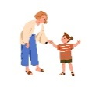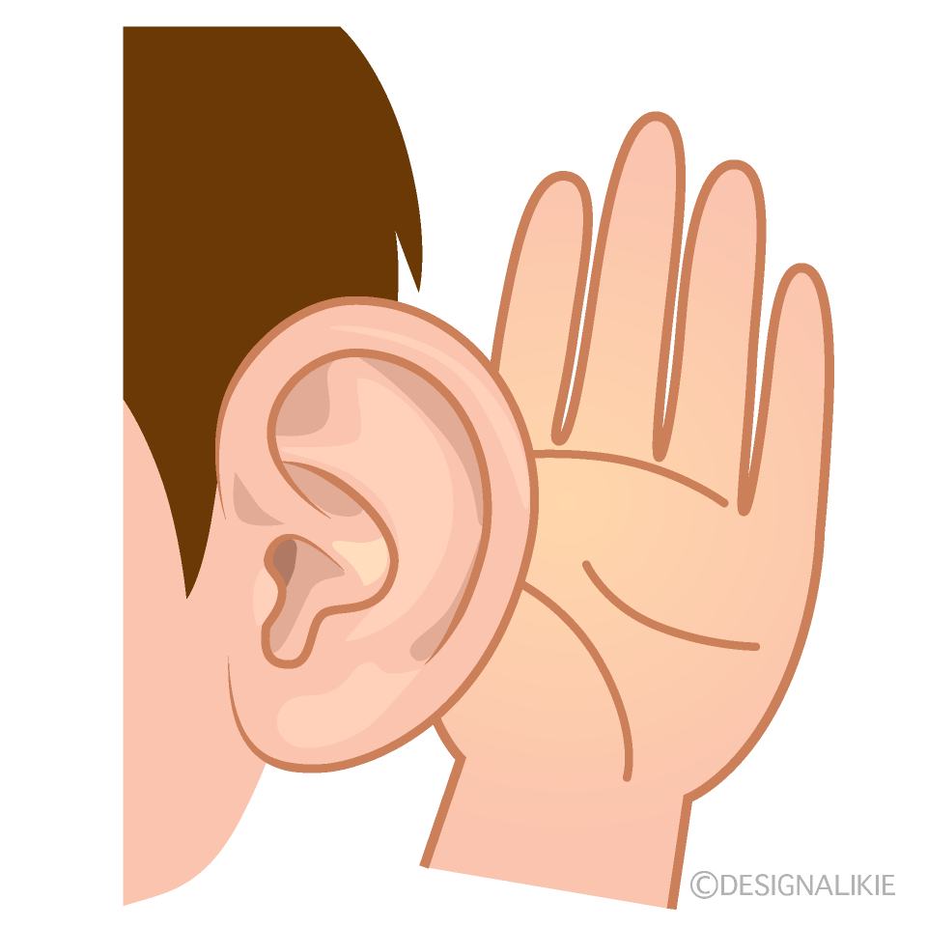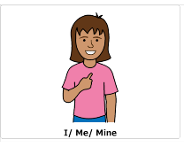 |  | 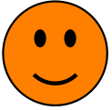 | 
Example | Eating peanut butter every day is  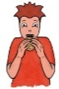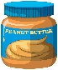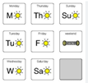

The Survey
Here are the ideas. Circle or mark the face that you think matches the idea.
There is a box under each question if you want to write something.

Idea | Not that important | A bit important | Very important
Doing well at school is  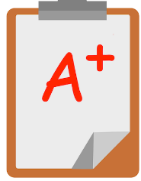 | 
Having friends at school is
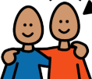

Learning with my friends at school is
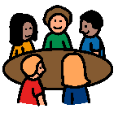

Making choices about what I do at school is
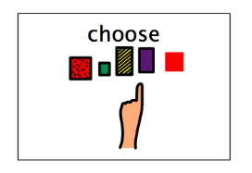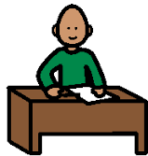

Teachers knowing how to help me learn is
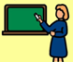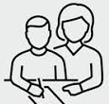

Being happy at school is
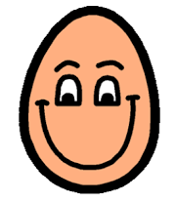

Teachers listening to me is
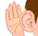

Getting the help to learn when I need it is
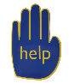

Getting a good job when I leave school is


Learning more after I leave school is


Earning money when I leave school is


Choosing where I live when I leave school is


Choosing who I live with when I leave school is


Doctors explaining things to me is
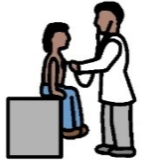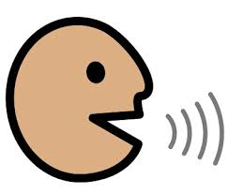

Thank you very much. We are happy you shared your thinking.

