
Valuing access to work
The 2025 update
NZIER report to Whaikaha – Ministry of Disabled People
February 2026

About NZIER
New Zealand Institute of Economic Research (NZIER) is an independent, not-for-profit economic consultancy that has been informing and encouraging debate on issues affecting Aotearoa New Zealand, for more than 65 years.
Our core values of independence and promoting better outcomes for all New Zealanders are the driving force behind why we exist and how we work today. We aim to help our clients and members make better business and policy decisions and provide valuable insights and leadership on important public issues affecting our future.
We are unique in that we reinvest our returns into public good research for the betterment of Aotearoa New Zealand.
Our expert team is based in Auckland and Wellington and operates across all sectors of the New Zealand economy. They combine their sector knowledge with the application of robust economic logic, models and data and understanding of the linkages between government and business to help our clients and tackle complex issues.
Authorship
This paper was prepared at NZIER by Michael Bealing and Daniel Hamill.
It was quality approved by Todd Krieble.
The assistance of Sarah Spring is gratefully acknowledged.

How to cite this document:
NZIER. 2025. Valuing access to work: The 2025 update. A report for Whaikaha – Ministry of Disabled People.

Key points
This report examines the potential macroeconomic benefits of improving employment and educational outcomes for disabled people in New Zealand
The NZIER research, commissioned by Whaikaha – the Ministry of Disabled People, examines the potential macroeconomic benefits of improving employment and educational outcomes for employed disabled people in New Zealand. The study models two key scenarios to quantify the wider economic and social benefits of increasing labour force participation and productivity among employed disabled people.
The research questions were:
- What is the gross domestic product (GDP) impact of equalising unemployment among disabled people to that among non-disabled people?
- What is the GDP impact of lifting educational outcomes among employed disabled people?
The 2025 Household Labour Force Survey reveals stark disparities in employment outcomes between disabled people and non-disabled people
- Disabled people have significantly lower labour force participation and employment rates than non-disabled people, with participation at 26.8 percent versus 72.9 percent, and employment at 23.4 percent versus 69.3 percent.
- The unemployment rate for disabled people is more than twice that of non-disabled people (12.6 percent versus 4.9 percent), indicating substantial challenges in securing employment even when actively seeking work.
Closing this employment gap would contribute an estimated $578 million increase in GDP in 2025
The model predicts that closing this employment gap would contribute an estimated $578 million increase in GDP in 2025. This outcome would also reduce welfare dependency, increase tax contributions, and improve overall household income.
Better educational outcomes for disabled people would have driven a $132 million increase in GDP in 2025
Disabled people are more likely to have no formal qualifications and less likely to attain higher education, especially at the bachelor’s and postgraduate levels.
The estimated macroeconomic impact under this scenario is a $132 million increase in GDP in 2025, reflecting the long-term benefits of investing in education and skill development for this population.
Better educational outcomes for disabled people improve wellbeing beyond economic outcomes, such as improvements in mental wellbeing, social participation and health literacy
Improved educational outcomes for disabled people unlock better employment prospects, higher earnings, and greater financial independence, narrowing the employment and income gap while reducing reliance on welfare support.
Education fosters social inclusion and civic participation by enabling disabled learners to build diverse social networks, develop professional skills, and actively engage in community life, thereby strengthening their role as valued members of the community.
Higher educational attainment enhances personal wellbeing, contributing to increased self-esteem, life satisfaction, health literacy, and long-term health.
The implications for the economy
Both scenarios demonstrate that improving employment and productivity outcomes for disabled people can deliver significant economic returns for all of New Zealand, alongside wider social benefits. Increased employment and higher productivity would improve living standards for disabled people, reduce poverty risks, and promote financial independence. From a fiscal perspective, these improvements would relieve pressure on welfare systems and contribute to a more inclusive, productive economy.
The study also highlights persistent structural barriers that prevent disabled people from participating fully in the labour market, including lower educational attainment, limited access to high-skilled occupations, and higher exposure to job insecurity. International evidence, including OECD research, confirms that early intervention, accessible education, and integrated employment services are essential to achieving sustained improvements in outcomes for disabled people.
These findings reinforce the need for coordinated policies that address educational disparities, workplace accessibility, and inclusive hiring practices. Improving employment and educational outcomes for disabled people is not only a matter of social equity but also an opportunity to realise untapped economic potential and deliver long-term benefits to the New Zealand economy.

Contents
1 Objectives and scope 1
2 Disability, educational and labour market outcomes at a glance 3
3 Educational outcomes at a glance 6
3.1 Educational outcomes in New Zealand 6
4 What works for improving outcomes 9
4.1 International evidence on disability, employment and policy tools 9
4.2 Remote working and labour market outcomes for disabled people 11
4.3 Education as empowerment for disabled people 12
5 Our modelling approach 14
5.1 NZIER’s computable general equilibrium model 14
5.2 How do they work? 14
5.3 How do we shock the model? 15
5.4 What are our closure conditions? 15
6 Analysis and results 17
6.1 What are the potential macroeconomic benefits of better employment and educational outcomes? 17
6.2 Decreasing unemployment among disabled people 17
6.3 The economic benefits of better educational outcomes among disabled people 18
7 Bring it all together 20
7.1 Implications for current policy settings 20
7.2 Opportunities for further research 21
8 References 23

Figures
Figure 1 Comparing labour market outcomes 4
Figure 2 Comparing unemployment rates over time 5
Figure 3 Comparing educational outcomes 7
Figure 4 Our CGE model represents the circular flows in the economy 15
Figure 5 Increase in real GDP from equalising unemployment among disabled people 18
Figure 6 Increase in real GDP from improved educational outcomes 19

Tables
Table 1 OECD findings and recommendations 9

Objectives and scope
Disabled people are more likely to be unemployed or engaged in part-time work compared to those without disabilities. This contributes to lower living standards for disabled people and increases government spending through long-term welfare support.
The Government has prioritised reducing long-term welfare dependency by decreasing the number of people who rely on income assistance. Expanding access to meaningful, sustainable employment opportunities for disabled people is a critical step toward achieving this goal. It can reduce reliance on welfare, improve individual incomes, and support better overall wellbeing.
Enhancing educational outcomes for disabled people delivers substantial benefits for both individuals and society. It opens pathways to improved employment prospects, increased income, and reduced reliance on welfare, while also fostering social inclusion, autonomy, and overall wellbeing. Addressing the education gap is not merely an issue of equity – it is a crucial foundation for building a more inclusive, efficient, and fair society.

Purpose of this research
Whaikaha – the Ministry of Disabled People commissioned NZIER to provide a contemporary update on the potential macroeconomic benefits of improving labour force and educational outcomes for disabled people, which NZIER previously assessed in 2017 (NZIER 2017).

Research questions
What are the potential macroeconomic benefits of the following scenarios?
- Scenario 1 models the economic impact of increasing employment among disabled people. It illustrates the potential effect on the economy if the unemployment rate for disabled people were reduced to match the national average for non-disabled people.
- Scenario 2 models the impact of higher productivity driven by improved educational outcomes for employed disabled people. It demonstrates how enhanced education can enable disabled people to achieve higher income levels.

Scope of the assessment
The scope of the assessment of the potential macroeconomic benefits of improving employment opportunities and educational outcomes for disabled people included the following activities:
- Analysis of statistics and outcomes associated with labour force trends and education
- Comparison of outcomes among the disabled and non-disabled people
- Reviewing the literature on the benefits of employment and educational attainment, as well as the economic and social consequences of prolonged unemployment or welfare dependency.
The following activities are outside the scope of this research: primary data gathering, interviews and surveys.

Disability, educational and labour market outcomes at a glance
Labour market outcomes for disabled people are materially different from those of non-disabled people. The Household Labour Force Survey (June quarter) 2025 (Stats NZ 2025) shows the radical difference in labour market outcomes for disabled people compared to the general population. Figure 1 presents a comparison of key labour market indicators between disabled and non-disabled populations aged 15 to 64 years. It illustrates differences in labour force participation, employment rates, unemployment rates, and underutilisation rates, providing a snapshot of the labour-market disadvantage faced by disabled people.
The key metrics are defined as follows:
- Labour force participation rate: The proportion of the working-age population that is either employed or actively seeking employment and available to work. It measures the degree of active engagement in the labour market.
- Employment rate: The proportion of the working-age population that is currently employed. It indicates the share of people who have jobs out of the total working-age population.
- Unemployment rate: The proportion of the labour force that is not employed but is actively seeking work and available to start. It is calculated as the number of unemployed people divided by the total labour force.
- Underutilisation rate: The underutilisation rate provides a broader indicator of spare capacity in the labour market beyond unemployment alone. It encompasses four groups: those who are unemployed (not in paid work but actively seeking and available for employment), underemployed (working fewer than 30 hours per week and wanting and available to work more hours), available potential job seekers (willing and available to work but not actively seeking a job), and unavailable job seekers (actively looking for work but currently unavailable to start, though expected to be available within the next month).
Figure 1 Comparing labour market outcomes
People aged 15 years and over
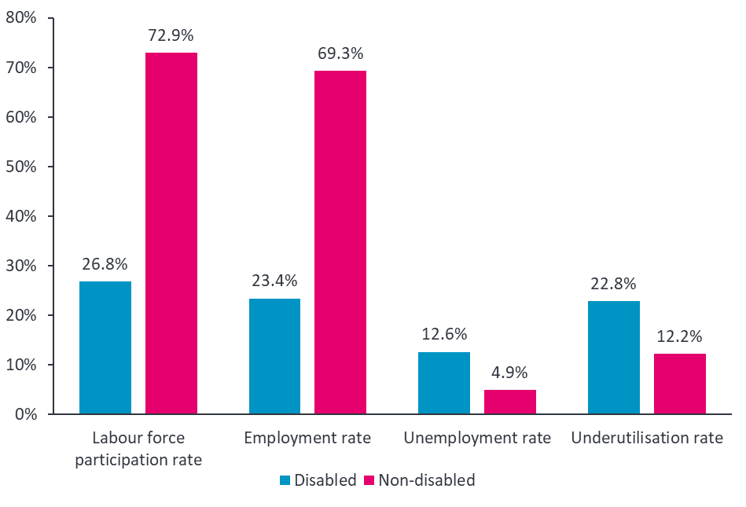
Source: Stats NZ (2025)
The data show that disabled people aged 15+ years old have a labour force participation rate of 26.8 percent, significantly lower than the 72.9 percent rate for non-disabled people. Similarly, the employment rate for disabled people is 23.4 percent, compared to 69.3 percent for non-disabled people. These gaps indicate that disabled people are considerably less likely to be actively engaged in the labour market and are much less likely to be employed. Disabled people face barriers to both entering and remaining in employment. The lower participation and employment rates suggest that many disabled people are excluded from the workforce, potentially due to accessibility issues, discrimination, or insufficient workplace accommodations.
Figure 1 also highlights a large disparity in the underutilisation rate, which captures people who are unemployed, underemployed, or marginally attached to the labour force. The underutilisation rate is 22.8 percent for disabled people, more than double the 12.2 percent rate for non-disabled people. The high underutilisation rate signals that a significant proportion of disabled people who are available and willing to work are not fully employed, representing an underuse of their skills and capacity.
In 2025, the unemployment rate for disabled people is 12.6 percent, more than double the 4.9 percent rate for non-disabled people (see Figure 2). This suggests that even when disabled people are participating in the labour force, they face greater difficulty securing employment. Even when actively seeking work, disabled people are less likely to find employment, indicating that the labour market does not adequately accommodate or provide opportunities for this group.
Caution is warranted when interpreting the trend in the unemployment rate among disabled people, as the year-on-year change is not statistically significant. However, there is international evidence that disabled people participating in the labour force are more exposed to the effects of macroeconomic cycles compared to non-disabled people. This phenomenon has been found in research from the US, where disabled people are disproportionately impacted in economic recessions (Stapleton 2003).
Figure 2 Comparing unemployment rates over time
Source: Stats NZ (2025)

Educational outcomes at a glance
According to the OECD and recent economic studies, education plays a critical role in improving labour-market outcomes for disabled people. The OECD’s Sickness, Disability and Work series (2010) finds that higher educational attainment significantly increases employment rates among disabled people and helps narrow the disability employment gap. Disabled people with tertiary qualifications are much more likely to participate in the labour force and to access higher-quality jobs with better pay, job security, and flexible conditions (OECD 2010).
The OECD also highlights that education is essential for adapting to the digital economy, where many accessible and remote working opportunities require advanced cognitive and digital skills (OECD, 2023). Without higher education, disabled people are more likely to be concentrated in low-skill, routine jobs at risk of automation. Higher education also delivers long-term benefits, including improved lifetime earnings, reduced reliance on social protection, and greater economic independence (OECD, 2022).
Overall, the literature consistently shows that improving educational access for disabled people is essential to reducing structural employment disparities and promoting sustained labour market inclusion.

Educational outcomes in New Zealand
Disabled people are overrepresented among those with no qualifications and underrepresented at higher education levels, particularly at the bachelor’s and postgraduate levels. Figure 3Figure 3 highlights an educational attainment gap between disabled and non-disabled populations, which may contribute to observed disparities in labour outcomes.
Figure 3 provides a clear comparison of the highest educational qualifications attained by disabled and non-disabled populations. It shows that disabled people are much more likely to have lower levels of education and significantly less likely to hold higher qualifications.

Figure 3 Comparing educational outcomes
Aged 15–64 years
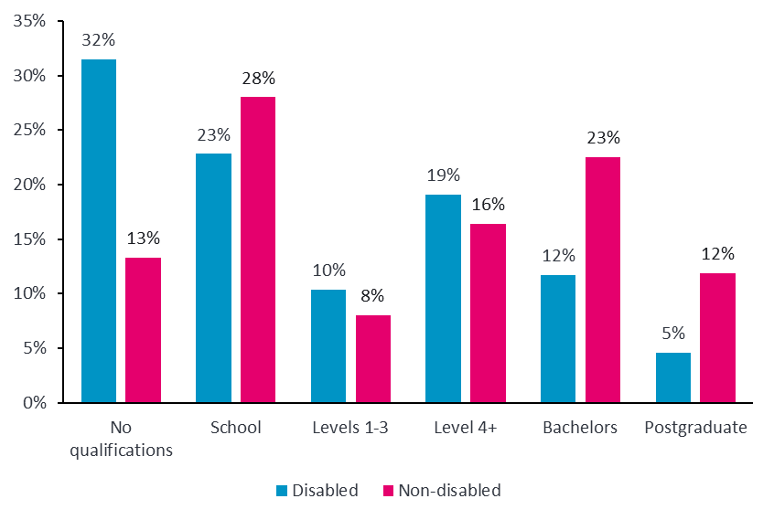
Source: Ministry of Business, Innovation and Employment (2025)
A notable 32 percent of disabled people have no qualifications, compared to 13 percent of non-disabled people. This is the largest gap in the chart and indicates that a substantial proportion of disabled people may face early disengagement from formal education or barriers to educational participation.
At the school qualification level, 23 percent of disabled people and 28 percent of non-disabled people are represented. The difference here is smaller but still suggests slightly lower retention rates for disabled people in secondary education.
For Levels 1–3 qualifications, the percentages are relatively close, with disabled people at 10 percent and non-disabled people at 8 percent.
Interestingly, at the Level 4+ category (which typically includes certificates and diplomas), disabled people slightly exceed non-disabled people, with 19 percent compared to 16 percent. This may reflect participation in vocational or alternative post-secondary pathways that are more accessible.
However, the gap widens again at higher education levels. Only 12 percent of disabled people hold a bachelor’s degree, compared to 23 percent of non-disabled people. At the postgraduate level, the difference is also significant, with 5 percent of disabled people compared to 12 percent of non-disabled people.

Implications of current educational outcomes
The distribution highlights a persistent educational attainment gap that likely contributes to broader labour market disparities. Lower qualification levels are strongly associated with reduced employment prospects, lower earnings, and higher risks of job insecurity. The underrepresentation of disabled people at bachelor’s and postgraduate levels suggests limited access to high-skill, high-wage occupations, which can contribute to the higher unemployment and underutilisation rates observed in other data.
This pattern points to the importance of improving access to inclusive education, addressing barriers that prevent disabled people from pursuing higher qualifications, and supporting pathways to lifelong learning to reduce these disadvantages.

What works for improving outcomes

International evidence on disability, employment and policy tools
The OECD report Disability, Work and Inclusion: Mainstreaming in All Policies and Practices (OECD 2022) provides a summary assessment of the persistent disparities in labour-market outcomes between disabled people and non-disabled people across OECD countries. Despite incremental policy reforms over the past two decades, the disability employment gap remains substantial among OECD members.
Table 1 OECD findings and recommendations

Key findings | Recommendation
Disability employment rates remain persistently lower than for non-disabled people, with an average gap of approximately 40%. | Implement disability mainstreaming across all policy domains, including education, labour market, social protection, and technology development.
Unemployment rates for disabled people are consistently more than twice as high as for those without disabilities. | Prioritise early intervention in sickness and unemployment systems to prevent long-term labour market detachment.
Despite some improvement in educational attainment, the skills and qualifications gap between disabled people and non-disabled people remains. | Strengthen school-to-work transitions for young disabled people through inclusive education and targeted employment support.
Young disabled people face particularly high rates of early school leaving and are disproportionately represented among those not in employment, education, or training (NEET). | Enhance the capacity of public employment services to address disability-related barriers and provide integrated employment and health support.
Labour market shifts, such as automation and the expansion of remote work, present both risks and opportunities for disabled people, but structural barriers persist. | Promote universal design principles and invest in accessible and assistive technologies to ensure equal participation in the evolving labour market.
Participation in adult learning and training is significantly lower among disabled people, particularly among those not in employment. | Ensure adult learning systems are accessible, flexible, and adequately funded, with targeted outreach to disabled people.
Source: OECD (2022)
The employment rate of disabled people is consistently lower than that of non-disabled people. On average, disabled people are approximately 40 percent less likely to be in employment, and they experience unemployment rates more than twice as high as those observed for non-disabled people. Although educational attainment among disabled people has improved, the relative education and skills gaps persist. The pace of improvement has been insufficient to reduce the employment disparity, suggesting that supply-side measures alone are inadequate.
The disadvantage is particularly pronounced for young disabled people. Young disabled people face elevated risks of early school leaving and are disproportionately represented among those not in employment, education, or training (NEET). Mental health conditions, particularly chronic depression, have become a significant and increasing contributor to disability prevalence among young cohorts. This trend has been exacerbated by the COVID-19 pandemic, which has worsened mental health outcomes in many OECD countries.
Labour market dynamics suggest that disabled people face higher barriers to labour market entry and are more likely to exit employment. Hiring rates for disabled people are consistently lower, and transitions into unemployment or inactivity are more frequent compared to non-disabled people. However, once employed, disabled people exhibit job-to-job mobility rates similar to those of their counterparts, indicating that, conditional on employment, their labour market attachment is comparable.
The report emphasises the importance of early intervention, particularly in managing sickness absences and preventing long-term labour market exit. Countries with more active sickness benefit management and early return-to-work policies are better positioned to prevent transitions from temporary sickness to permanent disability benefit dependency. The role of public employment services (PES) is critical for early identification of health-related employment barriers and in delivering integrated employment and health services.
Policies targeting young disabled people require specific attention. The report identifies the need to improve school-to-work transitions through inclusive education and active labour market programmes. Mandatory registration with PES, along with conditional participation in training and vocational support, is recommended to improve outcomes for this group. Current youth policies insufficiently address the compounded barriers faced by young disabled people.
The report also examines the potential implications of structural labour market changes, including digitalisation, automation, and the expansion of non-standard forms of employment. Disabled people are overrepresented in occupations at high risk of automation and are less likely to hold roles amenable to teleworking. Without targeted policy intervention, these structural changes risk further entrenching labour market disadvantage. Investment in assistive technologies, the promotion of universal design in product and service development, and improved accessibility of digital tools are identified as critical policy responses.
The quality of employment for disabled people is consistently lower across measured dimensions. Disabled people are more likely to work part-time, face lower wages, and are more often engaged in jobs with low autonomy and high routine content. The disability wage penalty persists, with average hourly wages for disabled people approximately 10 to 15 percent lower than those for non-disabled people across most countries.
The report identifies a persistent skills gap as a major constraint on the employment prospects of disabled people. Participation in adult learning programmes is substantially lower among disabled people, particularly among the non-employed. This gap reflects both systemic exclusion and individual barriers such as time and cost constraints. The report recommends the following actions:
- adoption of universal design principles in adult learning systems
- targeted financial incentives
- broader access to training leave to address these barriers.

Remote working and labour market outcomes for disabled people
Recent economic research and policy analysis have examined the extent to which remote and hybrid working arrangements can improve employment outcomes for disabled people in OECD countries. The COVID-19 pandemic significantly accelerated the adoption of telework, raising the question of whether this shift in work practices can help reduce the persistent disability employment gap.
Hoque and Bacon (2022) provide a detailed empirical analysis on this topic using nationally representative data from the United Kingdom. Their study found that disabled people are consistently less likely to work from home compared to non-disabled people. This outcome persists even after controlling for occupational and sectoral differences and is largely attributed to the underrepresentation of disabled people in professional, technical, and managerial roles where remote working is more common. The study also found that remote work arrangements are associated with improved job control, greater job satisfaction, and better mental health outcomes across the entire workforce. However, these benefits do not meaningfully reduce the structural disadvantages experienced by disabled people in the labour market. The authors conclude that while remote work can improve conditions for some disabled workers, it does not significantly alter the underlying employment disparities unless supported by wider labour market reforms that address systemic barriers to occupational progression and workplace inclusion.
Florisson et al. (2025) in their study focused on the labour market experiences of disabled people in the United Kingdom. This study identifies a strong latent demand for remote and hybrid working among disabled workers. Approximately 85 percent of respondents with disabilities indicated that access to remote or hybrid work is essential or highly desirable when seeking employment. However, the supply of such roles is minimal. The researchers report that only 3.8 percent of job postings on the UK Department for Work and Pensions (DWP) platform explicitly offer remote or hybrid work options. The study also finds that remote work substantially improves the ability of employees with disabilities to manage their health, with 80 percent of participants reporting positive effects. Despite this, the structural availability of remote work remains insufficient to meet demand, reflecting a supply constraint in the accessible labour market for disabled people.
OECD (2023) provides complementary analysis in its policy brief Teleworking, Workplace Policies and Trust. The OECD emphasises that while the expansion of teleworking has the potential to support labour market inclusion, the benefits will not be fully realised without deliberate policy efforts to ensure accessibility. The OECD notes that inclusive teleworking arrangements, trust-based management practices, and investments in assistive technologies are essential for making remote work accessible to disabled people on equal terms. Furthermore, the OECD highlights the importance of ensuring that social protection systems adequately cover workers in remote, hybrid, and non-standard employment categories. Without inclusive policies, the expansion of teleworking could reinforce existing labour market segmentation.
Collectively, these studies indicate that remote and hybrid working arrangements offer individual-level benefits for disabled people by reducing transport barriers, improving health management, and providing flexible working conditions. However, the capacity of remote work to materially reduce the disability employment gap is limited unless supported by broader structural reforms. These reforms include improving access to higher-skilled occupations, encouraging employer-led inclusive hiring practices, and ensuring that remote work opportunities are systematically available in sectors that are accessible to disabled people.
The evidence suggests that telework should not be regarded as a sufficient solution to address labour market exclusion for disabled people. Without complementary policies to remove systemic barriers and to ensure access to high-quality roles, the introduction of remote work will deliver only marginal improvements in employment outcomes for disabled people. Effective policy responses must integrate remote working opportunities into wider strategies that promote disability inclusion across labour market structures, recruitment processes, and social protection systems.

Education as empowerment for disabled people
Improving educational outcomes for disabled people delivers wide-ranging social, economic, and personal benefits. Education plays a pivotal role in supporting employment, financial independence, social inclusion, and overall wellbeing for disabled individuals, while also contributing to broader societal and fiscal gains.
One of the most significant benefits of better educational outcomes is improved access to employment. Research consistently shows that higher educational attainment is associated with higher employment rates for disabled people. In New Zealand, disabled individuals with tertiary qualifications are more likely to secure jobs than those with lower levels of education. Although disparities remain compared to non-disabled peers, education helps to significantly narrow this employment gap. Higher qualifications also provide access to more skilled, stable, and better-paying jobs, reducing the risk of disabled people being confined to low-wage or precarious employment.
Public investment in education improves outcomes for individuals and the wider economy by increasing labour productivity, which is directly linked to earnings and macroeconomic performance (Card 1994; 1999; Becker 1992). Education has a direct impact on higher lifetime earnings. In New Zealand, disabled graduates tend to earn less than non-disabled graduates, but they still earn considerably more than disabled people with lower or no qualifications. This higher earning potential supports greater financial security and personal independence. Financial stability, in turn, reduces reliance on long-term welfare, which is a priority for government policy.
The social benefits of better educational outcomes are equally important. Inclusive education experiences promote participation, foster the development of diverse social networks, and support the growth of social and professional skills. Disabled learners who are included in mainstream education settings are more likely to pursue further study, access employment, and participate fully in community life. Education also fosters civic engagement, with higher educational attainment linked to greater involvement in social and community activities. For disabled people, this strengthens their sense of belonging and reinforces their role as active citizens.
Improved educational outcomes also enhance individual wellbeing. Success in education contributes to a stronger sense of agency, self-esteem, and personal achievement. Disabled people who attain higher qualifications are more likely to report satisfaction with their lives and have greater confidence in their ability to control their future. Additionally, higher education is associated with better health literacy and improved long-term health outcomes, contributing to overall quality of life. The benefits of education, including its effects on many non-market outcomes, are greater for individuals with lower ability. Tertiary graduation decreases welfare use, lowers depression, and raises self-esteem more for less-able individuals (Heckman et al. 2018).
Improving educational outcomes for disabled people offers significant individual and societal benefits. It leads to better employment opportunities, higher earnings, and reduced welfare dependency, while also promoting social inclusion, greater independence, and improved wellbeing. Closing the education gap for disabled people is not only a matter of fairness. It is an essential step towards creating a more inclusive, productive, and equitable society.

Our modelling approach

NZIER’s computable general equilibrium model
Computable general equilibrium (CGE) models are data-driven and used to capture the effects of new policies, technologies, or other external shocks on economic activity. They capture the economy-wide effects of changes (‘shocks’ in modelling jargon) directly on the affected industry and indirectly on supplying industries, competing industries, and factor markets (labour and capital). CGE models show the full effect of a change, which includes impacts from indirect effects that aren’t immediately obvious. The cumulative impact of indirect effects can outweigh the direct effect of a change.
CGE models also estimate the effect of a shock on macroeconomic variables such as GDP, employment, wages and trade. They are a powerful tool, allowing economists to empirically explore many issues for which econometrics or multiplier analysis would be unusable. For these reasons, CGE models have become widely used internationally (e.g. by OECD, IMF, World Bank) for economic impact analysis.

How do they work?
A CGE model consists of equations that describe the model's variables. It also uses detailed data on the structure of the economy that is consistent with these model equations. This data provides a snapshot of the economy in a particular year, which is used as a baseline (or business-as-usual (BAU)) against which to compare policy simulations or economic changes. These baselines are updated every few years when official statistics allow. In this case, the most recent official update is for 2020. An update is expected sometime in 2026.
The model data are linked through a set of equations that capture how the economy evolves over time in response to a shock. These equations, based on the economic theory of general equilibrium, ensure that supply and demand for goods, services, and factors of production in the economy are balanced and determine how firms and households respond to changes in incentives.
In any CGE model, we must choose what is to be determined within the model (the endogenous variables) and what is to be considered external to the model (the exogenous variables). A CGE model is just a way of explaining the endogenous variables in terms of the exogenous variables.
Where we draw the line between endogenous and exogenous variables and which ones can vary or have to remain fixed depends on a number of factors, including the purpose for which the model simulations are to be used. The choice that we make is called the model closure. Determining the closure is a key part of any modelling exercise, and it is very important that the modeller be transparent about the modelling result and the assumptions imposed via the closure.
The difference between the initial and the new equilibrium can then be analysed to determine the effect of the shock on a range of economic indicators, such as GDP, employment, wages and living standards. Figure 4 provides a stylistic representation of the relationships between different parts of the model.
Figure 4 Our CGE model represents the circular flows in the economy
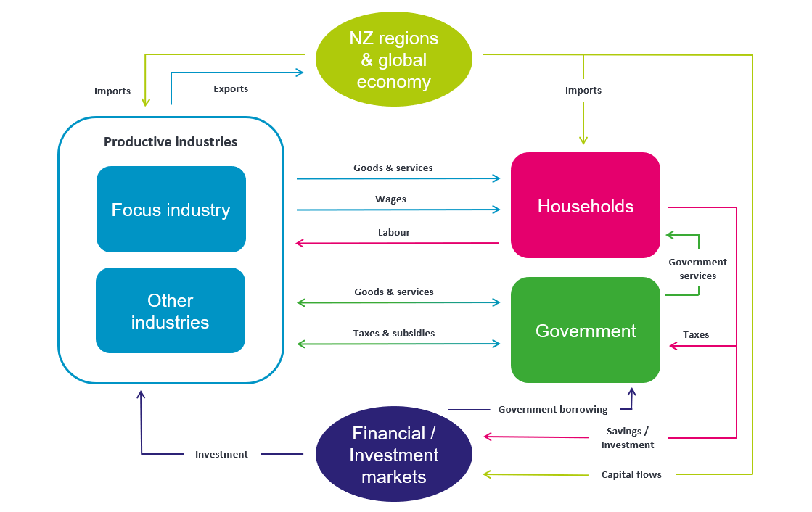
Source: NZIER

How do we shock the model?
To reach the different scenario outcomes, we must ‘shock’ the model to generate changes in national and regional economies. When we shock the model, we select specific input parameters and change their values. The change in some input parameter values produces further changes throughout the economy.
Resources are reallocated to reflect changing conditions. These changes result in increases or decreases in the industries in the model, leading to increases or decreases in commodities produced. There are flow-on effects to markets and supply chains. The model tries to find a mathematical solution that shows how the economy would resettle into a steady state given the new input parameter value.
We can then examine the changes by industry and region or at the national level. We can also compare changes across scenarios to look for differences in how the economy reacts to various shocks.
For the purposes of this modelling exercise, we did not produce a regional breakdown. We also made no assumptions about the distribution of disabled people who would be entering the labour force.

What are our closure conditions?
CGE models require researchers to make a few assumptions about how the economy operates. Essentially, there are too many moving parts for the amount of economic data we have, so we have to nail down a few of those parts to allow the model to find a solution. These assumptions are called closure conditions. They typically concern labour markets, capital markets, government behaviour, and foreign exchange.
Determining the closure is a key part of any modelling exercise, and it is very important that the modeller be transparent about what is a result of the modelling and what has been imposed by assumption via the closure. We investigated several sets of closure conditions to select one that led the model to behave in a way that reflected medium-term adjustments in the economy: sufficient flexibility to represent the choices and changes that businesses and consumers might make, but with some constraints on their options.
The closure conditions used for this modelling are that:
- Aggregate employment is fixed, but the real wage varies, so that changes in the macroeconomy have an impact on the average household. In scenario one, this increases to reflect the equalisation in unemployment rates.
- Capital is flexible, but the rate of return is fixed, which provides investment capital for changes in business activities as long as the changes are sufficiently profitable.
- Real government consumption follows household consumption, so that government spending is constant as a percentage of the whole economy.

Analysis and results

What are the potential macroeconomic benefits of better employment and educational outcomes?
In this section of the report, we explore the following scenarios:
- Scenario 1 models the economic impact of increasing employment among disabled people.
- Scenario 2 models the impact of higher productivity driven by improved educational outcomes for disabled people who are currently employed.

Decreasing unemployment among disabled people
Disabled people in New Zealand form a significant and broad group of people. Disabilities can range in type, including physical, visual, auditory, learning, and intellectual. The severity of disability also varies considerably, from very mild to very severe. In this context, it is a large community of people, many of whom are available and able to participate in the labour force. However, some face employment challenges too great to overcome. Nevertheless, with more than half of the community not currently participating in the labour force, there is likely a group that would like to be in employment. Survey responses from the Disability Survey 2023 indicate that the cohort of disabled people who want to work is larger than the tight definition of the Household Labour Survey suggests, due to the narrow definition of unemployment.
Scenario 1 models the economic impact of reducing the unemployment rate for disabled people to match the national average among non-disabled people. Currently, the unemployment rate for disabled people is significantly higher than for non-disabled people. This scenario considers what would happen if that gap were closed, assuming additional employment for disabled people without displacing existing workers.
We focus on equalising the unemployment rate rather than the labour participation rate. This is because unemployed people have actively sought work in the past four weeks, whereas someone not in the labour force can be due to a range of reasons, including:
- are retired
- have personal or family responsibilities, such as unpaid housework or childcare
- are attending educational institutions
- are permanently unable to work due to sickness, injury, or disability
- are temporarily unavailable for work in the survey reference week
- are not actively seeking work, which may reflect challenges disabled people face, including discrimination and inaccessible workplaces or recruitment processes.
Unlocking this untapped potential in the disabled population presents a significant opportunity for both social and economic gain. By addressing the barriers that prevent willing disabled individuals from entering the workforce, such as access to inclusive education, workplace accommodations, transport, and flexible working conditions, New Zealand can increase labour force participation, reduce welfare dependency, and promote a more equitable society. Better recognition of the diverse aspirations and capabilities within the disabled community is essential to designing effective employment and education policies that enable fuller participation in economic life.
Figure 5 shows the increase in real GDP from equating unemployment from 2017 to 2025. The model predicts that closing this employment gap would have contributed an estimated $578 million increase in GDP in 2025. This outcome would also reduce welfare dependency, increase tax contributions, and improve overall household income.
Figure 5 Increase in real GDP from equalising unemployment among disabled people
$ millions
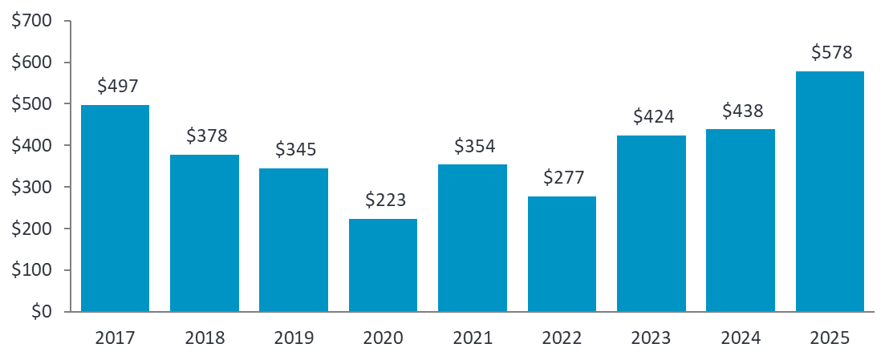
Source: NZIER

The economic benefits of better educational outcomes among disabled people
Scenario 2 models the effect of a 2 percent increase in the productivity of disabled people, achieved through improved educational outcomes. It assumes that enhanced education enables employed disabled people to enter higher-skilled, better-paid occupations and contribute more effectively to economic output.
The estimated macroeconomic impact under this scenario is a $132 million increase in GDP in 2025, reflecting the long-term benefits of investing in education and skill development for this population. Figure 6 shows the macroeconomic benefit of improved educational outcomes over time.
Figure 6 Increase in real GDP from improved educational outcomes
$ millions
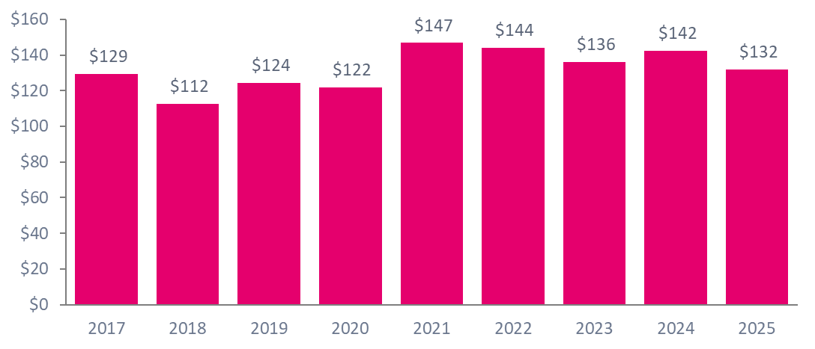
Source: NZER

Bring it all together
This research highlights the significant macroeconomic and social benefits of improving employment and educational outcomes for disabled people in New Zealand. The modelling demonstrates that reducing the unemployment rate of disabled people to match the national average and increasing their productivity through better educational attainment can deliver measurable gains to the national economy. These benefits include increased GDP, reduced reliance on welfare, higher household incomes, and expanded labour force capacity.
Beyond the direct economic gains, the scenarios modelled in this study suggest substantial improvements in social wellbeing for disabled people. Increased employment and access to higher-quality jobs are associated with greater financial security, improved mental health, and higher levels of social inclusion. Education plays a particularly critical role in enabling disabled people to access sustainable employment and participate meaningfully in the evolving labour market, especially as digital and knowledge-based sectors continue to grow.
However, the analysis also reinforces that systemic barriers continue to constrain opportunities for disabled people. Addressing these barriers requires a coordinated policy response that integrates accessible education pathways, inclusive workplace practices, early intervention strategies, and equitable access to remote and flexible work arrangements.
Realising the economic potential identified in this research will require deliberate, sustained investment in disability inclusion. Doing so will not only improve outcomes for disabled people but also strengthen New Zealand’s long-term economic resilience, fiscal sustainability, and social cohesion. Creating a more inclusive labour market is both an economic opportunity and a social imperative.

Implications for current policy settings
Many active labour market policy interventions are currently in place to support disabled people. While this research does not examine their effectiveness or the optimal mix of support, it is clear that there is significant economic and social potential in supporting the large group of disabled people into more and better employment.
Current policy settings to consider in more granularity with scaling and refinement in mind for disabled people include:
- integrated support across health, education and work
- employer-focused interventions
- assistive technology
- accessible infrastructure.
Attention to design, scale and coherence comes from working closely with disabled people.

Opportunities for further research
This study offers valuable insights into the macroeconomic benefits of improving employment and educational outcomes for disabled people, but several areas warrant further investigation to strengthen the evidence base and inform policy development. Collectively, these research opportunities would contribute to a more comprehensive understanding of the pathways to economic inclusion for disabled people and provide practical evidence to guide disability-inclusive policy and investment.
The opportunities for further research include the following:

Disaggregated economic impacts
Further research could quantify the macroeconomic impacts by industry and region to understand where the greatest gains from disability inclusion are likely to occur. Sector-specific modelling could help identify industries with the highest potential to absorb additional disabled workers or benefit from improved productivity.

Longitudinal analysis of employment pathways
There is a need for longitudinal studies that track the employment trajectories of disabled people over time. Such research would provide a better understanding of the barriers to sustained employment, transitions between education and work, and the long-term earnings and wellbeing outcomes associated with different qualification levels.

Cost-benefit analysis of targeted Interventions
Future studies could assess the costs and benefits of specific policy interventions, such as workplace accessibility improvements, inclusive education initiatives, expanding remote work, and employer incentives. This would support more targeted and efficient policy design.

Employer behaviour and demand-side barriers
Research into employer attitudes, hiring practices, and organisational readiness for disability inclusion would help to address demand-side constraints in the labour market. Understanding how businesses can be supported to improve the recruitment and retention of disabled employees is essential.

Barriers to remote work for disabled people in New Zealand
While international studies have explored the impact of teleworking on disabled people, New Zealand-specific evidence is limited. Investigating the accessibility, availability, and effectiveness of remote work arrangements in the New Zealand labour market would provide relevant guidance for local policy.

Intersections with other forms of disadvantage
Further research is needed to explore how disability intersects with other factors such as gender, ethnicity, age, and socioeconomic status in shaping labour market outcomes. This would allow for more nuanced policy responses that address compounded disadvantage.

Impact of early education interventions
Evaluating the long-term impacts of inclusive early childhood and secondary education on employment outcomes for disabled people would support investment in education as a key enabler of future labour market participation.

References
Becker, Gary S. 1992. “Education, Labor Force Quality, and the Economy.” Business Economics 27 (1): 7–12.
Card, David. 1994. “Earnings, Schooling, and Ability Revisited.” Working Paper No. 4832. Working Paper Series. National Bureau of Economic Research, August. https://doi.org/10.3386/w4832.
Card, David. 1999. “Chapter 30 - The Causal Effect of Education on Earnings.” In Handbook of Labor Economics, edited by Orley C. Ashenfelter and David Card, vol. 3. Elsevier. https://doi.org/10.1016/S1573-4463(99)03011-4.
Florisson, Rebecca, George Williams, Alice Martin, et al. 2025. Beyond the Office? How Remote and Hybrid Working Can Help Close the Disability Employment Gap. Interim report of the Inclusive Remote and Hybrid Working Study. Lancaster University. https://www.lancaster.ac.uk/media/lancaster-university/content-assets/documents/lums/work-foundation/reports/BeyondtheOffice(LU,WF,MMU,UI).pdf.
Heckman, James J., John Eric Humphries, and Gregory Veramendi. 2018. “The Nonmarket Benefits of Education and Ability.” Journal of Human Capital 12 (2): 282–304. https://doi.org/10.1086/697535.
Hoque, Kim, and Nick Bacon. 2022. “Working from Home and Disabled People’s Employment Outcomes.” British Journal of Industrial Relations 60 (March): 32–56. https://doi.org/10.1111/bjir.12645.
Ministry of Business, Innovation and Employment. 2025. “Disabled Peoples (Aged 15 to 64 Years) Labour Market Statistics Snapshot - June 2025.” https://www.mbie.govt.nz/dmsdocument/31056-disabled-peoples-aged-15-to-64-years-labour-market-statistics-snapshot-june-2025-pdf.
NZIER. 2017. Valuing Access to Work. Blind Foundation for the Access Alliance.
OECD. 2010. “Sickness, Disability and Work: Breaking the Barriers.” OECD. https://www.oecd.org/en/publications/sickness-disability-and-work-breaking-the-barriers_9789264088856-en.html.
OECD. 2022. Disability, Work and Inclusion: Mainstreaming in All Policies and Practices. https://www.oecd.org/en/publications/disability-work-and-inclusion_1eaa5e9c-en/full-report.html.
OECD. 2023. “Teleworking, Workplace Policies and Trust.” OECD, March 8. https://www.oecd.org/en/publications/teleworking-workplace-policies-and-trust_64cd6e8e-en.html.
Stapleton, David C. 2003. The Decline in Employment of People with Disabilities: A Policy Puzzle. W.E. Upjohn Institute.
Stats NZ. 2025. Household Labour Force Survey.

