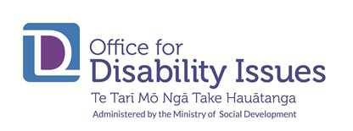
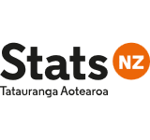

Disability Data and Evidence Advisory Group

Date: 13 September 2023
Time: 10.00am-12.30pm
Venue: Online via zoom

Invited

Unfortunately, a record of attendees was expected to be saved in zoom and has not been. There were a range of attendees from government agencies, independent agencies and the DPO coalition. Because the DDE Community of Practice session was tagged to this hui, over 100 people were invited. 54 attended.

Apologies
- Peter Reynolds

Meeting opened with karakia at 10am.
No closing karakia as it transitioned to the CoP session and presentation from Growing up in New Zealand.

Apologies for the technical frustrations experienced with zoom, this has now been remedied.

Welcome and mihi/farewell to Brian Coffey 10am

- Acknowledgement of Te Wiki o Te Reo Māori
- Clarity to come regarding the division of mahi/content between the Disability Data and Evidence Working Group and the Community of Practice.
- Contribution of Whaikaha to Stats NZ across the board is valued, links being made.
- Minutes from previous meeting (June 2023) approved by group.
- Mihi to Brian for his work in DDEWG and shift from ODI to Whaikaha, Director of ODI since 2017 and saw the expansion of the team from 6 to 18 members. Brian noted the Public Service doesn’t make progress unless its citizens demand progress, and acknowledged the importance of continuing to work for better data.

FERNZ Research on tāngata whaikaha Māori Dr Tristram and Bernadette Ingham and Meredith Perry, University of Otago.

- Whaikaha invited Tristram & Bernadette to showcase current government-funded research and thinking on disability measurement among tāngata whaikaha Māori. Presentation is of draft analysis of confidential and preliminary results, funded by Health Research Council.
- Insights into the meaning of Māori health and disability.
- Whakawhiti kōrerō to validate analysis.
- Disablement is a secondary experience to the exclusion of Māori from culture & society.
- Different ways of identifying, development of terms in te reo – lower engagement from Māori with common English terms, leading to undercounting.
- Of more than 7,000 participants, those experiencing “some difficulty” do experience different outcomes and have impairments that merit investigation.
- Physical health significantly limits access to te ao Māori.

- Note discussion of flux in disabled population
- Refer to notes of Community of Practice Session in August regarding exploratory analysis in the IDI by SWA.
- Suggest continuing to grow our understanding of rate of entry/exit and different experiences of disability (short vs. long-term/core vs. transient population).

- Quarter 4 Meeting
- To be set

- Action Points
- Awaiting appointment of the new Whaikaha GM Quality & Insights who is expected to co-chair DDEAG.

