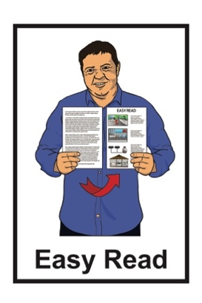
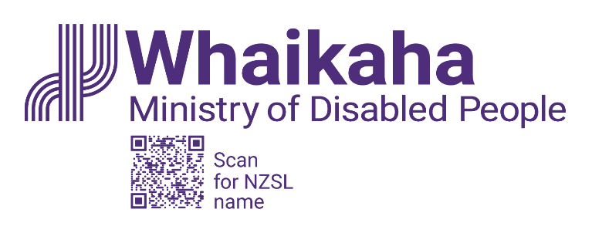

Cabinet paper –

Confirming the status of the Accessibility for

New Zealanders Bill
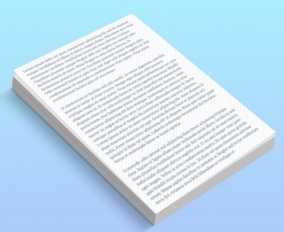

Easy Read published: April 2025

What is in this document

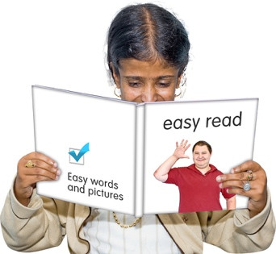
Page number:

About this Easy Read 2

The main idea of the Bill 6

Accessibility Committee 8
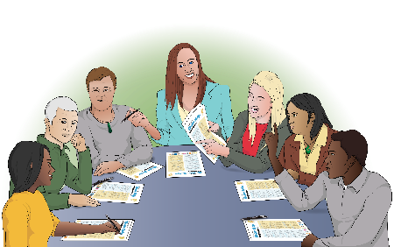

Why the Bill is important 12

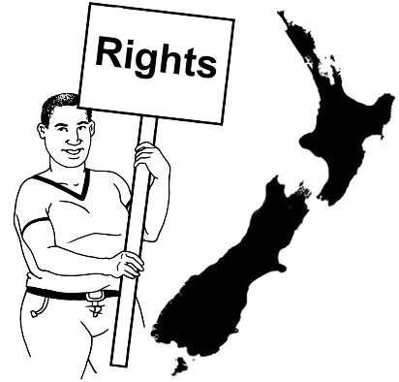
Progress on the Bill so far 16

Human rights implications 21

About this Easy Read

This Easy Read is a summary of a Cabinet paper.

A summary:
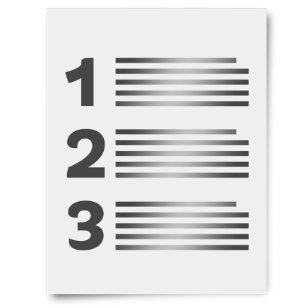
is shorter than the full document
includes the main points of the information.

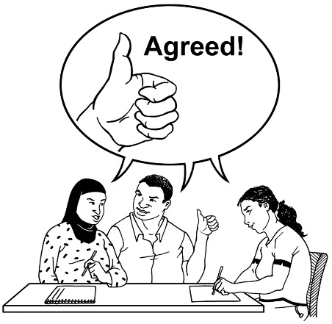
A Cabinet paper is a document:
from a minister
asking Cabinet to agree to something.

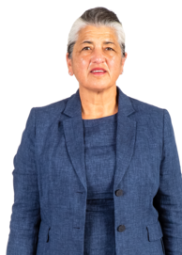
A minister is an important person who works in the Government.
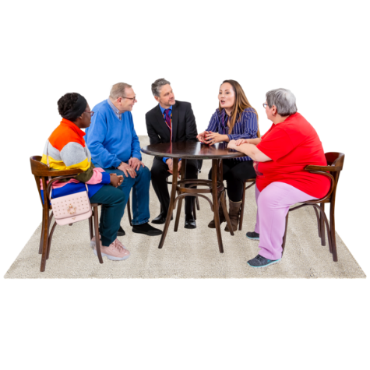

Cabinet is a group of ministers that meet to make decisions.

The Cabinet paper is:
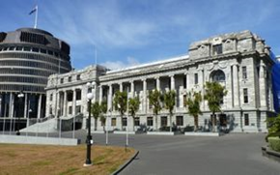
about the Accessibility for
New Zealanders Bill
from the Minister for Disability Issues Hon Penny Simmonds.

Every law starts off as a document called a bill.

The bill says what the idea for the law is.

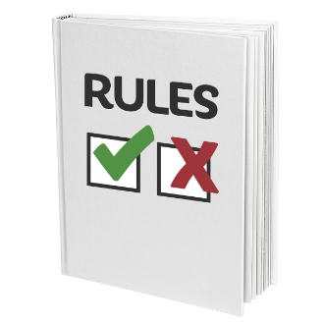
Laws are the rules that everyone in New Zealand have to follow.

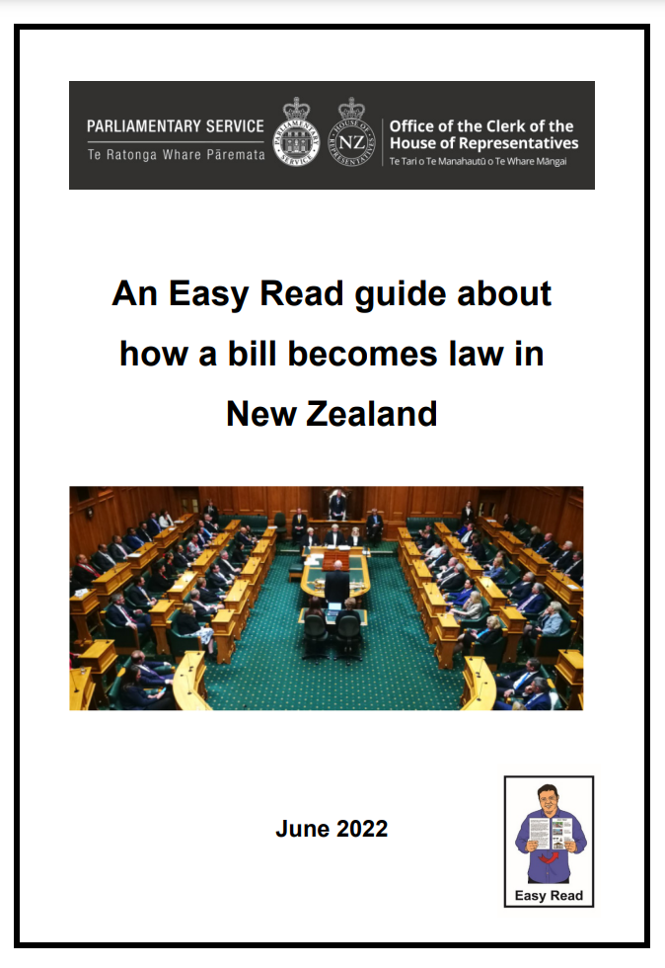
There is an Easy Read document called:
An Easy Read guide about how a bill becomes law in
New Zealand.

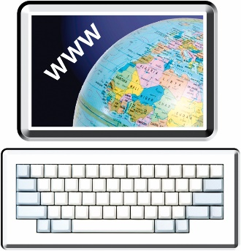
You can find this Easy Read here:

tinyurl.com/4kcs8fcb

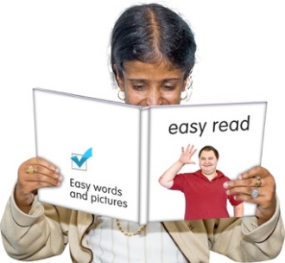
In this Easy Read:
the Accessibility for
New Zealanders Bill will be
called the Bill
Hon Penny Simmonds will be called the Minister
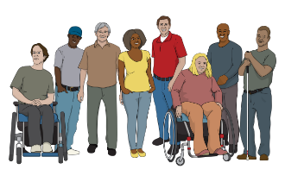
when you see the words disabled community this includes:
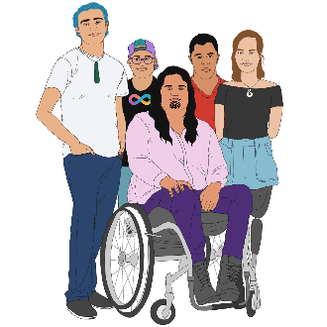
- disabled people
- tāngata whaikaha Māori
- people who live with accessibility difficulties.

The main idea of the Bill

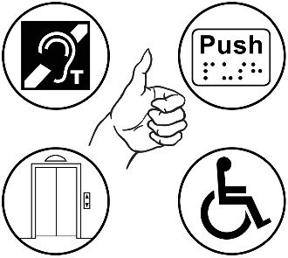
The Bill was made with the goal of making New Zealand fully accessible.

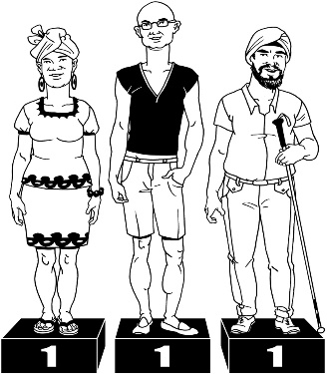
Here fully accessible means people from the disabled community have the same chance to reach their goals as everyone else.

The main idea in the Bill is to make an Accessibility Committee as a Ministerial Advisory Committee.

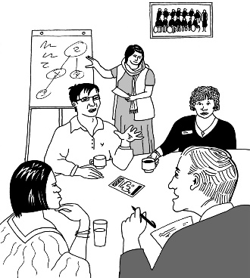
A Ministerial Advisory Committee is a group of people who:
know a lot about something
give suggestions to Ministers about something
usually do not work for the government.

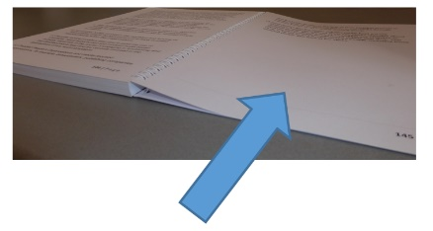
More information about the Accessibility Committee is on the next page.

Accessibility Committee

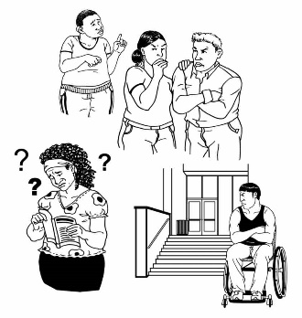
The Accessibility Committee would:
find accessibility barriers
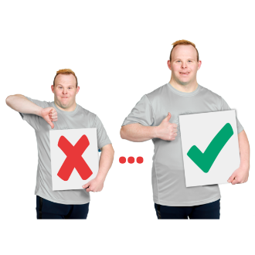
make recommendations to the Minster on how to fix the accessibility barriers
have up to 10 members
have members who are part of the disabled community
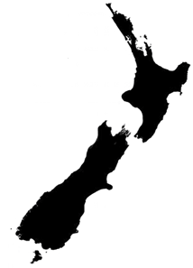
keep track of how accessibility is getting better in New Zealand
report to the Minister about how accessibility is getting better in New Zealand.

Accessibility barriers are things that stop something from being accessible.

Recommendations are
ways to make something better.

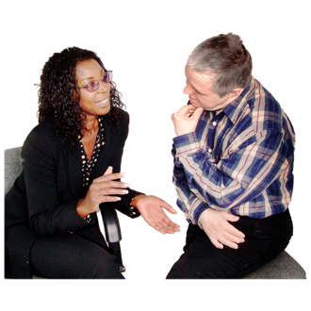
The Accessibility Committee would also listen to what the disabled community have to say about accessibility.
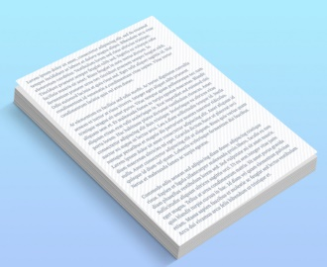

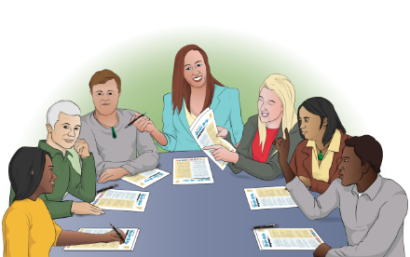
The Bill has information about the responsibilities others have about the work the Accessibility Committee does.

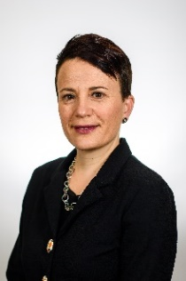
These include:
Ministers
Chief Executive of Whaikaha.
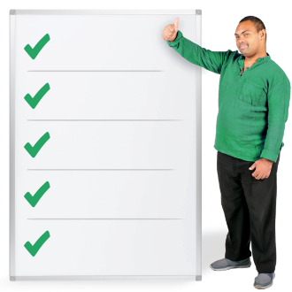
Here responsibilities mean things people would have do for the Accessibility Committee.

The Minister of Disability Issues would have to:
tell the Accessibility Committee what the Government thinks about their recommendations
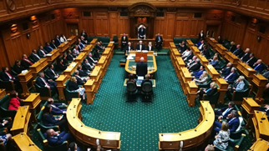
show the report done by the Accessibilty Committee to the House of Representatives.

The House of Representatives is
in Parliament.

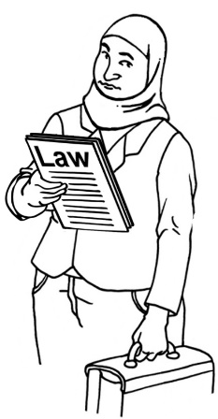
Parliament is where Members of Parliament make important decisions about how New Zealand should be run.
Members of Parliament are:
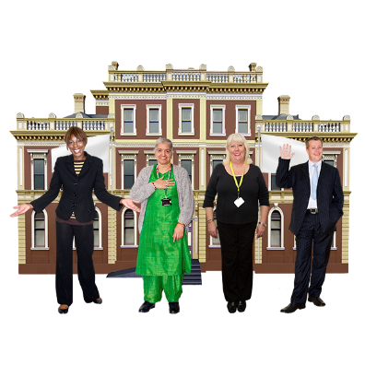
the people you vote for at election time
called MPs.

The bill also has information on how the:
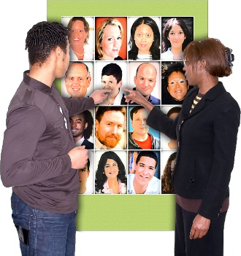
Accessibility Committee members will be chosen
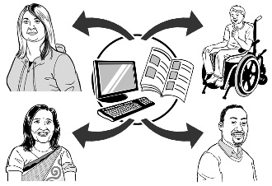
Accessibility Committee will be given the information they need
work program will be set.

Why the Bill is important

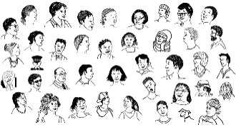
There are over 1 million disabled people in New Zealand.

Most disabled people deal with accessibility barriers around:
work
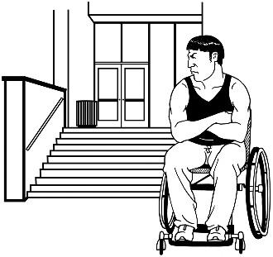
education like school
where they live.

This means disabled people have a harder time:
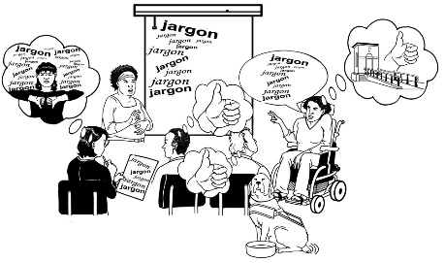
getting a good education
working in a job that pays well
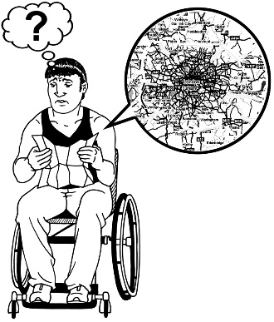
living in a nice place
taking part in the community around them.

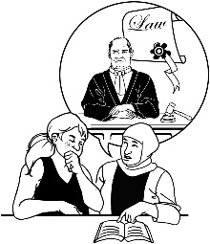
The disabled community has asked for accessibility legislation for a long time

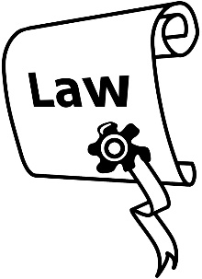
Accessibility legislation is laws around accessibility.

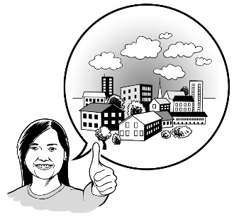
Accessibility legislation supports people from the disabled community to:
live with the people they choose to
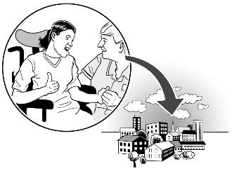
be part of the community around them.

New Zealand does not have
systems / wasy of doing things that make accessibility important.

Not having a system / way of doing things means work has been slow on making accessibility better.

The Bill is an important step to making a framework to support better accessibility in New Zealand.

Here framework means a
system / rules for checking that things are working as they should.

Progress on the Bill so far

Here progress means how close the Bill is to becoming part of the law.

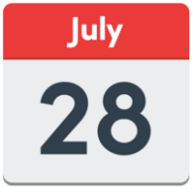
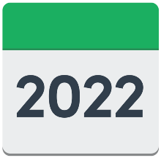
Parliament was told about the Bill on
28 July 2022.

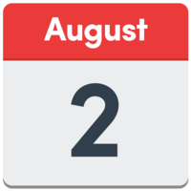
The Bill passed its First Reading on 2 August 2022.

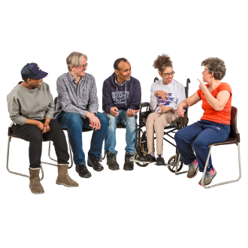
The First Reading is when MPs talk about the bill.

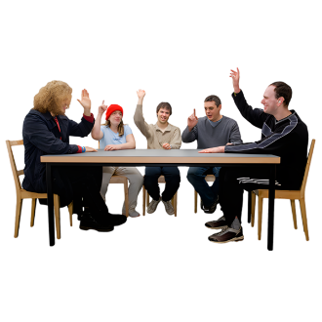
If more than half of the MPs vote yes then the bill is sent to a select committee.

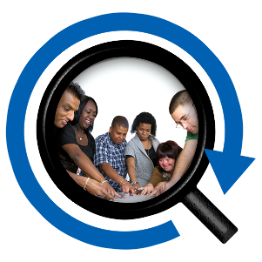
A select committee is when a smaller group of MPs take a closer look at the bill.

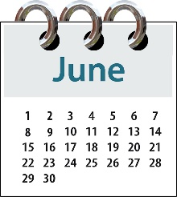
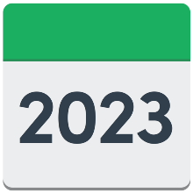
The Social Service and Communities Committee looked at the Bill in
June 2023.

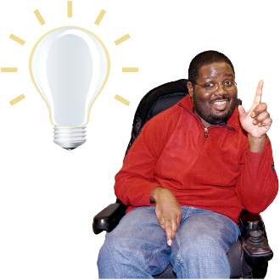
This Committee:
supported the idea of more laws around making accessibility better

think the Bill needs changes to be better.

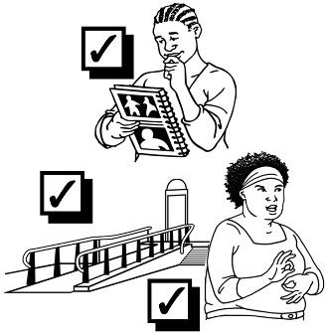
The Minister thinks the changes the Social Service and Communities Committee said the Bill needs would:
only be good for fixing some accessibility barriers
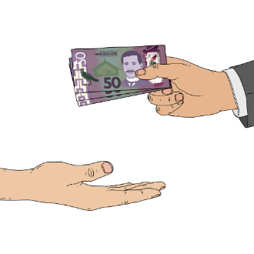
cost more money
be harder to manage.

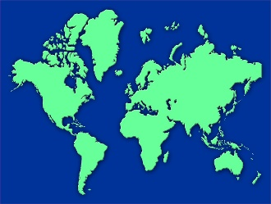
The Minister has asked for more research to be done on:
accessibility legislation in other countries

things that need to be made better in the accessibility legislation in New Zealand
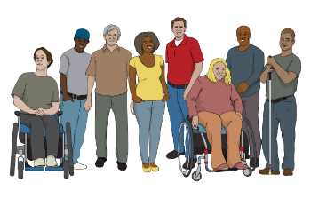
what the disabled community in New Zealand think.

The Minister has put in a legislation bid for this Bill.


A legislation bid is when Ministers put in bills that they think should be part of the legislation programme for the next year.
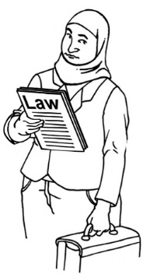

A legislation programme is all the bills that Ministers think should be part of the law.

All the bills in the legislation programme are put into 9 categories.

The Minister has put this Bill in category 8 – on hold.

Category 8 – on hold means:
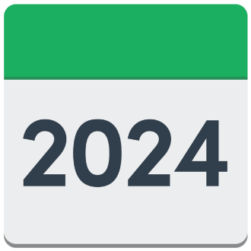
it is not going to be part of the legislation programme in 2024
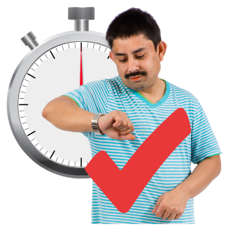
there is more time to work on the changes the Social Service and Communities Committee said the Bill needs.

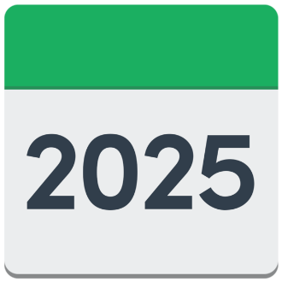
The Minister will decide what to do with this Bill in early 2025.

Human rights implications

Implications means things that will happen because of the Bill.

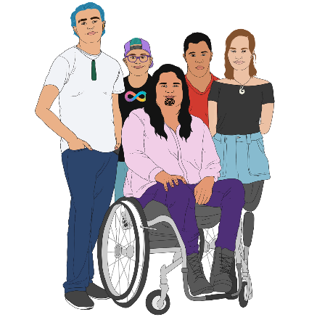
Making accessibility better will mean the of disabled people will have their human rights looked after better.

Human rights are things everyone should:
have
be able to do.

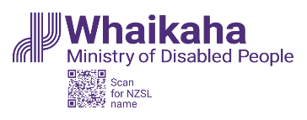
This information has been written by
Whaikaha – Ministry of Disabled People

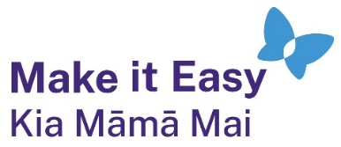
It has been translated into Easy Read by the Make it Easy Kia Māmā Mai service of People First New Zealand Ngā Tāngata Tuatahi.

The ideas in this document are not the ideas of People First New Zealand Ngā Tāngata Tuatahi.

All images used in this Easy Read document are subject to copyright rules and cannot be used without permission.


Make it Easy uses images from:

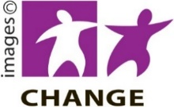
- Photosymbols

- Change Images


- Huriana Kopeke-Te Aho

- SGC Image Works

- T Wood


- Studio Rebeko

- Inga Kramer.

