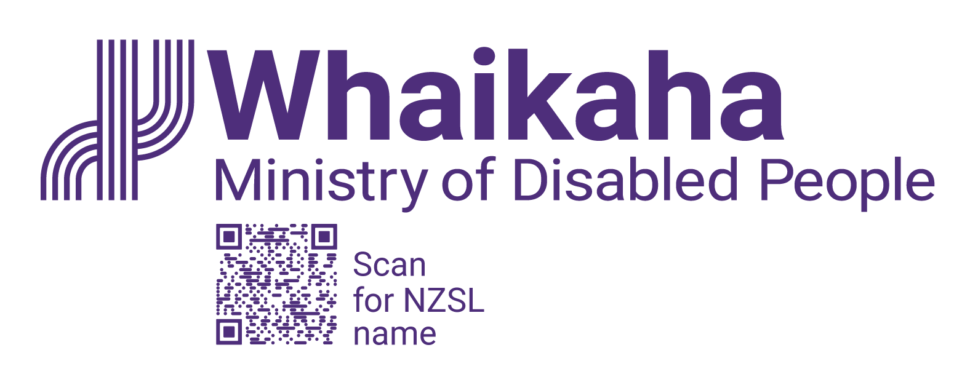
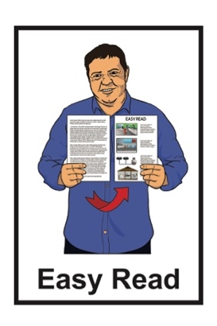

Summary of
Atoatoali’o – National Pacific Disability Approach
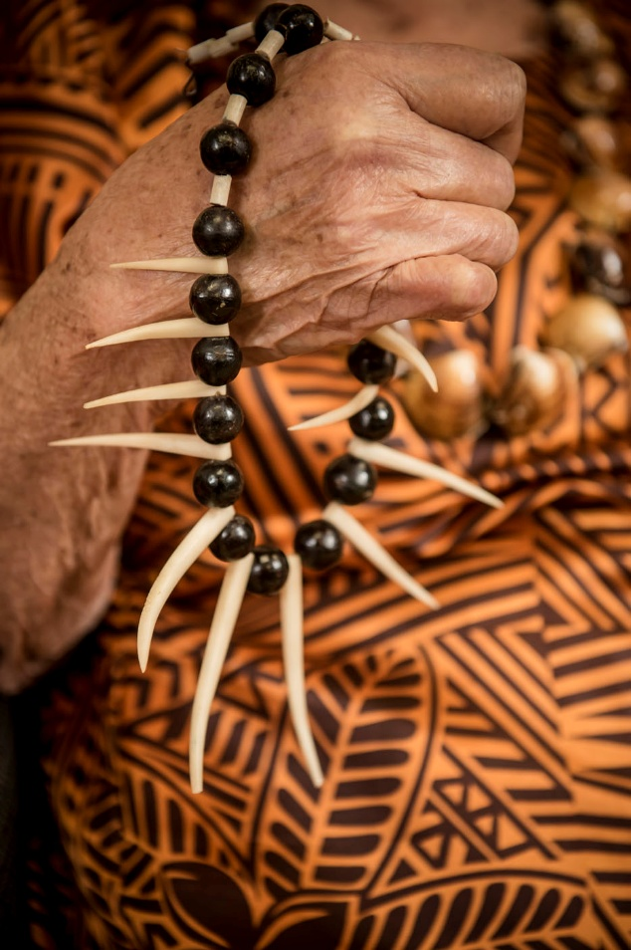

Published: April 2025

What this Easy Read is about

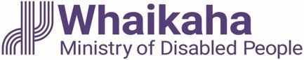
This Easy Read is from Whaikaha –Ministry of Disabled People.

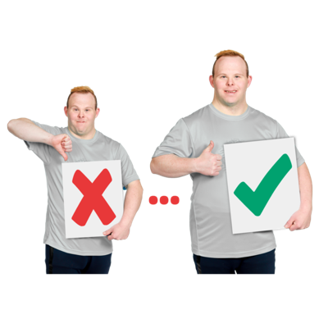
Whaikaha – Ministry of Disabled People works to make change for disabled people to make their lives better.

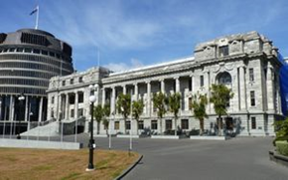
Whaikaha – Ministry of Disabled People makes things better for disabled people by working with:

the Government
the community
businesses.

When you see we / our / us in this Easy Read it means Whaikaha –Ministry of Disabled People.

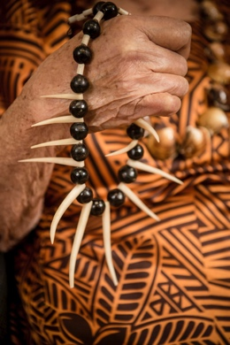
This Easy Read is about
Atoatoali’o – the National Pacific Disability Approach.

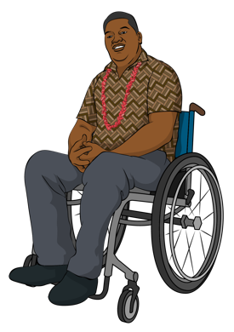
Atoatoali’o – the National Pacific Disability Approach says what we can do to make support and services better for Pacific disabled people.

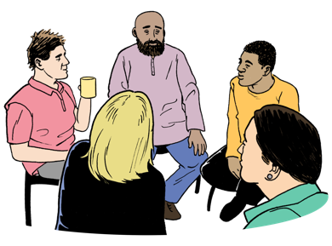
Atoatoali’o is a Samoan word about people sitting in a circle where everyone:
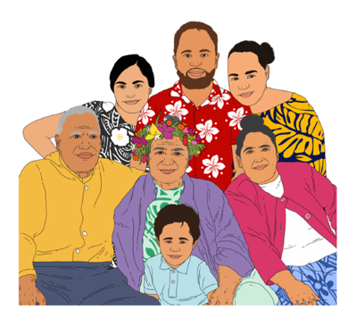
fits
belongs.

In this Easy Read we will call Atoatoali’o the National Pacific Disability Approach Atoatoali’o.

This Easy Read is a summary of the full document.

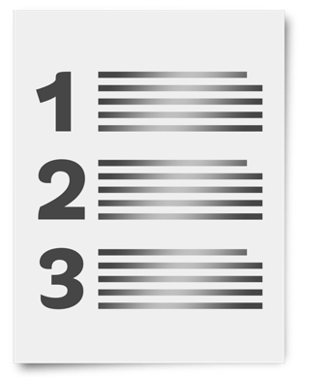
A summary:
is shorter than the full document
tells the main ideas.

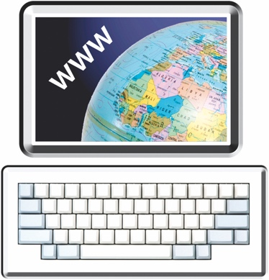
You can find the full document at:

https://tinyurl.com/3mczckx9

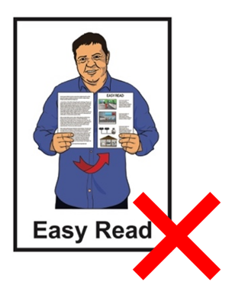
The full document is not in
Easy Read.

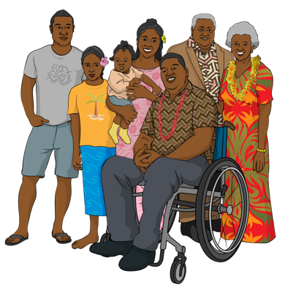
Atoatoali’o uses ideas from:
Pacific disabled people
the aiga / families of Pacific disabled people.

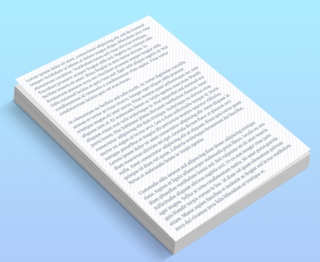
We will use Atoatoali’o when we update the New Zealand Disability Strategy.

The New Zealand Disability Strategy supports the Government to know how to make life better for disabled people.

What Atoatoali’o says

Atoatoali’o talks about our priorities for Pacific disabled people.

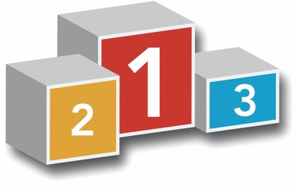
Here priorities means the things that are the most important to do.

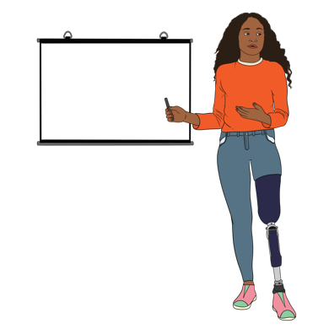
We want to support Pacific disabled people to be leaders in their communities.

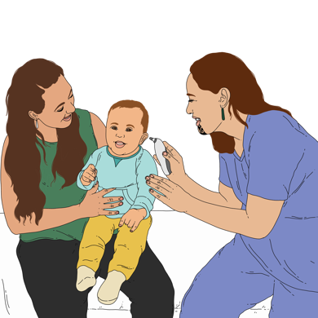
We want to make sure people who work in health / disability services understand:
about Pacific cultures
what Pacific disabled people need.
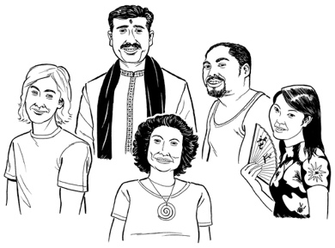
Culture is a way of:
thinking that a group shares
doing things as a group.

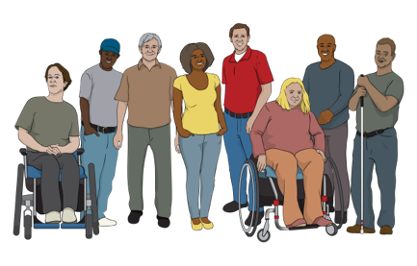
We want to support Pacific communities to understand about disability.

This will make it easier for Pacific disabled people to get support from their:
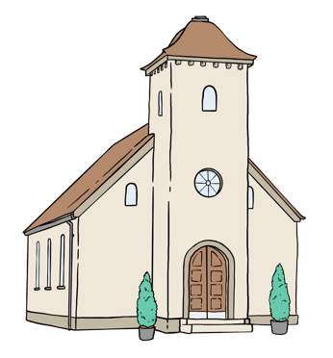
aiga / family
church
community.

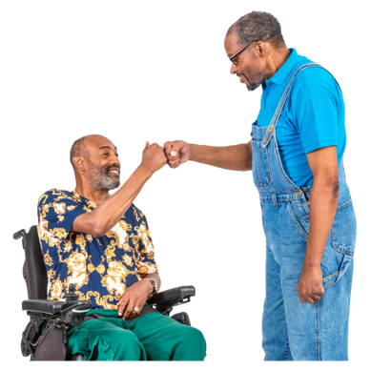
We want to make sure
Pacific disabled people feel:
supported
valued.


Here valued means being treated like:
you are important
people care about you.
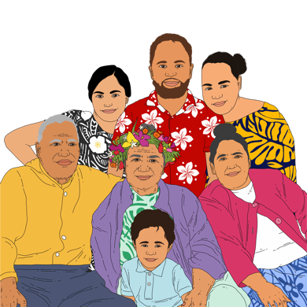

We want the aiga / families of Pacific disabled people to feel this way too.

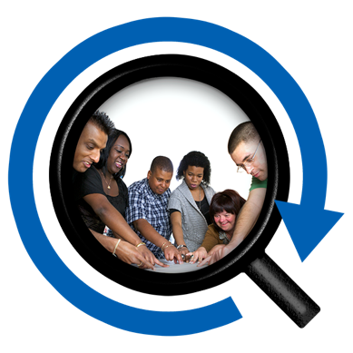
We want to make sure any research the Government does includes Pacific disabled people.

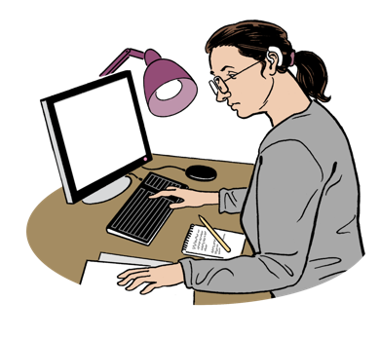
Research is when someone:
looks at what is happening
tries to find ways to do things better.

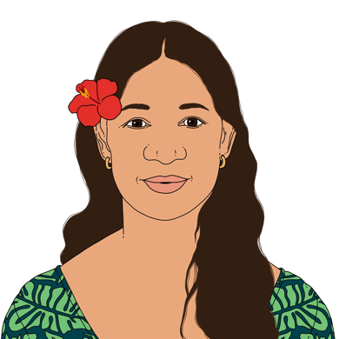
We want to work in ways that are good for:
Pacific disabled people
the aiga / families of Pacific disabled people
the whole community.

Thank you

We wrote Atoatoali’o with a lot of support from:
Pacific disabled people
Pacific communities.
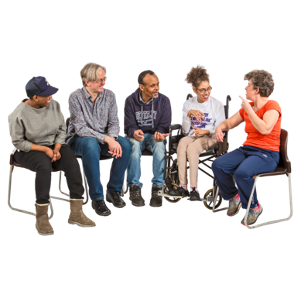

We want to thank everyone who:
came to talanoa / meetings
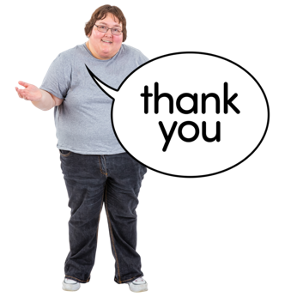
told us their stories / ideas.

We could not have written Atoatoali’o without those people.


We need to make sure the New Zealand Disability Strategy shows that we have listened to the things everyone told us.

Where to find more information

You can find out more about how we wrote Atoatoali’o here:

https://tinyurl.com/3mczckx9

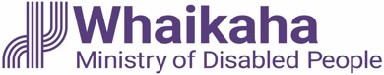
This information has been written by Whaikaha -Ministry of Disabled People.

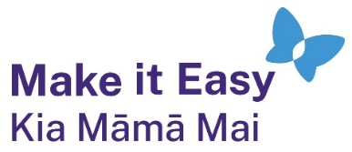
It has been translated into Easy Read by the Make it Easy Kia Māmā Mai service of People First New Zealand Ngā Tāngata Tuatahi.
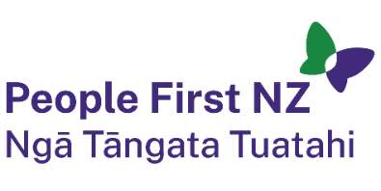
The ideas in this document are not the ideas of People First New Zealand Ngā Tāngata Tuatahi.

All images used in this Easy Read document are subject to copyright rules and cannot be used without permission.


Make it Easy uses images from:

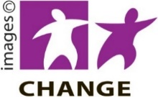
- Photosymbols

- Change Images


- Huriana Kopeke-Te Aho

- SGC Image Works

- T Wood

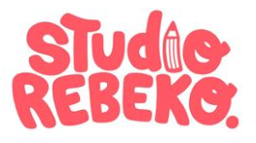
- Studio Rebeko

- Inga Kramer.

