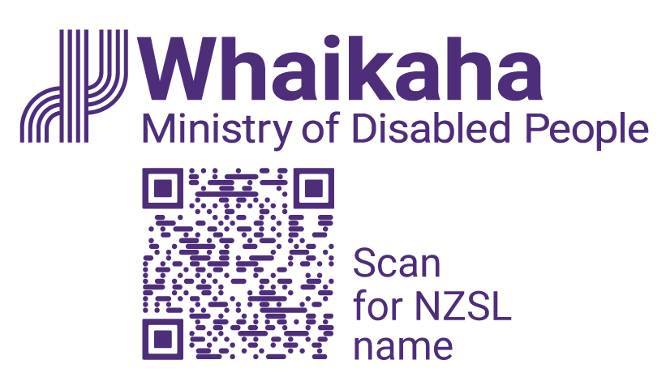
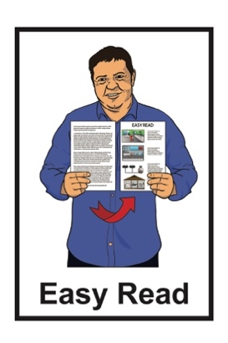

How the Government is getting on with the Disability Action Plan
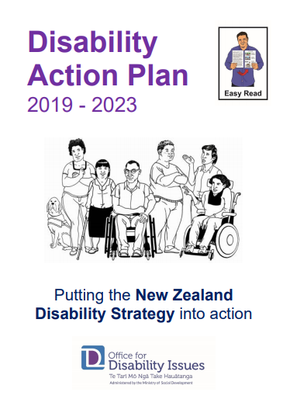


Review of July – December 2022

About this report

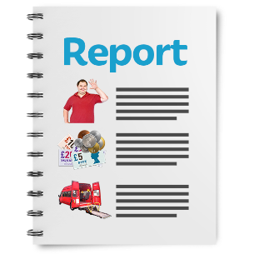
This Easy Read document is a report about how well the Disability Action Plan is working.

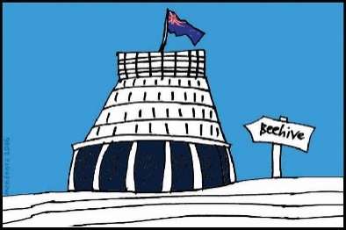
The Disability Action Plan is how the Government will make the New Zealand Disability Strategy happen.

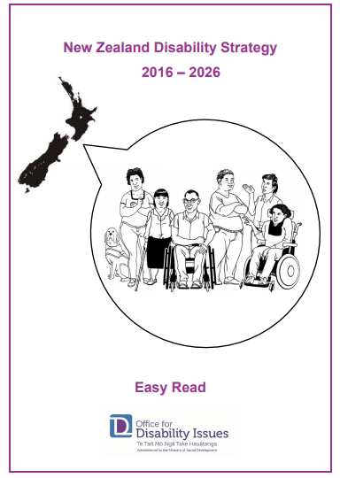
The New Zealand Disability Strategy works to make sure disabled people:

- are treated fairly

- get what they need to have a good life

- are part of the community

- can make their own decisions.
There are Easy Read translations about the:
New Zealand Disability Strategy
Disability Action Plan.


You can find these Easy Read translations on the Office for Disability Issues website:

https://www.odi.govt.nz

What is the Disability Action Plan?

The Disability Action Plan works to improve the wellbeing of disabled people by working on 8 main outcomes.


Wellbeing means how people feel about their lives.


Some of the things that are important to wellbeing are:
- health

- money
- housing.


Outcomes are the things we want to happen from the Disability Action Plan.




These outcomes are:
education
jobs and money
health and wellbeing
protecting the rights of disabled people
accessibility
attitudes towards disability
disabled people having choices
and control over their own lives
disabled people as leaders.

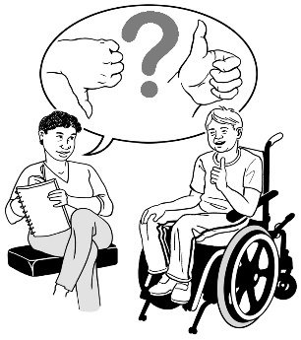
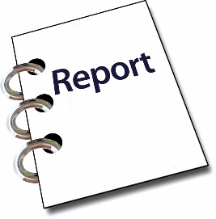
Every 6 months there is a report about what the different parts of Government are doing from the Disability Action Plan.

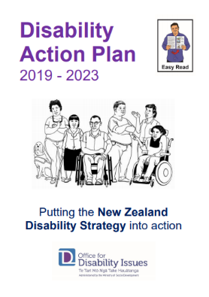
These reports are 1 of the ways to see how well the Disability Action Plan is working.

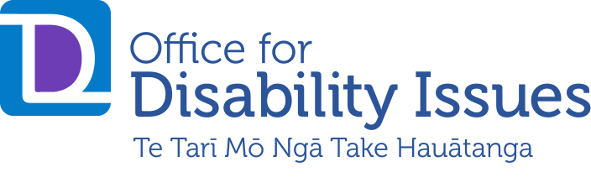
The Office for Disability Issues used to make these reports.


The Office for Disability Issues is now part of Whaikaha – Ministry of Disabled People.

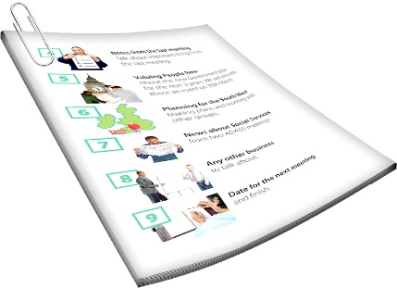
When we talk about Whaikaha – Ministry of Disabled People in this document we will just say Whaikaha.

Whaikaha is a new part of the Government that will:
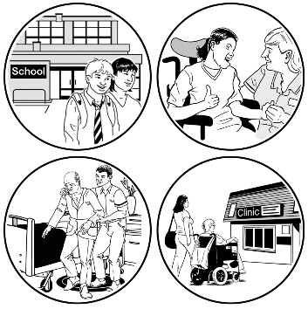
make disability support services better for disabled people and their families / whānau


use an Enabling Good Lives way of doing things
work with other government agencies to better support disabled people.

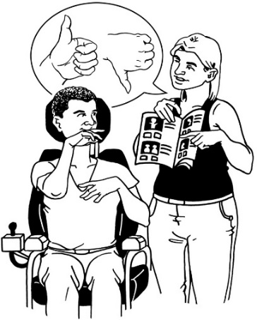
Enabling Good Lives is a different way of thinking about disability support that gives people more choice.

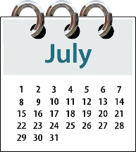
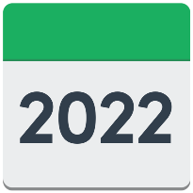
This report looks at what the different parts of Government did from:

July 2022
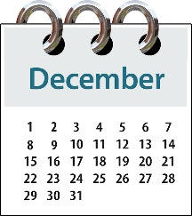
to

December 2022.

The Office for Disability Issues became part of Whaikaha in this time.

How things are going

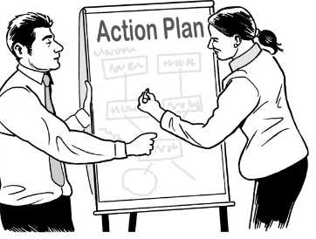
29
The Disability Action Plan has 29 work programmes.

7
The people working on 7 of these programmes said their work is going well.
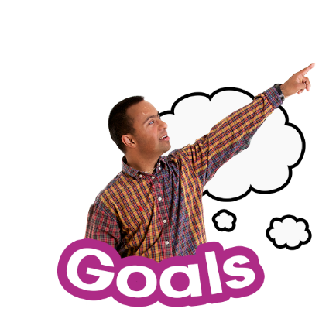

The people working on these 7 programmes said they are meeting the goals set out in the Plan.

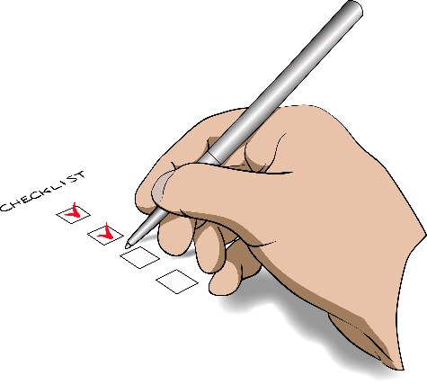
Goals are the things the people planned to do by a certain time.

Some of those people said the programmes are closer to being done than planned.
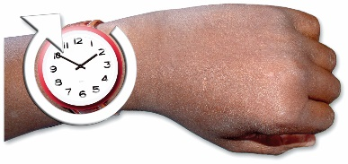
The people working on 15 of the programmes said they will finish on time.
15

The people working on 5 of the programmes said they have not done as much as the Plan said.
5

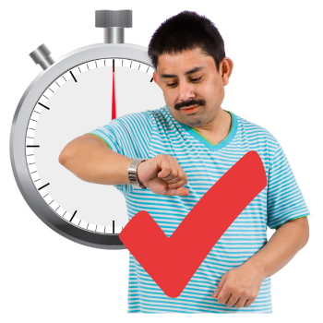
The people working on these 5 programmes said they think they will still finish their work on time.


1 of the work programmes has had problems with doing the work on time.
1

There was no report on 1 of the programmes.

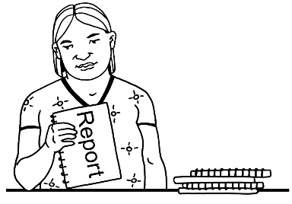
This was because the people who worked on it changed.


The COVID-19 pandemic was the reason given most for work programmes not having things done as soon as they planned.

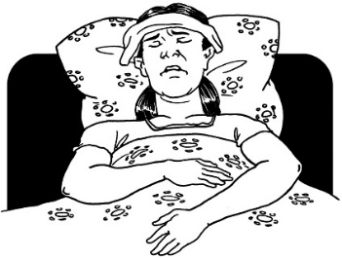
Other reasons included:
staff being sick with other things

computer problems.


The Disability Action Plan Review Group had some things to say about how the:
work programmes are going
reports about the work programmes are written.

The Disability Action Plan Review Group is a group of people who check how the Disability Action Plan is going.

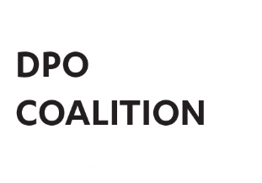
This group is made up of people from:
the DPO Coalition
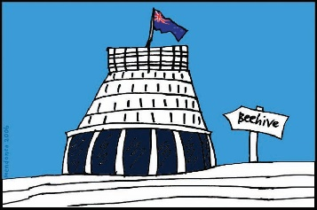
the Government.

What happens next

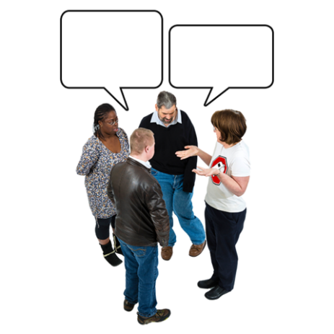
The DPO Coalition has asked for different parts of government to talk to them if:
they want to change what they do in their work programme
they think all their work is done.

This is because there might be:
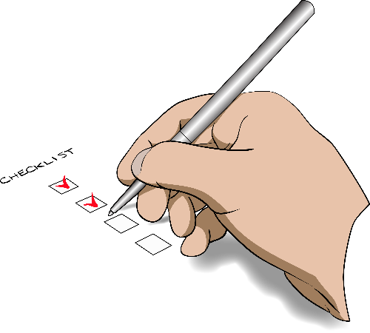
other things to do before this Disability Action Plan finishes
things to do in the new Disability Action Plan.

Work is about to begin on making the new Disability Action Plan.

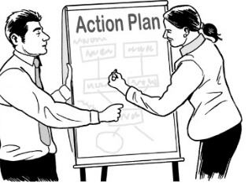
The new Disability Action Plan will last for the next 4 years.

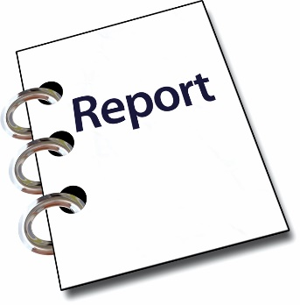
Government agencies need to:
write their reports thinking about disabled people as the main people who read them

set dates to get their work done quickly.

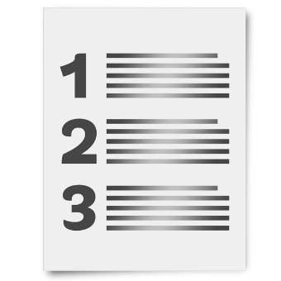
The Disability Action Plan Review Group said future reports should focus on some recommendations.

Recommendations are things that should be done.

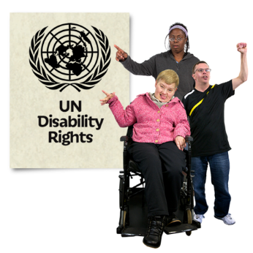
The recommendations are made by the groups that are checking New Zealand is following the United Nations Convention on the Rights of Persons with Disabilities.

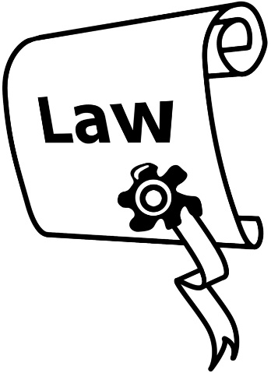
The United Nations Convention on the Rights of Persons with Disabilities is a law lots of countries have agreed to.

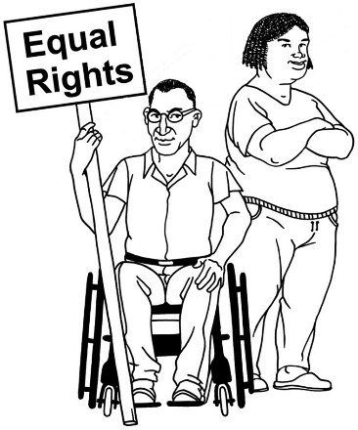
It says what governments must do to make sure disabled people get the same rights as everybody else.

You can find an Easy Read translation of the United Nations Convention on the Rights of Persons with Disabilities at:
www.odi.govt.nz/united-nations-convention-on-the-rights-of-persons-with-disabilities/read-the-convention/

More information

You can find more information about Whaikaha on our website at:

www.whaikaha.govt.nz


You can also contact us by:

email at:
contact@whaikaha.govt.nz
phone on:
0800 556 601
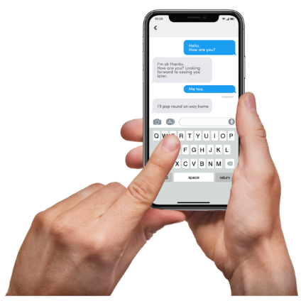
text at:
4206


If you find it hard to use the phone the New Zealand Relay service is for people who are:


- Deaf / hard of hearing

- deafblind

- speech impaired / find it hard to talk.


You can find out more about the New Zealand Relay service at:

www.nzrelay.co.nz

This information has been written by Whaikaha – Ministry of Disabled People.

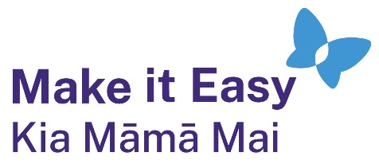
It has been translated into Easy Read by the Make it Easy Kia Māmā Mai service of People First New Zealand Ngā Tāngata Tuatahi.

The ideas in this document are not the ideas of People First New Zealand Ngā Tāngata Tuatahi.
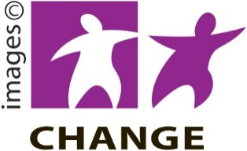
Make it Easy uses images from:


- Changepeople.org



            - Photosymbols.com

- SGC Image Works
- Huriana Kopeke-Te Aho
- T. Wood.

All images used in this Easy Read document are subject to copyright rules and cannot be used without permission.

