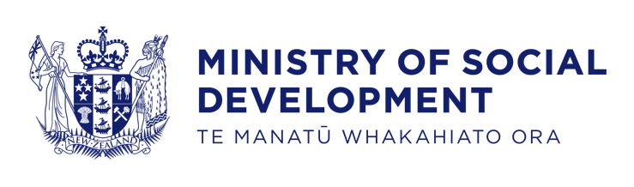

Briefing to the Incoming Minister
Disability Issues
2020

24% (1.1m) of New Zealanders are disabled [2013 Census].
The Minister for Disability Issues leads and advises across government on behalf of disabled New Zealanders, to ensure government services and policy consider their needs and interests. Promising progress is seen in employment and wellbeing but there is still much to do.

The following data is from the Household Labour Force Survey, June 2020

Among disabled people aged 18-64:
- 23% reported not having enough money to meet every-day needs
(7% for non-disabled people)
- 30% experienced discrimination within the last 12 months
(19% for non-disabled people)
- 16% reported having a house/flat with a major problem with heating
(6% for non-disabled people)
- 39% of disabled people aged 18+ have no qualification (16% for non-disabled people)
- 65% of disabled people aged 18+ held trust in the health system (a rating of 7 and above), up from 55% in 2018
- Only 23% of disabled 15+ year-olds are employed, with 22% being underutilised
(70% for non-disabled people employed, 12% underutilised)
- 46% of disabled people aged 18+ reported having poor overall mental wellbeing
(7% for non-disabled people)

Contents
Contents 3
Welcome to the Disability Issues portfolio 1
Appropriation responsibilities 1
The Office for Disability Issues reports to and supports your role as Minister for Disability Issues 1
Disability, Seniors and International Policy team 2
You have key roles and responsibilities 3
The United Nations Convention on the Rights of Persons with Disabilities 4
The New Zealand Disability Strategy 2016-2026 5
The Disability Action Plan 2019-2023 6
New Zealand Sign Language (NZSL) 8
Moving towards a non-disabling society is important 11
Significant opportunities to progress the rights and opportunities for disabled people 11
How are disabled people in New Zealand doing? 13
Disabled New Zealanders are not a homogenous group 15
Disability rates are higher for Māori 16
Pacific people are also more likely to experience disability 16
Matters that require your early attention 17
We would like to discuss these key matters with you: 17
Other activities you may wish to undertake include: 17
The impact of growing demand for ODI advice 18
Shifting the paradigm/settings 18
Appendix 1 – ODI’s current work programme 19
Appendix 2 - Key contacts for the Office for Disability Issues 20
Appendix 3 - DPO Coalition Briefing to the Incoming Minister 21
Appendix 4 - NZSL Board Briefing to the Incoming Minister 24
Appendix 5 – Key disability-related stakeholders 25

Welcome to the Disability Issues portfolio
The Office for Disability Issues, Te Tarī Mō Ngā Take Hauātanga, (ODI) looks forward to working with you and discussing the most effective ways we can support you and your priorities as Minister.
This briefing provides you with initial information on:
- your role and responsibilities as the Minister responsible for disability issues
- the disparity in outcomes experienced by disabled people in New Zealand
- the key decisions and matters requiring your attention, including the future direction of the portfolio.
It also introduces you to ODI and key stakeholders.

Appropriation responsibilities
You are the appropriation Minister for the departmental appropriation Promoting Positive Outcomes for Disabilities within Vote Social Development.
This is the appropriation for providing services to promote and monitor the implementation of the New Zealand Disability Strategy 2016-2026 and the New Zealand Sign Language Strategy 2018-2023, to monitor and implement the UNCRPD, and to provide information and advice to Ministers and other agencies on disability matters.
For 2019/2020, the appropriation’s $7.198 million provided baseline funding:
- the work of ODI
- supporting the work of the DPO Coalition and the NZSL Board
- monitoring, led by disabled people, of disabled people’s rights
- initiatives and contracts supported by the NZSL Fund ($2,068,824).

The Office for Disability Issues reports to and supports your role as Minister for Disability Issues
Since 2002, ODI has supported the Minister for Disability Issues. The ODI team of 13.6 FTE is led by a Director and is based in the Disability, Seniors and International Policy team in the Ministry of Social Development (MSD). The ODI team does not have a service provision role or fund services for disabled people.
We act as a focal point in government on disability issues. We support implementation in New Zealand of the United Nations Convention on the Rights of Persons with Disabilities (UNCRPD) and the New Zealand Disability Strategy and work towards a vision of New Zealand as a non-disabling society, where disabled people have an equal opportunity to achieve their goals and aspirations.
In addition to serving the Minister for Disability Issues, ODI is an advisor to the public and across government on disability issues. We work closely with the disability community and seek to amplify the voice of disabled people within government. We have been active in influencing other agencies and bringing attention to issues that affect disabled people and their communities.
The core priorities of ODI’s current work programme, including cross-agency contributions, are outlined in Appendix 1. We look forward to discussing these with you. Appendix 2 provides a list of key contacts for ODI.

Disability, Seniors and International Policy team
The Disability, Seniors and International Policy team is responsible for disability-focused policy development and advice within MSD and cross-government disability work programmes, such as actions under the Disability Action Plan, that you have Ministerial responsibility for.
MSD’s Disability, Seniors and International Policy team also has responsibility for the Enabling Good Lives demonstration in the Waikato. Enabling good lives is an approach to supporting disabled people that offers greater choice and control over the support they receive.
While the team is accountable to the Minister for Social Development, with agreement from the Minister of Social Development they can also support your portfolio and provide you with policy advice, on key issues.

You have key roles and responsibilities
Your primary role as Minister for Disability Issues is to lead and advocate for the rights of, and opportunities for, disabled people across all Government portfolios.
There are important mechanisms in place or under development that progress the rights and opportunities for disabled people. These include the Disability Strategy 2016-2026 and Disability Action Plan 2019-2023, the systematic and ongoing engagement of disabled people through their representative organisations, and policy work on accessibility.
While progress for disabled people as a population group is achieved across all Government portfolios, the four key portfolios for you to remain close to are those for the agencies through which the majority of services and supports for disabled people (including children and young people) and their family/whānau are funded:
- the Ministry of Health (Disability Directorate)
- the Ministry of Education
- the Ministry of Social Development
- the Accident Compensation Commission.
There have been recent significant budget increases across these agencies for these services and supports.
The following agencies also have a significant impact on the lives of disabled people:
- the Ministry of Transport
- the Ministry for Business, Innovation and Employment
- Kāinga Ora
- the Ministry for Housing and Urban Development
- Statistics NZ
- the Ministry of Culture and Heritage
- the Ministry for Justice
- Oranga Tamariki.
Outside of government, you work closely with the disability community, including through the DPO Coalition. The DPO Coalition is a group of national membership-led organisations established to give effect to Article 4.3 and Article 33.3 of the UNCRPD. These articles oblige State Parties to “closely consult with and actively involve persons with disabilities, including children with disabilities and their representative organisations”.
The DPO Coalition brings considerable experience in representing the views and aspirations of disabled people. Disability service providers also provide valuable insights into disability issues. They welcome opportunities to engage with you.
The DPO Coalition has provided a contribution to this briefing at Appendix 3 for your consideration. This reflects the increasing government agency use in recent years of co-design for disability-related policy. Co-design approaches are leading to improvements in:
- choice and control for disabled people
- reasonable accommodations in employment relationships
- clarifying expectations around inclusive education
- elimination of seclusion and restraint.
Our Te Tiriti o Waitangi obligations require you to closely consult and engage with Māori. This obligation sits alongside consultation and engagement with the wider disability community, including disabled youth, Pacific peoples, families, and whānau.
You have direct responsibility for, and have stewardship over, the following:
- the New Zealand Disability Strategy 2016-2026 (Disability Strategy)
- the Disability Action Plan 2019-2023 (Disability Action Plan)
- the New Zealand Sign Language Act 2006 (NZSL Act)
- the New Zealand Sign Language Strategy 2018-2023 (NZSL Strategy).
Hard copies of these will be provided to you.
Figure 1 (below) illustrates the relationship between the UNCRPD, the Disability Strategy, and the Disability Action Plan.

The United Nations Convention on the Rights of Persons with Disabilities
You lead the co-ordination of the New Zealand Government reporting on our progress with giving effect to the UNCRPD.
The UNCRPD was adopted by the United Nations in 2006 and ratified by the New Zealand Government in 2008. The UNCRPD human rights approach affirms the need for State Parties’ progressive realisation of equal rights and better life outcomes for disabled people.
The UNCRPD consists of 50 articles which focus on specific areas of life, including the rights to education, having a family, emergency responsiveness, choosing where you live, non-discrimination and decision-making.
The UNCRPD gives no extra rights to disabled people than are already given across other conventions, declarations, and human rights mechanisms, but promotes that more needs to be done for disabled people to achieve the same rights as non-disabled people.
The UNCRPD recognises the right of disabled people to make free and informed decisions about their own lives. It emphasises ‘reasonable accommodation’ [making appropriate changes or modifications to ensure disabled people have equal opportunities and rights], and it promotes universal design [designing products, environments, programmes and services so everyone can use them].
New Zealand adopted the Optional Protocol to the UNCRPD in 2016. This additional agreement to the UNCRPD establishes an individual complaints mechanism for disabled people who allege that their rights under the UNCRPD have been denied.
Regular reporting on progress includes your reports on behalf of the New Zealand Government, as well as from the Independent Monitoring Mechanism (IMM), on behalf of civil society, and others.
The New Zealand Government submitted its latest report to the United Nations in March 2019. The United Nations Committee’s periodic review of New Zealand’s implementation of the Convention was planned for 2019 but was significantly delayed, in part due to COVID-19, and has yet to be re-scheduled.

The New Zealand Disability Strategy 2016-2026
New Zealand has had an overarching disability strategy since 2001. New Zealand ratified the 2006 UNCRPD in 2008 and remains committed to its progressive realisation.
The New Zealand Disability Strategy2016-2026 was developed in close consultation with the disability community with a vision of New Zealand being a non-disabling society – a place where disabled people have an equal opportunity to achieve their goals and aspirations, and all New Zealanders work together to make this happen.
The three principles underpinning the Disability Strategy are based on Te Tiriti o Waitangi, the UNCRPD, and ensuring disabled people are involved in decision-making that impacts them. The two approaches to implementing the Disability Strategy are:
- investing in disabled people’s whole lives (a long-term approach)
- investing in specific and mainstream services (a twin-track approach).
Figure 1 also illustrates the eight interconnected Disability Strategy outcome areas that will contribute to achieving the vision.
For each of the eight areas, outcome indicators have been developed to track impacts. Measures for the indicators are under development. Gaps remain in the data available.

The Disability Action Plan 2019-2023
The Disability Action Plan 2019-23 coordinates contributions across government agencies. The Plan was developed in consultation with disabled people in 2018/2019, agreed by Cabinet, and launched by the Minister for Disability Issues in November 2019. It is the primary vehicle for implementing the Disability Strategy.
As part of this work officials from the Office for Disability Issues and from other government agencies worked with the DPO Coalition to agree a package of 29 cross-government work programmes and two cross cutting issues to be progressed over the three years to 2023. This package is intended to create a significant shift in the lives of disabled people.
Government agencies are expected to provide six-monthly reports on the progress being achieved in the work programmes. Some agencies have multiple programmes.
Of the 40 government agencies, 39 have also committed to the Accessibility Charter 2019.
The Disability Action Plan is not static. Additional work programmes can be added as agencies see fit. New work programmes you may wish to consider include:
- digital inclusion
- flexibility of service provision
- Oranga Tamariki’s work on development of disability advocates
- a disabled people’s focus in the Joint Venture work on Family Violence and Sexual Violence
- a disability youth leadership initiative
- growing disability leadership capability and capacity within the disability sector and across all sectors of society.

Figure 1: The relationship between the UNCRPD, the Disability Strategy 2016-2026 and the Disability Action Plan 2019-2023.
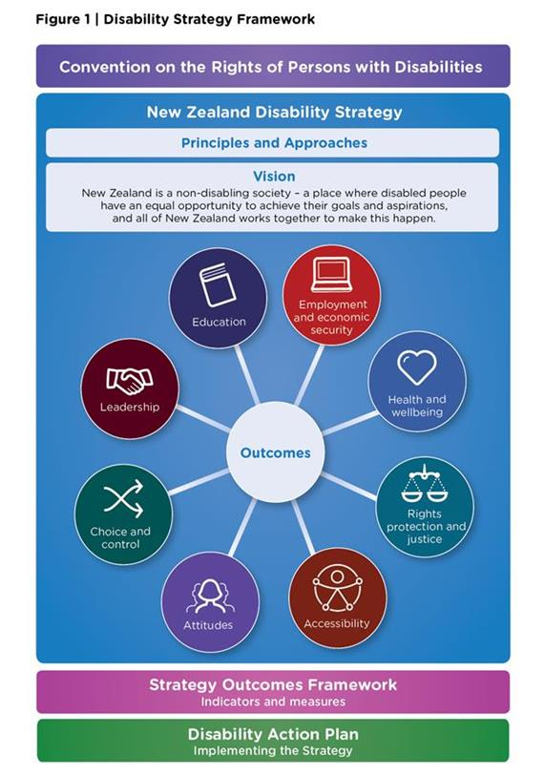

New Zealand Sign Language (NZSL)
NZSL is the language of the Deaf community, and for many Deaf people it is their first language. Like other languages, NZSL is integral to Deaf culture, wellbeing, and identity.
Census 2018 results show that 22,986 people can use NZSL, which is 0.5 percent of the New Zealand population. NZSL is considered a threatened language.

The NZSL Act
New Zealand legally recognises NZSL through the NZSL Act 2006. The Act is administered by MSD through ODI. The NZSL Act:
- recognises NZSL as an official language of New Zealand
- gives a person who uses NZSL the right to use NZSL in legal proceedings
- enables the making of regulation setting competency standards for the interpretation of legal proceedings in NZSL
- states principles to guide government departments on matters relating to NZSL.
The NZSL Board proposed a review of the NZSL Act 2006 in their April 2019 annual report to the Minister for Disability Issues. Phase 1 of this review was completed on the 5 October 2020 and a report on Phase 2 is due by 4 Dec 2020.

The NZSL Strategy
The NZSL Strategy is intended to guide the work of government agencies and Crown entities to maintain and promote the use of NZSL by Deaf people and other NZSL users. It consists of the following five planning priorities:
- Acquisition (the learning of NZSL by children and adults)
- Use/Access (the ability to use NZSL in all domains of society, including within whānau)
- Attitude (the beliefs and opinions of NZSL users and others towards the language)
- Documentation (the systematic recording of NZSL’s use for research and reference)
- Status (how NZSL is regarded by its users and others).
Figure 2 illustrates the relationship between the NZSL Act, the NZSL Strategy, the NZSL Board, and Secretariat.

The NZSL Board and Secretariat
In 2014, Cabinet established the NZSL Board as an independent advisory committee. The Office for Disability Issues provides the Secretariat and programme office for the Board. The Secretariat commissions, monitors, and reports on work programmes initiated by the Board. The Board’s purpose is to:
- promote and maintain the use of NZSL by ensuring the development, preservation, and acquisition of the language
- ensure the rights of Deaf people and NZSL users to use NZSL as outlined in the NZSL Act 2006
- provide expert advice to government and the community on NZSL.
The NZSL Board funds community activities and ongoing activities and projects through the NZSL Fund, a fund of $1.645m for promoting NZSL. Ongoing activities and projects supported from the NZSL Fund include NZSL week, the maintenance of the NZSL Dictionary, and multi-year programmes such as a Māori Deaf Development project.
You are responsible for approving the policy and criteria for the NZSL Fund.
The NZSL Board has provided a contribution to this briefing in Appendix 4, for your consideration.
NZSL Board appointments
The NZSL Board has up to 10 members, all of whom are NZSL users, and most members are Deaf NZSL users.
You are responsible for making appointments to the NZSL Board. These are confirmed by the Cabinet Appointments and Honors Committee. The current membership of the Board is included in Appendix 4.
One Board membership is currently vacant as the DPO nominee has yet to be identified by Deaf Aotearoa New Zealand. You will be consulted on the appointment. Two anticipated vacancies for regular membership are also expected to require appointment in 2021. We will engage with you ahead of these appointments.
The work of the Secretariat team has changed over time
In response to a significant shift in the NZSL Board work programme to strategically commissioning work, rather than focusing only on allocation of the NZSL Fund, we have extended our original role as Secretariat to become more of a programme office.

Figure 2: The relationship between the NZSL Act 2006, the NZSL Strategy 2018-2023, the NZSL Board and its Secretariat
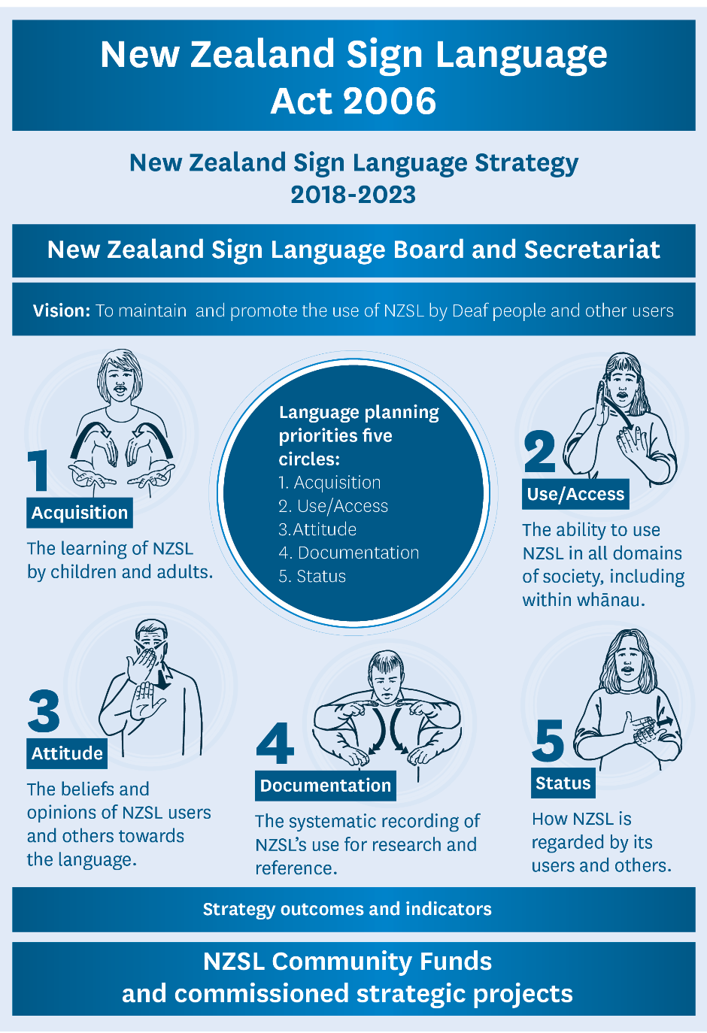

Moving towards a non-disabling society is important
People with impairments are disabled by barriers in society. If the barriers are removed people with impairments can enjoy life and contribute, just as others do.
The vision of the New Zealand Disability Strategy is:
“New Zealand is a non-disabling society - a place where disabled people have an equal opportunity to achieve their goals and aspirations, and all of New Zealand works together to make this happen.”
New Zealand Disability Strategy 2016-2026
Moving towards a ‘non-disabling society’ is about removing the barriers in society that disable people with impairments. The New Zealand Disability Strategy uses this term rather than ‘enabling’, as ‘non-disabling’ recognises the need to completely remove barriers rather than expecting disabled people to navigate around them.
Impairments can occur at any age and can be permanent or temporary. People may have or develop impairments from birth, injury, aging, or a health condition.
Disabled New Zealanders and their families want life-opportunities equivalent to others. Just like everyone else, they want to enjoy our country, make their contribution, be employed, feel they belong in their community, have fun, be safe, and access support to make choices over their life.
However, many disabled people face reduced opportunities and this experience of poorer life outcomes has persisted over time.
Disabled New Zealanders have poorer life outcomes compared with non-disabled people. Data from Statistics NZ surveys and the census consistently show disabled people have lower rates of employment, experience poorer educational outcomes, face higher health risks, live in poorer areas, and are over-represented in low-income groups.

Significant opportunities to progress the rights and opportunities for disabled people
Disabled people and representatives from the disability sector are also keen to engage with you. Appendix 5 provides a list of disability sector and wider community stakeholders that you are likely to have relationships with. We can facilitate introductions when you are ready to meet with them.
While the Disabled People’s Organisations (DPO) Coalition reports that “significant progress has been made” across a wide range of difficult issues [see Appendix 3], it also reports that there is more work to do to achieve equity with other New Zealanders.
There is opportunity to consider whether new machinery of government or institutional arrangements are needed across government to progress the rights and opportunities of disabled people.
There are substantial disability-focused policy programmes underway across government. ODI, MSD Disability Policy and the Ministry of Health, as well as the disability sector, as represented by the Enabling Good Lives National Advisory Group, believe these key government work programmes creating a need to consider whether current institutional arrangements are optimal for progressing the outcomes intended for disabled people. There are three major policy work programmes, being led out of the Department of Prime Minister and Cabinet, the Ministry of Health and the Ministry for Social Development that create the opportunity to consider whether the current institutional or machinery of government arrangements are fit for purpose. These are significant work programme that will impact the lives of disabled people.
- The Department of Prime Minister and Cabinet has responsibility for responding to the recommendations of the Health and Disability System Review Report. The disability community sees the Report as a hugely important opportunity to improve the disability support system and to devolve it from Health. The disability community seeks equity of access to, and outcomes from, the health system, and close and meaningful engagement of disabled people in the development of the Government’s response to the report.
- In particular, the disability community is raising questions as to whether disability funding administered by the Disability Directorate of the Ministry of Health should remain in the Ministry of Health. There is long-held disquiet in the disability community with disability support funding remaining in the health system because of its medical model legacy.
- The Ministry of Health (with MSD Policy) will be providing a paper to Cabinet on the future of the Mana Whaikaha prototype being implemented in Mid Central DHB and the Enabling Good Lives demonstration projects in Waikato and Christchurch. At the heart of these initiatives is disabled people, and their families and whanau, having greater choice and control in their lives. The key principles and elements of this work are that the approaches support:
- self-determination by disabled people, with the system investing early
- being mana enhancing, person-centred and easy to use
- disabled people being able to live an everyday life like others at similar stages
- access to mainstream services
- building and strengthening relationships between disabled people, their whānau and families and the community.
- In June 2020, the Minister for Disability Issues gained Cabinet commitment to further policy work on a new legislative framework to accelerate progress on accessibility in New Zealand. This work is an action under the Disability Action Plan that MSD has responsibility for. While the work has a focus on disabled people, improved accessibility will also bring benefits to others including Māori, older people, and carers.
- MSD is working in partnership with the Access Alliance to progress this work and final Cabinet decisions on a proposal for a new legislative framework are expected in May 2021. There is cross-party support for this work through the Parliamentary Champions for Accessibility Legislation (PCAL).
- The secondary BIM on accessibility provides more detail on the accessibility work.

How are disabled people in New Zealand doing?
There is a lack of timely, reliable and accessible administrative data collected about disabled New Zealanders. This is a barrier to effective policy and service development and to measuring and reporting on the progress for disabled people.
In the interim, the New Zealand Disability Survey (2013) is still relied on as a source of comprehensive data on the lives of disabled people and estimates of the number of disabled people in Aotearoa. The Disability Survey will run again in 2023, following the 2022 census.
Most agencies do not systematically collect administrative data on the reach of their services and policies for disabled people or on the impact for disabled people.
The data currently available, such as census data and other Statistics NZ and agency surveys, is important but insufficient for reporting progress against the outcomes and indicators in the New Zealand Disability Strategy 2016-2026. The development of disability data to better inform policy and services for all people remains a priority issue.
The data that is available and represented in Figure 3 shows the disparity in life outcomes between disabled people and non-disabled people. Your role, with ministerial colleagues, is crucial to improving outcomes for disabled people.

Figure 3: Disparity in life outcomes between disabled and non-disabled people
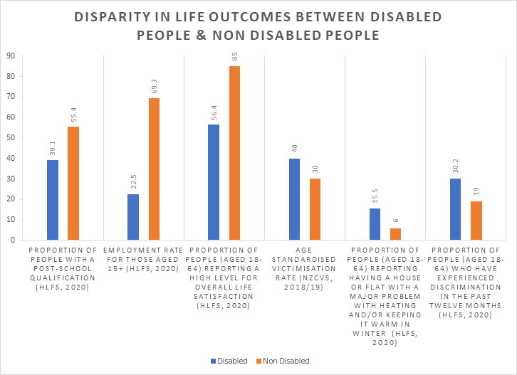

COVID-19 shone a light on many good things in the disability sector and highlighted that some things still need to be done. There is an opportunity to build on responses to concerns about the impacts of COVID-19 on disabled people through enhancements to the Disability Action Plan work programmes.
Online platforms and digital services provided opportunities for some disabled people, and increased barriers for others.
The positives noted in ODI surveys and through anecdotal feedback included:
- increased flexibility of services, and community-based support
- having more time with family and less time with inaccessible transport
- designated supermarket shopping times and more access to the Total Mobility scheme, funded by the New Zealand Transport Agency.
The difficulties and challenges noted focused on:
- the accessibility of COVID-19 communications and information
- access to PPE, particularly for services provided in a person’s home
- increased reliance on others for shopping and community access
- increased fear of exposure for those with elevated risk levels
- mask wearing and the process to establish exemptions when required.

Disabled New Zealanders are not a homogenous group
There are many ways in which a disabled person may identify as disabled, and there are different ways in which people may experience disability. Many disabled people experience multiple forms of disability.
The New Zealand Disability Strategy explains that disability is something that happens when people with impairments face barriers in society. It is society that disables people, not people’s impairments.
The disability community is a priority population to be considered in policy and service development alongside other priority population groups, such as Māori, Pacific peoples, children, seniors, women, people who are gender diverse, veterans, rural communities and ethnic communities.
In the 2013 New Zealand Disability Survey, 1.1 million New Zealanders (24 percent of New Zealand’s population) identified as being disabled, meaning they identified that they have some form of long-lasting impairment.
Every person is unique, and even if a person has the same impairment as someone else, that person may experience different opportunities and barriers because of where they live and how they are treated by people around them. The time and context in a disabled person’s life when they may acquire their impairment(s) also informs what barriers or opportunities they may experience. This social model (as opposed to a medical model) of disability is embodied in the UNCRPD. It promotes a human rights perspective being consistently applied and sees progress being achieved through policies and services that are designed to work for all.
Some disabled people face compounded issues and discrimination with intersecting forms of discrimination and disadvantage, as other identity factors can also impact their experience. These factors include gender, ethnicity, socioeconomic status, sexual orientation, age, family responsibilities, and where they live. A disabled woman living rurally, for instance, may face three forms of discrimination.
As our population ages, the proportion of disabled New Zealanders is increasing. Disabled people are living for longer and more people have age-related impairments. Of all people aged 65 and over, 59 percent are disabled.
It is important to note that the impact of acquired impairments for those aged 65 and over can be less than for others as they have had time and economic resources to make adaptations relating to their impairments as they got older.

Disability rates are higher for Māori
The 2013 Disability Survey shows that Māori have higher-than-average disability rates and that tāngata whaikaha (Māori disabled) have poorer life outcomes compared with other Māori. This is despite the younger age profile for Māori meaning they are less likely to be in the older age groups where disability is more common. The disability rate among Māori is 26 percent, compared with 24 percent for all New Zealanders. When the younger age profile of the Māori population is considered, proportionally the Māori disability rate is much higher at 32 percent. Māori children under 15 years have a disability rate of 15 percent, compared to nine percent for non-Māori children.
Higher rates of impairment among Māori contribute to poorer socio-economic outcomes. Māori also have higher rates of moderate impairment related to environmental factors such as ill health, poor housing quality, or injury from more risky occupations. Other common factors for tāngata whaikaha include low income, and discrimination.
This highlights the need for a greater focus on Māori disabled. As Minister for Disability Issues, you have an opportunity to encourage all agencies to collect rigorous data and to include a focus on tāngata whaikaha in all initiatives targeting disabled people.

Pacific people are also more likely to experience disability
There is limited information about Pacific people’s experience of disability and few reliable sources of data. The 2013 Disability Survey found a disability rate for Pacific people of 19 percent. This figure is unusually low and may indicate underreporting.
A lower rate of reporting could also reflect differences in cultural beliefs related to disability. For instance, in the disabled people-led 2015 monitoring report, “Disability rights in Aotearoa New Zealand: Acceptance in Society”, disabled research participants from cultural minorities spoke about not always feeling accepted by their communities. This suggests they may be less likely to self-identify.

Matters that require your early attention

We would like to discuss these key matters with you:
- Drafting of your annual report to Parliament on the disability issues portfolio. This needs to be tabled in Parliament in mid-December 2020.
- Section 9(2)(f)(iv) of the Official Information Act
- Any wider disability-related decisions that Government may consider, and any opportunities and issues you would like ODI to prioritise.
- The Accelerating Accessibility programme has been the responsibility of the previous Minister for Disability Issues. It will be important to confirm that this work programme, which is of potential significant benefit for disabled people and others, remains in the Disability portfolio.

Other activities you may wish to undertake include:
- engaging with key stakeholders to establish or strengthen relationships, or to drive work programme priorities (we can provide you with advice on this)
- Section 9(2)(f)(iv) of the Official Information Act
- convening the Ministerial Leadership Group on Disability Issues meeting on 9 December 2020, bringing together key Ministers to meet with the IMM. You may also consider a process for government officials to meet the IMM in early 2021
- Section 9(2)(f)(iv) of the Official Information Act
- Section 9(2)(f)(iv) of the Official Information Act
- participating in the election of members to the United Nations Committee on the Rights of Persons with Disabilities in New York City in December 2020; deferred from June 2021 due to COVID 19. The elections may occur virtually rather than in person, or the current membership may be extended into 2021.

The impact of growing demand for ODI advice
The ODI team has experienced a significant increase in demand for expertise and advice across government on disability matters, and we must carefully prioritise our project commitments and contributions, beyond providing advice, across the public sector. The Department of the Prime Minister and Cabinet also now requires all policy cabinet papers to consider disability issues.

Shifting the paradigm/settings
There is an expectation that disabled people should increasingly lead and provide stewardship for disability services. They seek choice and control by disabled people for disabled people to inform the direction of travel for disability policy and services.

Appendix 1 – ODI’s current work programme
You have ministerial direction over the ODI work programme. We look forward to discussing the current core priorities and focus areas with you.
Servicing the Minister for Disability Issues and government
- Leading cross-government reporting on the UNCRPD and supporting Sir Robert Martin’s re-election to the UNCRPD Committee.
- Overseeing implementation and reporting on the New Zealand Disability Strategy through the Disability Action Plan.
Supporting cross-government progress on disability issues
- Amplifying the voice of disabled people within government through the sharing of data, the promotion of effective engagement, and the provision of feedback, particularly on work programme progress and Cabinet papers.
- Providing secretariat support for the Ministerial Leadership Group on Disability Issues, Chief Executives Group on Disability Issues, Disability Data and Evidence Working Group, NZSL Board and other groups.
- Providing advice to our Chief Executive, and secretariat support to the Chief Executives Group on Disability Issues.
- Responding to requests from agencies on policy work and participating in advisory groups, including the Caring for Communities programme within the COVID-19 All-of-Government Response Group.
- Supporting local authorities to accelerate progress on their accessibility policies and work programmes.
- Maintaining a disability nominations database connecting disabled candidates to state-sector governance boards.
Providing sector leadership
- Providing secretariat support for the NZSL Board.
- Preparing communications, media releases, speeches, social media posts, newsletters and stakeholder engagement.
- Managing contracts and supporting the DPO Coalition and agency engagement - giving voice to disabled people and raising the profile of disability issues, including delivery for tangata whaikaha, Māori disabled people.
- Planning for the 2021 International Disability Leadership Initiative conference.
- Hosting international delegations wanting to learn about how New Zealand progresses disability issues.
- Supporting i.Lead, a national disabled youth network providing advice to government agencies.

Appendix 2 - Key contacts for the Office for Disability Issues

Office for Disability Issues
Brian Coffey, Director
Section 9(2)(a) of the Official Information Act
Section 9(2)(a) of the Official Information Act, Manager
Section 9(2)(a) of the Official Information Act

MSD Policy
Julia Bergman, General Manager, Disability Seniors and International Policy
Section 9(2)(a) of the Official Information Act
Section 9(2)(a) of the Official Information Act, Manager, Disability Policy
Section 9(2)(a) of the Official Information Act

Appendix 3 - DPO Coalition Briefing to the Incoming Minister
August 2020
DPO Coalition
by email: us-dpo@groups.io

Dear Minister,
The Disabled People’s Organisations (DPO) Coalition is the agency for direct access to the collective and informed voice of disabled people for input and advice into Government policy and decision-making. The focus of the DPO Coalition is full achievement of disability rights in Aotearoa New Zealand. It is not about prioritising the rights, it's about setting plans and timeframes to achieve them. Including the voice of disabled people is crucial in ensuring that advice to Government is informed by the people for whom it has the most impact. Our seven member organisations are all led by disabled people. We strongly adhere to the principle of 'nothing about us, without us'.
The DPO Coalition is ready to work with you to continue New Zealand’s progress on disability rights to meet its obligations under the United Nations Convention on the Rights of Persons with Disabilities (UNCRPD).
Our partnership with Government is required by Article 4.3 of the UNCRPD. We also provide independent Disabled People Led Monitoring under Article 33.
Maintaining relationships – the DPO Coalition has worked well with successive governments through strong partnership relationships with Ministers and across government agencies. We are proud of the significant progress achieved during the last parliamentary term including: the NZ Disability Strategy; Disability Action Plan 2019-23 covering all government agencies; Accessibility Charter signed by 39 of the 40 government agencies. Government has delivered progress across a wide range of difficult issues. Momentum needs to be maintained. The United Nations General Comment #7 provides a useful guide.
Choice and control – significant progress has been made over the last several years in advancing choice and control for disabled people in their disability supports and services through the Enabling Good Lives principles and its demonstration pilots, including the Mana Whaikaha prototype. Another Disability Action Plan work programme has been looking at the machinery of government for disability supports and services. Together the DPO Coalition and Government can design a disability support system that ensures the human rights, self-determination and dignity of disabled people.
Supported decision-making – this is a key enabler of choice and control. Good work has been done, and this needs to be taken up across Government and promoted throughout New Zealand society.
Health and Wellbeing – our work across government agencies has highlighted the importance of coordination to deliver value for disabled people. The COVID-19 response has reinforced this, and we have an opportunity to accentuate coordination going forward. The DPO Coalition believes that now is the right time to move to a Disability agency to coordinate all government services for disabled people. Unfortunately, the Health and Disability System Review has not engaged well with disabled people and has missed the opportunity to explore this. The DPO Coalition has raised serious concerns that the Review’s recommendations are inconsistent with the Government’s obligations under the UNCRPD and undermine the progress being made on choice and control. It further risks re-medicalising disability as a health issue and undoing many years of hard-won work to have disability seen as a human rights issue and not a health or medical issue. The disability sector continues to call for a nationally consistent and coordinated disability support system separate from the health system. The Review’s recommendations need to be reconsidered with respect to disabled people.
Housing – our Disabled People Led Monitoring Report Housing in New Zealand – My Experiences, My Rights provides evidence on disabled people’s experiences with housing and proposes a way forward. It is critical that Government considers this report and shows leadership through policy change, housing standards, and its investment in public housing.
Employment – it is positive to see Government showing leadership in employment of disabled people. Reasonable accommodations are becoming part of the employment relationship rather than being seen as additional. Much more needs to be done to achieve equal opportunity across all employers. Awareness raising, education, training and support will be required.
Transport – many disabled people rely on access to public transport and footpaths in order to participate in society. Challenges remain in balancing access for disabled people with other users of the transport system (such as e-scooters). The DPO Coalition has good engagement with the Transport agencies and this needs to continue.
Education – inclusive education has been a legal requirement in New Zealand since 1989 but has not been achieved. The DPO Coalition has released a definition of Inclusive Education and this needs to be fully reflected in the future direction for education. There has been good engagement with the Ministry and with the various education reviews.
Mental Health – the recommendations of He Ara Oranga need to be implemented including the repeal and replacement of the Mental Health Act and elimination of seclusion and restraint. Progress has been made, but there is much more to do.
Justice – disabled people’s experience of the justice system is poor due to lack of awareness and training. There are many examples where issues could have been avoided. Work to improve the ‘journey through justice’ has been very slow and focus is needed to address this.
Taxation – there is opportunity to improve how the tax system contributes to the all-of-government work on disability rights. There has been limited attention to this in the past and there are some significant anomalies. The DPO Coalition wants to address these issues to improve the lives of disabled people.
Accessibility Legislation – work on Accessibility Legislation needs to continue so that New Zealand can ensure that all legislation is consistent with and upholds disability rights.
Information – data and evidence are enablers of all government activity on disability rights. Disability data is recognised as poor and useful work has begun to address this. Failures in the 2018 Census have compounded the problem however. Data and evidence need to remain a core focus of the Government.
Access to Parliament – Parliament should be an exemplar in access for disabled people in all respects including: information; the precinct, engagement with parliamentary processes; and archives. Progress has been slow and there is opportunity for the incoming Government to commit to addressing this.
Advocacy – the DPO Coalition and its member DPOs advocate for disabled people. The United Nations expects Governments to support their DPOs and ensure that they are sustainably resourced. While there has been short-term Government funding for the DPO Coalition, medium-term sustainability has not been addressed and member DPOs also remain financially fragile. A medium to long term financial commitment from Government is required to enable the voice of disabled people to be sustainable and to deliver maximum value.
Thank you for receiving our advice. We look forward to meeting with you.

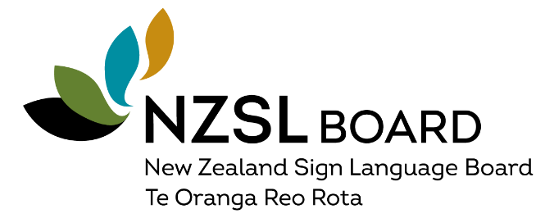

Appendix 4 - NZSL Board Briefing to the Incoming Minister
August 2020
Who are we
The New Zealand Sign Language Board was established in 2015 as a Government Advisory Board to provide monitoring, leadership, advice and co-ordination on the maintenance and promotion of NZSL. Current membership of the NZSL Board is: Rhian Yates (Chair), Catherine Greenwood (Deputy Chair), David Brown, Natasha Cloete, Angela Sew Hoy, Haamiora Sam TeMaari and Rachel Turner.
Our role
We are the caretakers of the NZSL Strategy (2018-2023), adopted by Government in September 2018. The Strategy is based on international language planning principles, identifying priorities to maintian and promote NZSL as a vulnerable language.
Data gathering and regular reporting are essential for monitoring progress against the Strategies priorities: Acquisition, Use/Access, Attitude, Documentation, Status. Draft indicators will be discussed by the end of 2020 with key Government agencies who have the largest potential to promote and maintain NZSL. These are the Ministry of Education, Ministry of Justice, Ministry of Health and Ministry for Social Development.
What’s important to us
The NZSL Board priorities that involve working with Government agencies, include:
- Access to education in NZSL and opportunties for Deaf children to learn and use NZSL with their peers.
- Access to Te Ao Māori for Māori Deaf to engage as Tangata Whenua alongside their whanaū, hapu and iwi.
- Determing the effectiveness of the NZSL Act 2006 to maintain and promote NZSL. Idenfiying ways to align the Act with the Strategy could enhance the daily experiences of NZSL users, while increasing recognition of the language and increased accessbility to public sector information.
We would appreciate your support to help us progress these priorities, especially with the Ministry of Education and Te Puni Kōkiri (Ministry for Māori Development).

Appendix 5 – Key disability-related stakeholders
The Independent Monitoring Mechanism: The IMM was established in accordance with Article 33 of the UNCRPD, which requires governments to establish an independent mechanism to promote, protect and monitor the implementation of the UNCRPD. The IMM consists of the DPO Coalition, the Office of the Ombudsman and the Human Rights Commission.
Human Rights Commission: In 2017, Paula Tesoriero was appointed as the first dedicated Disability Rights Commissioner under the Human Rights Act 1993 and was reappointed in 31 July 2020 for five years.
Office of the Ombudsman: Peter Boshier, Chief Ombudsman.
Office of the Health and Disability Commissioner: Kevin Allan, Mental Health Commissioner and Rose Wall, Deputy Commissioner Disability.
Parliamentary Champions for Accessibility Legislation: PCAL is a cross-party group of Parliamentarians committed to ensuring New Zealand has accessibility legislation that is fit for purpose.
DPO Coalition: Article 4(3) of the UNCRPD promotes active involvement by government agencies with representative organisations of disabled people which are governed by disabled people. These are the Association of Blind Citizens New Zealand, Balance Aotearoa, Deaf Aotearoa, Disabled Persons Assembly NZ, Kāpo Māori Aotearoa, Muscular Dystrophy Association on New Zealand Inc and People First New Zealand Ngā Tāngata Tuatahi. The DPO Coalition is a key point of contact.
Key disability sector organisations: Access Alliance, Arts Access Aotearoa, Auckland Disability Law, Autism New Zealand, Barrier Free Trust, Be. Institute, Blind and Low Vision NZ, CCS Disability Action, Christchurch Earthquake Disability Leadership Group, Complex Care Group, IHC Advocacy, i.Lead Committee, Inclusive NZ, Hearing New Zealand, Lifemark, National Foundation for the Deaf, NZ Disability Support Network, Yes Disability Resource Centre. Engagement with the many other service providers and advocacy groups can be considered on a case-by-case basis.
Transformation of the disability support system: This is led by the National Co-design Group within the Ministry of Health, the National Enabling Good Lives Leadership Group, and the Mid-Central Leadership Group.
NZSL Board (see Appendix 2)

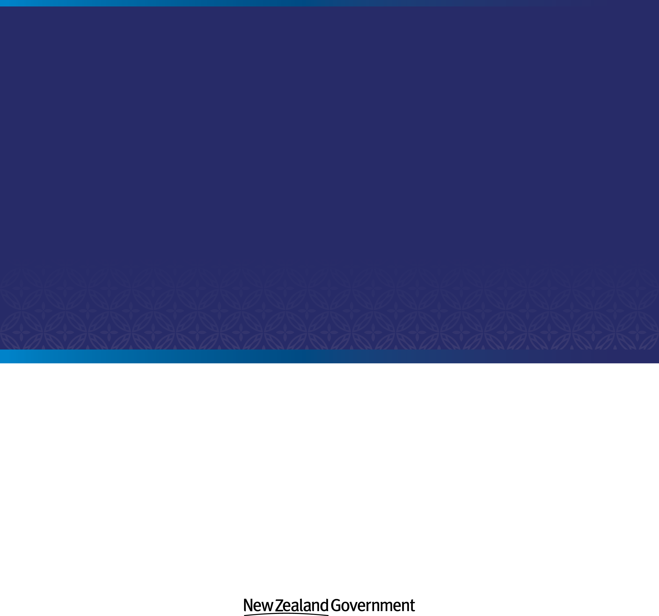

A list of member organisations is provided in Appendix 5.
The IMM comprises the Office of the Ombudsman, the Human Rights Commission and Disabled Peoples Organisations (DPO) Coalition – see Stakeholder section for more information.
This is accurate at the time of writing. This number may change as new programmes are added or programmes are combined.
Health and Disability System Review Report https://systemreview.health.govt.nz/
As noted in the 2020 IMM Report to the United Nations, and identified as a priority in the Disability Action Plan 2019 to 2023.
Data is from the 2020 Household Labour Force Survey except for Victimisation which is from the 2018/19 New Zealand Crime and Victim Survey.
New Zealand Disability Survey 2013 (the next New Zealand Disability Survey will be conducted in 2023).
New Zealand Disability Survey 2013.
Statistics New Zealand (2015). He Hauā Māori: Findings from the 2013 Disability Survey.
This report is required to be submitted annually on the key activities undertaken under section 8 of the New Zealand Public Heallth and Disability Act 2000.
Member countries vote for the Committee. Sir Robert Martin, from New Zealand, is up for re-election to the Committee. The Ministry of Foreign Affairs and Trade and the Office for Disability Issues have been working on Sir Robert’s re-election campaign.

