
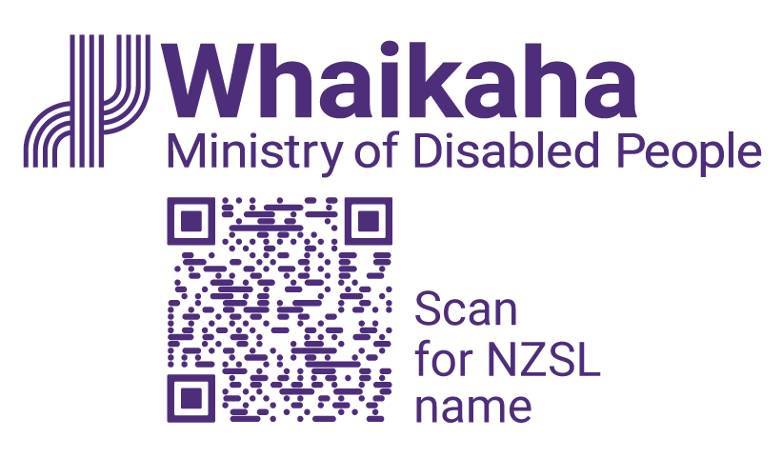

Access Activator
Information is also available in alternate formats:
- Audio
- Braille
- Easy Read
- Large Print
- New Zealand Sign Language
You can find these alternate formats at https://www.whaikaha.govt.nz/about-us/our-work/accessibility-work-programme/access-activator
(https://whaikaha.short.gy/qwc8)

Call for applications:
We are calling for impactful solutions that improve access and inclusion for Deaf and disabled people, Turi Māori, and tāngata whaikaha Māori and their whānau in Aotearoa New Zealand. We are especially interested in solutions and ideas about:
- transport.
- digital and information.
- the built environment.
- emergency management.
Funding is available for solutions at two different stages of development:
Idea stage:
- You can ask for up to $25,000 in funding.
- This is for early ideas.
- You might not have created a first version yet, but you have a clear idea with a plan and are ready to build a prototype (a simple, testable version of your idea).
Scale stage:
- You can ask for up to $100,000.
- You have already tested and can show your solution works.
- Your solution is already being used, and you want to make it bigger to help more people.
Applications open on 2 March 2026 and close at midnight 29 March 2026.
Applications to the Access Activator are made using an Application Form.
Please send your application form via email to outreach@whaikaha.govt.nz
Creative HQ will help with project support, learning, and practical advice, alongside Whaikaha.
More information about Access Activator, the selection criteria, and application forms can be found at https://www.whaikaha.govt.nz/about-us/our-work/accessibility-work-programme/access-activator
(https://whaikaha.short.gy/qwc8)
End of information | Access Activator
This Large Print document is adapted by Blind Citizens NZ from the standard document provided by Whaikaha | Ministry of Disabled People

