
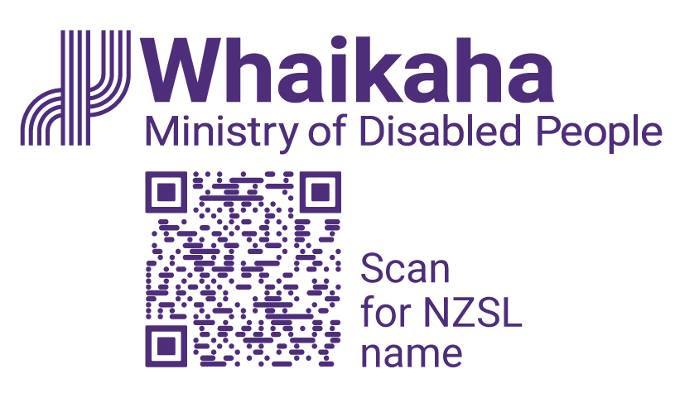

Access Activator

Innovating for access and inclusion
Information is also available in alternate formats:
- Audio
- Braille
- Easy Read
- Large Print
- New Zealand Sign Language
You can find these alternate formats at https://www.whaikaha.govt.nz/about-us/our-work/accessibility-work-programme/access-activator
(https://whaikaha.short.gy/qwc8)

Call for applications:
We are calling for impactful solutions that improve access and inclusion for Deaf and disabled people, Turi Māori, and tāngata whaikaha Māori and their whānau in Aotearoa New Zealand. We are especially interested in ideas about:
- transport.
- digital and information.
- the built environment.
- emergency management.
This might include solutions for better digital experiences, improved communication, or new ways for people to engage and participate in their community.
Funding is available for solutions at two different stages of development:
Idea stage:
- You can ask for up to $100,000 in funding.
- This is for early ideas.
- You might not have created a first version yet, but you have a clear idea with a plan and are ready to build a prototype (a simple, testable version of your idea).
Scale stage:
- You can ask for up to $100,000.
- You have already tested and can show your solution works.
- Your solution is already being used, and you want to make it bigger to help more people.
Mentoring will be offered to successful applicants to support them to develop and deliver their idea through May and June 2026.

Why we are running this programme
We want to find new ideas that help solve access and inclusion problems, or support really good existing ideas that may have struggled to get underway due to lack of funding. These ideas should be able to be tested or delivered quickly so we can see how well they improve disabled people’s daily life.
We support practical ideas that can be:
- prototyped (a simple version made to test).
- piloted (tested with a small group).
- or scaled (expanded to reach more people).

We focus strongly on:
- lived experience of Deaf and disabled people, Turi Māori, tāngata whaikaha Māori, and their whānau.
- equity.
- noticeable results.
Creative HQ will help with project support, learning, and practical advice, alongside Whaikaha.

Selection criteria for all applications
Your application should:
- Show involvement from disabled people who will benefit from your solution.
- Clearly describe the problem you are trying to fix, and have evidence (facts, examples, research, or lived experience) that shows it is a real problem.
- Be accurately scoped for time and budget, showing you can deliver the project by 30 June 2026 (final report may be delivered by 31 July 2026).
- Show that your idea will deliver a practical and affordable solution that makes a real positive difference to disabled people.
- Benefit a large number of different disabled people, or impacts a smaller number of disabled people in a deep and meaningful way.
- Works toward equity, including addressing access for Turi Māori and tāngata whaikaha Māori.
- The team has or can access the skills needed to deliver the project.
- Think about how the project will work including:
- how cost-effective the solution is and future funding pathways.
- whether any action (help) is needed from other agencies or providers.
- understanding of support required by relevant sector. For example, if your solution is about making public swimming pools more accessible, you will need to talk to local councils.
- understanding how it fits within existing systems and what is needed for adoption.

Additional criteria for ‘scale’ stage applications (up to $100,000)
Your application should also:
- Show that your solution actually works. This means you have tested it and can show it makes a positive difference.
- Have a clear plan to grow your idea with a reliable pathway for scaling/adoption.
- Delivers real, measurable impact for disabled people and their whānau.
- Plan for insights and feedback loops so your solution continues to grow and improve.

Notes for all applicants:
Application should be in line with the United Nations Convention on the Rights of Persons with Disabilities (UNCRPD) and Te Tiriti o Waitangi. The application questions help applicants to show this.

How to apply
Applications to the Access Activator are made using an Application Form.
The form is designed to help you clearly describe the problem, your solutions, the delivery plan, and the requested budget. The form reflects how the selection panel will assess applications.
Organisations may apply for funding for more than one solution, please use a separate application form for each.
Please send your application form via email to outreach@whaikaha.govt.nz by midnight on Sunday 29 March.

Using the Application Form
Applicants should complete all sections of the relevant application form (Idea stage or Scale stage). Each section includes guiding questions to help you understand the type of information we want to know.
Idea stage application form:
- ‘Idea stage’ application form (for up to $25,000) (word document).
- Audio ‘Idea stage’ application form (for up to $25,000).
- Braille ‘Idea stage’ application form (for up to $25,000).
- Large Print ‘Idea stage’ application form (for up to $25,000).
- New Zealand Sign Language guide to filling out the ‘Idea stage’ application form (for up to $25,000).
Scale stage application form:
- ‘Scale stage’ application form (for up to $100,000) (word document)
- Audio ‘Scale stage’ application form (for up to $25,000).
- Braille ‘Scale Stage’ application form (for up to $25,000).
- Large Print ‘Scale stage’ application form (for up to $25,000).
- New Zealand Sign Language guide to filling out the ‘Scale stage’ application form (for up to $25,000).
The sections are numbered to help those assessing the applications. You can start where you feel most confident and then build the full picture.

We encourage you to:
- Be clear and specific rather than overly detailed
- Focus on what you know now, not what you think you should promise
- Use plain language and avoid jargon where possible
- Include links or references where helpful (for example, to an existing solution, feedback, or evidence).
If you need help filling out the application, or want to apply in a different format, please email outreach@whaikaha.govt.nz with what help you need. Or you can call us on 0800 Whaikaha (0800 942 452).

What happens after you apply?
Completed application forms will be reviewed against the selection criteria. Shortlisted applicants will be asked to join a short online meeting to further discuss the proposal. You may also be contacted for follow-up questions before final decisions are made. Applicants can expect to be contacted in late April 2026.

Extra information

Who this programme is for?
The programme welcomes applications from:
- Disabled-led organisations and collectives.
- Community groups and NGOs (non-government organisations).
- Māori organisations and iwi entities.
- Social enterprises.
- Startups, and small and medium-sized organisations.
- Teams or partnerships that combine lived experience with delivery skills and knowledge.
If you’re an individual with a great idea, you would need to be funded through a fundholder. Get in touch with us to learn more by emailing outreach@whaikaha.govt.nz or calling 0800 WHAIKAHA (0800 942 452). If you are Deaf, hard of hearing, deafblind, speech impaired or find it hard to talk, you can use the New Zealand Relay Service. www.nzrelay.co.nz
Applicants must be able to enter into a funding agreement and show they have the skills and relationships needed to deliver the proposed work.
To enter into a funding agreement, you must be a legal entity or have a fundholder. Funds cannot be paid to an individual’s bank account or to organisations that are not legal entities.
Legal entities are:
- registered charitable trusts.
- incorporated societies.
- Crown entities e.g., universities or a company controlled by one or more Crown entities.
- Limited Liability Companies (businesses).
If your organisation is a legal entity, the grant can be paid to your organisation directly. If your organisation is not a legal entity, you must have a fundholder.

What is a fundholder?
A fundholder is an organisation that:
- is a legal entity;
- is willing to hold your grant money in its bank account while you complete your project.
If you have a fundholder, the grant will be paid into the fundholder organisation's bank account.
You will be responsible for completing the project and reporting to Whaikaha on its progress, and you will be responsible for communicating with your fundholder. The fundholder’s only role is to hold your grant in its bank account and work with you on spending it.
Your fundholder must sign a declaration stating they are happy to receive the grant on your behalf.

What are the expectations of funded projects?
If funded, project teams are expected to deliver on the areas outlined below:

Participation and engagement
- Actively take part in programme support activities that are there to help projects succeed, such as check-ins, workshops, or advisory sessions relevant to delivery and learning.
- Work openly and constructively with Whaikaha, Creative HQ, and any delivery partners involved in the programme.
- Respond on time to reasonable requests related to delivery, reporting, or learning.

Delivery and testing

Complete the agreed work on time and within the budget. If you think something might go wrong or the plan needs to change, you should tell the programme team early.
- Test ideas in real-world settings whenever possible. This means testing with people in real life situations rather than only using assumptions or paper-based design.
- Work with the people who will use your solution. Engage with people who will use your solution throughout delivery.

Learning and evidence
- Reflect on what is working and what is not, recognising that learning what works and what does not work, is an important outcome of the programme.
- Collect and share evidence of impact appropriate to the stage of the project (for example, user feedback, usage data, or observed changes).

Evaluation and review
- Take part in evaluation, review, or learning activities related to the programme.
- Share insights and lessons learned to support learning across the accessibility sector, where appropriate.
Support through the programme aims to strengthen projects, reduce delivery risk, and help teams focus on achieving real impact. Working together with Whaikaha and Creative HQ, and a willingness to learn are important to the success of both individual projects and the programme as a whole.

About the Delivery Partner Creative HQ
Whaikaha has partnered with Creative HQ to help design and deliver this programme. Creative HQ is a mission-driven innovation hub, and startup and tech support organisation. Creative HQ are based in Wellington, with impact felt nationally and internationally.
All information about Access Activator, the selection criteria, and application forms can be found at https://www.whaikaha.govt.nz/about-us/our-work/accessibility-work-programme/access-activator
(https://whaikaha.short.gy/qwc8)
End of information | Access Activator Innovating for Access and Inclusion
This Large Print document is adapted by Blind Citizens NZ from the standard document provided by Whaikaha | Ministry of Disabled People

